

**MINISTRY OF EDUCATION AND TRAINING**

**FPT UNIVERSITY**

Capstone Project Document

**Car Rental Portal**

|  |  |
| --- | --- |
| **Group 3** | |
| **Group members** | Trần Hữu Đức – SE61448  Huỳnh Công Thành – SE61297  Lê Vũ Đăng Khoa – SE61238  Nguyễn Tường Tâm – SE61384 |
| **Supervisor** | Lâm Hữu Khánh Phương |
| **Ext. Supervisor** | N/A |
| **Capstone Project Code** | CRP |

- Ho Chi Minh City, 01 September 2016 -

This page is intentionally left blank

Table of Contents

Table of Contents 3

List of Tables 7

List of Figures 8

Definitions, Acronyms, and Abbreviations 10

A. Introduction 11

1. Project Information 11

2. Introduction 11

3. Current Situation 11

4. Problem Definition 11

5. Proposed Solution 12

5.1. Featured functions 12

5.2. Advantages 12

5.3. Disadvantages: 12

6. Functional Requirements 12

7. Roles and Responsibility 13

B. Software Project Management Plan 14

1. Problem Definition 14

1.1. Name of this Capstone Project 14

1.2. Problem Abstract 14

1.3. Project Overview 14

2. Project organization 16

2.1. Software Process Model 16

2.2. Roles and responsibilities 17

2.3. Tools and Techniques 18

3. Project Management Plan 18

3.1. Tasks 18

3.2. Task sheet 21

3.3. All Meeting Minutes 21

4. Coding Convention 21

C. Software Requirement Specification 22

1. User Requirement Specification 22

1.1. Guest requirements: 22

1.2. Customer requirements: 22

1.3. Provider requirements: 22

1.4. Administrator requirements: 23

2. System Requirement Specification 24

2.1. External Interface Requirement 24

2.2. System Overview Use Case 24

2.3. Use Cases 26

3. Software System Attribute 112

3.1. Usability 112

3.2. Reliability 112

3.3. Availability 112

3.4. Security 112

3.5. Maintainability 112

3.6. Portability 112

3.7. Performance 112

4. Conceptual Diagram 113

D. Software Design Description 115

1. Design Overview 115

2. System Architecture Design 116

2.1. Web Application architecture description 116

3. Component Diagram 117

4. Detailed Description 118

4.1. Class Diagram 118

4.2. Class Diagram Explanation 120

4.3. Interactive Diagram 128

5. User Interface Design 130

6. Database Design 131

6.1 Entity relationship diagram 131

6.2 Entity Dictionary 132

Algorithms 139

6.2. Recommender Engine 139

E. システムの展開とテスト 148

1. はじめに 148

1.1 概要 148

1.2 テストアプローチ 148

2. データベース関係ダイアグラム 148

2.1 ウェブアプリケーション物理的なダイアグラム 148

2.2 ウェブアプリケーションデータ辞書 150

3. パフォーマンス対策 150

3.1 製品検索、メンバーのパフォーマンス 150

3.2 送り状リストが展示されるパフォーマンス 150

3.3 収入統計など展示されるパフォーマンス 150

4. テスト計画 150

4.1 テストする機能 150

4.2 テストされない機能 151

5. システムテストのテストケース 151

F. ソフトウェアユーザーズマニュアル 152

1. インストレーションガイド 152

1.1. サーパ側の環境を設定 152

1.2. サーパ側で展開 152

1.3. クライアント側の環境の設定 156

2. ユーザーガイド 157

2.1. ログイン 157

2.2. 製品を注文すること 158

2.3. カートに製品を追加すること 158

2.4. かーとをチェックすること 159

2.5. カーとの精細 160

2.6. 送り状を確認すること 161

2.7. 送り状に顧客の情報を充実すること 161

2.8. 送り状のリストを見ること 162

2.9. 「人員」送り状を造ること 163

2.10. 送り状に顧客を追加すること 164

2.11. 新い顧客の口座で送り状をチェックアウト 165

2.12. 入力法案 リスク 166

2.13. 新入力法案を造ること 167

2.14. 入力原料 リスクを見る 168

2.15. 入力原料 の精細を見ること 169

2.16. 新入力原料を造ること 170

G. Appendix 172

List of Tables

Table 1: Definitions, Acronyms, and Abbreviations 11

Table 2: Roles and Responsibility 14

Table 3: Hardware requirement for Web Server 16

Table 4: Hardware requirement for Web Server 17

Table 5 : Software requirement 17

Table 6: Roles and responsibilities 18

Table 7: Tools and Techniques 19

Table 8: Component dictionary 118

Table 9: Class dictionary 120

Table 10: AspNetUser class - Attributes 121

Table 11: AspNetUser class – Methods 121

Table 12: AspNetRole class - Attributes 122

Table 13: AspNetRole class - Methods 122

Table 14: AspNetUserClaim class - Attributes 122

Table 15: AspNetUserClaim class - Methods 122

Table 16: AspNetUserLogin class - Attributes 122

Table 17: AspNetUserLogin class - Methods 122

Table 18: Vehicle class - Attributes 123

Table 19: Vehicle class - Methods 123

Table 20: VehicleImage class - Attributes 123

Table 21: VehicleImage class - Methods 123

Table 22: VehicleModel class - Attributes 123

Table 23: VehicleModel class - Methods 123

Table 24: VehicleBrand class - Attributes 124

Table 25: VehicleBrand class - Methods 124

Table 26: VehicleBrand class - Attributes 124

Table 27: VehicleBrand class - Methods 124

Table 28: Garage class - Attributes 124

Table 29: Garage class - Methods 124

Table 30: GarageWorkingTime class - Attributes 125

Table 31: GarageWorkingTime class - Methods 125

Table 32: Location class - Attributes 125

Table 33: Location class - Methods 125

Table 34: Nation class - Attributes 125

Table 35: Nation class - Methods 125

Table 36: VehicleGroup class - Attributes 126

Table 37: VehicleGroup class - Methods 126

Table 38: PriceGroup class - Attributes 126

Table 39: PriceGroup class - Methods 126

Table 40: PriceGroupItem class - Attributes 127

Table 41: PriceGroupItem class - Methods 127

Table 42: BookingReceipt class - Attributes 128

Table 43: BookingReceipt class - Methods 128

Table 44 : Entity dictionary 133

Table 45: User entity – Attributes 134

Table 46: Role entity - Attributes 134

Table 47: Vehicle entity – Attributes 135

Table 48: VehicleImage entity - Attributes 135

Table 49: VehicleModel entity - Attributes 135

Table 50: VehicleBrand entity - Attributes 136

Table 51: VehicleBrand entity - Attributes 136

Table 52: Garage entity - Attributes 136

Table 53: GarageWorkingTime entity - Attributes 137

Table 54: Location entity - Attributes 137

Table 55: Nation entity - Attributes 137

Table 56: VehicleGroup entity - Attributes 138

Table 57: PriceGroup entity - Attributes 138

Table 58: PriceGroupItem entity - Attributes 138

Table 59: BookingReceipt entity - Attributes 139

Table 60 – Example of vehicle with 4 neighbor attributes 142

Table 61 – Example tf values of vehicles with 6 binary attributes 143

Table 62 – Example weight of 5 vehicles with 6 binary attributes 144

Table 63 – Example of 5 bookings with 4 attributes 144

Table 64 – Example tf of 5 bookings with 4 attributes applying like-dislike scheme 144

Table 65 – Example weight for attribute vectors of a customer profile 145

Table 66 – Example score for 5 vehicles with 4 attributes 146

Table 67 – Time complexity of **Build customer profile** step 146

Table 68 – Time complexity of **Build vehicle vectors** step 147

Table 69 – Time complexity of **Score vehicles** step 147

テーブル70: ログインポップアップ 158

テーブル 71:　製品を注文する 159

テーブル 72: カートに製品を追加する 160

テーブル 73: かーとをチェックすること 160

テーブル 74: カートの精細 161

テーブル 75: 送り状を確認すること 162

テーブル 76: 送り状に顧客の情報を充実すること 163

テーブル 77: 送り状のリストを見ること 164

テーブル 78: 「人員」送り状を造ること 164

テーブル 79: 送り状に顧客を追加すること 165

テーブル 80: 新顧客の口座で送り状をチェックアウト 167

テーブル 81:入力法案 リスク 167

テーブル 82: 新入力法案を造ること 168

テーブル 83: 入力原料リスク 169

テーブル 84:入力原料の精細を見ること 170

テーブル 85:入力原料を造ること 172

List of Figures

Figure 1: Modified Waterfall Development Model 18

Figure 2: System Overview Use Case 27

Figure 3: <Guest> Use Case Overview 28

Figure 4: <Guest> Login Use Case 28

Figure 5: <Guest> Sign up Use Case 30

Figure 6: <Guest> Recover password Use Case 33

Figure 7: <Guest> Search vehicle Use Case 35

Figure 8: <Guest> View vehicle’s information Use Case 38

Figure 9: <Authenticated user> Use Case Overview 39

Figure 10: < Authenticated User > Log out Use Case 39

Figure 11: < Authenticated User > Change personal information Use Case 40

Figure 12: < Authenticated User > Change password Use Case 42

Figure 13: < Authenticated User > Search vehicle Use Case 44

Figure 14: < Authenticated User > View vehicle’s information Use Case 48

Figure 15 <Customer> Use Case Overview 49

Figure 16: < Customer > Book vehicle Use Case 49

Figure 17: < Customer > View booking history Use Case 52

Figure 18: < Customer > View detailed booking information Use Case 53

Figure 19: < Customer > Cancel booking Use Case 54

Figure 20: < Customer > Comment and rate booking Use Case 56

Figure 21: < Customer > Register providership Use Case 58

Figure 22 <Provider> Use Case Overview 60

Figure 23: < Provider > Create vehicle Use Case 61

Figure 24: < Provider > Duplicate existed vehicle Use Case 64

Figure 25: < Provider > Edit vehicle Use Case 67

Figure 26: < Provider > Delete vehicle Use Case 70

Figure 27: < Provider > View vehicle’s booking schedule Use Case 71

Figure 28: < Provider > View garage’s booking schedule Use Case 73

Figure 29: < Provider > Book own vehicle Use Case 75

Figure 30: < Provider > Cancel self-booking Use Case 76

Figure 31: < Provider > Create garage Use Case 78

Figure 32: < Provider > Delete garage Use Case 81

Figure 33: < Provider > Edit garage Use Case 82

Figure 34: < Provider > Close garage Use Case 85

Figure 35: < Provider > Reopen garage Use Case 86

Figure 36: < Provider > Add vehicle to garage Use Case 88

Figure 37: < Provider > Move vehicle to another garage Use Case 89

Figure 38: < Provider > Create vehicle group Use Case 90

Figure 39: < Provider > Delete vehicle group Use Case 94

Figure 40: < Provider > Edit vehicle group Use Case 96

Figure 41: < Provider > Deactivate vehicle group Use Case 100

Figure 42: < Provider > Reactivate vehicle group Use Case 101

Figure 43: < Provider > Add vehicle to group Use Case 102

Figure 44: < Provider > Remove vehicle from group Use Case 104

Figure 45: < Provider > Move vehicle to another group Use Case 105

Figure 46: < Provider > View reports Use Case 107

Figure 47: < Provider > Extend providership Use Case 108

Figure 48 <Admin> Use Case Overview 110

Figure 49: < Admin > View reports Use Case 110

Figure 50: < Admin > Deactivate user Use Case 111

Figure 51: < Admin > Reactivate user Use Case 112

Figure 52: Conceptual Diagram 115

Figure 53: System architecture design 118

Figure 54 : Component diagram 119

Figure 55 : Entity Relationship Diagram 133

Figure 56 – Example for 3-dimensional vector space 142

Figure 57 – Example for customer profile vector 143

Figure 58: ウェブサイトアプリケーション物理的なダイアグラム 151

図面59: ログインポップアップ 159

図面 60:製品を注文すること 160

図面 61: カートに製品を追加すること 161

図面 62: かーとをチェックすること 161

図面 63: カートの精細 162

図面 64: 送り状を確認すること 163

図面 65: 送り状に顧客の情報を充実すること 164

図面 66: 送り状のリストを見ること 164

図面 67: 「人員」送り状を造ること 165

図面 68: 送り状に顧客を追加すること 166

図面 69: 新顧客の口座で送り状をチェックアウト 167

図面 70: 入力法案 リスク 168

図面 71: 新入力法案を造ること 169

図面 72: 入力原料 リスク 170

図面 73:入力原料 の精細を見ること 171

図面 74: 新入力原料を造ること 172

Definitions, Acronyms, and Abbreviations

|  |  |
| --- | --- |
| Name | Definition |
| CRP | Car Rental Portal |

Table 1: Definitions, Acronyms, and Abbreviations

# Introduction

## Project Information

* Project name: **Car Rental Portal**
* Project Code: **CRP**
* Product Type: **Website Application**
* Start Date: **September 1st, 2016**
* End Date: **December 1st, 2016**

## Introduction

In this document, we introduce a car rental portal solution – a website application to help car rental service provider to bring their business online. The solution allows providers to define their own rental policy and price. It also simplifies the providers’ rental management process. Our solution also allows customer to easily find and book the most suitable car for their trip.

## Current Situation

Nowadays, there are many car rental providers in Vietnam. However, only a small percent of them have utilized internet to promote their business. Part of them (Large rental companies, taxi companies) have their own website or mobile application, while some choose to become driver for online rental portal solution like Uber and Grab.

Many small and middle-sized providers cannot afford their own website or mobile application, and also find contract with Uber and Grab too rigid because they are not allowed to define their own rental price and policy. Uber’s and Grab’s solutions also do not apply well for long-period rental.

A new solution that has just appeared recently is Aleka, which they themselves claimed to be inspired by Uber and Airbnb. Their approach take a lot after Airbnb. They allows providers to post their vehicles on their website, and then helps customer to find and book the most suitable vehicle in their system. Their solution however does not offer any way for customer to rate and comment about the service of provider, as well as to read other customers’ ratings and reviews before deciding to book the vehicle.

## Problem Definition

The current situation has several problems:

* **Cost barrier:** The cost to develop an online rental application is too high for small rental providers.
* **Ill-suited rental portal solutions:** There are great rental portal services like Uber, Grab, or Aleka on the market. However, their solutions have yet to completely satisfy the user. Their shortcomings include limiting provider’s action, cannot handle long-period rental very well, or lack of a mean for rating and reviewing provider’s service.

## Proposed Solution

Our proposed solution, named Car Rental Portal, is a car rental portal website application that takes after Airbnb. We provide a flexible mean for provider to promote their rental service online while still allows them to define their own rental policy. Our solution also allows customer to rate and comment about their past renting, as well as read others’ review on vehicles. Our solution also offers a searcher integrated with recommender engine that can help customer to find the best matched vehicle quickly and easily.

### Featured functions

* **Manage online rental service:** Provider can manage their vehicles’ and bookings’ information, as well as declare their own rental policies, including price contrainst, time constraint, travel distance constraint…
* **Advanced vehicle searcher with recommender engine:** System can help customers to find the most suitable vehicle fast and easily based on their booking history.
* **Review vehicle and read vehicle’s reviews:** Customer can comment and rate rental service after renting vehicle, as well as read reviews from other customer for a vehicle.
* **Book vehicle and cancel booking:** Customer can book and pay booking fee through NganLuong payment portal, as well as cancel their booking easily.

### Advantages

* Offer a cheap and easy online rental management solution.
* Allow provider to define their own rental policies.
* Support both hourly and daily rental.
* Offer vehicle searching with recommender engine.
* Offer rental service rating/reviewing function.
* Allow paying through NganLuong payment portal.

### Disadvantages:

* Since recommender works depending on customer’s booking history, customer must have booked at least once in the past to utilize it.
* Depends on NganLuong and has no alternative payment method in case NganLuong goes down.

## Functional Requirements

* Manage vehicles:
  + Provider can create, update, and delete vehicle.
* Manage vehicles’ bookings:
  + Provider can keep track of their vehicle’s booking schedule.
  + Provider can create self-booking to reserve their vehicle.
  + Provider can cancel self-booking.
* Manage garage:
  + Provider can create, update, and delete garage.
  + Provider can specify their garage’s rental policy.
  + Provider can group vehicle into garage.
  + Provider can close their garage temporary.
* Manage price group:
  + Provider can create, update, and delete price group.
  + Provider can group vehicle that he want to apply specific price options.
  + Provider can disable the group and every vehicle inside the group.
* Manage booking:
  + Customer can book vehicle.
  + Customer can cancel their booking.
  + Customer can keep track of their booking history.
  + Customer can rate and comment about their booking.
* Manage user account:
  + Administrator can lock and unlock user account.
* Search and view vehicle’s information.
* View report:
  + Administrator can view system’s business report in dashboard.
  + Provider can view personal business report in dashboard.
* Receive notification email:
  + Customer will receive notification email when he has booked a vehicle.
  + Provider will receive notification email when their vehicle has been booked.
  + Customer will receive notification email when he has canceled a booking.
  + Provider will receive notification email when their vehicle’s booking has been canceled.

## Roles and Responsibility

|  |  |  |  |  |
| --- | --- | --- | --- | --- |
| No | Full Name | Role | Position | Contact |
| 1 | Lâm Hữu Khánh Phương | Project Manager | Supervisor | phuonglhk@fpt.edu.vn |
| 2 | Trần Hữu Đức | Developer | Leader | ducthse61448@fpt.edu.vn |
| 3 | Huỳnh Công Thành | Developer | Member | thanhchse61297@fpt.edu.vn |
| 4 | Lê Vũ Đăng Khoa | Developer | Member | khoalvdse61238@fpt.edu.vn |
| 5 | Nguyễn Tường Tâm | Developer | Member | tamntse61384@fpt.edu.vn |

Table 2: Roles and Responsibility

# Software Project Management Plan

## Problem Definition

### Name of this Capstone Project

* **Official name**: Car Rental Portal
* **Vietnamese name**: Cổng thông tin cho thuê xe
* **Abbreviation**: CRP

### Problem Abstract

Nowadays, there are many car rental providers in Vietnam. However, only a small percent of them have utilized internet to bring their business online. Aside from creating their own online rental applications, providers can also utilize rental solution services like Grab, Uber, or Aleka. These new services however still contain many flaws that keep a large number of providers away.

### Project Overview

#### Current Situation

Our project has the following problems:

* **Recommender engine is dependent on customer’s booking history:** The recommender engine cannot work on customer that has not placed any booking in the past.
* **Has no alternative payment method:** Our system depends completely on NganLuong for payment processing. There is currently no alternative payment method.

#### The Proposed System

The proposed system is a rental portal website application that can help car rental service provider to bring and manage their rental service online and allow customer to find and book vehicle easily. The system utilize NganLuongApi to process payment and has a recommender engine to improve vehicle searching.

Separated based on user’s role, the system offers the following functions:

* For guests:
  + Search vehicle.
  + View vehicle’s rental information.
* For customers:
  + Search vehicle.
  + View vehicle’s rental information.
  + Book vehicle and cancel booking.
  + Track booking history.
  + Register providership.
  + Receive notification email upon booking or canceling booking.
* For providers:
  + Manage vehicles.
  + Manage vehicles’ bookings.
  + Manage garages.
  + Manage price groups.
  + View personal business report.
  + Extend providership period.
  + Receive notification email upon receiving booking or booking was canceled.
* Administrator:
  + Manage user accounts.
  + View system’s business report.

#### Boundaries of the System

* The system targets mainly small and mid-sized car rental service providers, but can also handle the needs of large providers with large number of vehicles and multiple garages.
* The system supports both daily and hourly booking.
* The language of the system is Vietnamese.
* The completed product includes:
  + Booking system for customer.
  + Rental service managing system for provider.

#### Future Plans

* Offer pricing scheduler so that price group can change price during special events.
* Support self-driving rental.
* Support motorbike rental.
* Offer driver management functions.
* Support internationalization.
* Develop mobile version.

#### Development Environment

##### Hardware requirement

For web server:

| Hardware | Minimum Requirements | Recommended |
| --- | --- | --- |
| Network Bandwidth | 4 Mbps | 8 Mbps |
| Operating System | Window Server 2008 | Window Server 2008 |
| Computer Processor | Intel® Xeon Dual Core® 1.4GHz (4MB Cache) | Intel® Xeon® Quad Core (8M Cache, 2.40 GHz) |
| Computer Memory | 2GB RAM | 4GB or more |
| Hard disk | 40GB | 80GB |

Table 3: Hardware requirement for Web Server

For web development:

| Hardware | Minimum Requirements | Recommended |
| --- | --- | --- |
| Internet Connection | 512 Kbps | 8 Mbps |
| Operating System | Window Vista, 7, 8 | Window 7, 8 |
| Computer Processor | 1 GHz | Intel® Core™ i5 CPU 2.53 GHz |
| Computer Memory | 2GB RAM | 4GB or more |

Table 4: Hardware requirement for Web Server

##### Software requirement

| Software | Name / Version |
| --- | --- |
| Operating system | Windows 7 or above |
| Modeling tool | StarUML version 2.7.0 (UML2.0 standard [2]) |
| IDE | Microsoft Visual Studio 2015 Community |
| DBMS | SQL Server 2014 |
| Source control | Git 2.9.0.windows.1 |
| Web browser | Chrome (v.42 and above), Firefox (v.38 and above), and any equivalent web browser |

Table 5 : Software requirement

## Project organization

### Software Process Model

Modified waterfall model (Sashimi [1]) is applied in this project. This model was chosen because:

* The requirements of the project are well-defined and well-understood by all team members.
* The deliverables in each phase of the model can be corresponded with the reports that have to be submitted in each process of the capstone project.

Requirement

Design and Architecture

Development and Coding

QA and Testing

Maintenance

Figure 1: Modified Waterfall Development Model

### Roles and responsibilities

|  |  |  |  |
| --- | --- | --- | --- |
| No | Full name | Role in Group | Responsibilities |
| 1 | Lâm Hữu Khánh Phương | Supervisor / Project Manager | - Clarify user requirement  - Give technical support and business analysis  - Track development process  - Review document and product |
| 2 | Trần Hữu Đức | Team leader, Business Analyst, Developer, Tester | - Manage development process  - Analyze requirement  - Design database  - Prepare documents  - Design GUI  - Code  - Test  - Deploy product |
| 3 | Huỳnh Công Thành | Team member, Business Analyst, Developer, Tester | - Analyze requirement  - Design database  - Prepare documents  - Design GUI  - Code  - Test |
| 4 | Lê Vũ Đăng Khoa | Team member, Business Analyst, Developer, Tester | - Analyze requirement  - Design database  - Prepare documents  - Design GUI  - Code  - Test |
| 5 | Nguyễn Tường Tâm | Team member, Business Analyst, Developer, Tester | - Analyze requirement  - Design database  - Prepare documents  - Design GUI  - Code  - Test |

Table 6: Roles and responsibilities

### Tools and Techniques

| Tool / Technique | Name / version |
| --- | --- |
| Frontend | HTML5, CSS3, JavaScript, jQuery, Bootstrap |
| Backend | ASP.NET MVC 5, Entity Framework, NganLuong, Cloudinary |
| Web server | IIS 8 |
| Development tool | Microsoft Visual Studio 2015 Community |
| DBMS | MSSQL Server 2014 |
| Source control | Git 2.9.0.windows.1 |
| Modeling tool | StarUML 2.7.0 |
| Document tool | Microsoft Word 2013 |

Table 7: Tools and Techniques

## Project Management Plan

### Tasks

#### Initiating

| Task name | Initiating |
| --- | --- |
| Description | - Clarify user requirements on the rental portal.  - Research business logic of car rental service.  - Research popular car rental solutions (Grab, Uber, Aleka) as well as other similar websites (Carmudi, Airbnb).  - Offer team’s solution, declare its pros and cons, introduce some core function of the new system. |
| Deliverables | Report No.1 – Introduction |
| Resource needed | 20 man-days |
| Dependencies and constraints | No |
| Risk | - Missing requirement  - Unclear project scope  - Lacking teamwork in new formed team |

#### Planning

| Task name | Planning |
| --- | --- |
| Description | - Review team’s solution  - Verify project’s scope  - Build project management plan |
| Deliverables | Report No.2 – Software Project Management Plan |
| Resource needed | 16 man-days |
| Dependencies and constraints | - Base on Report No.1 – Introduction.  - Planned project must be completed in the following 12 weeks |
| Risk | Impractical plan |

#### Specifying requirements

| Task name | Specifying requirements |
| --- | --- |
| Description | Identify and clarify software requirements. |
| Deliverables | Report No. 3 – Software Requirement Specification |
| Resource needed | 20 man-days |
| Dependencies and constraints | Base on Report No.2 – Software Project Management Plan. |
| Risk | Misunderstood or unclear system’s requirement |

#### Designing database

| Task name | Designing database |
| --- | --- |
| Description | - Create conceptual, logical and physical database designs  - Implement in SQL Server 2014 |
| Deliverables | Physical database and SQL script. |
| Resource needed | 12 man-days |
| Dependencies and constraints | Base on Report No. 3 Software Requirement Specification |
| Risk | Unreasonable database design |

#### Create Software Design Description

| Task name | Create Software Design Description |
| --- | --- |
| Description | Decide software architect and clarify software detail design. |
| Deliverables | Report No. 4 – Software Design Description |
| Resource needed | 40 man-days |
| Dependencies and constraints | Base on Report No. 3 Software Requirement Specification and designed database |
| Risk | Unreasonable software design |

#### Implementing

| Task name | Implementing |
| --- | --- |
| Description | Implements all functions of system. |
| Deliverables | Software package. |
| Resource needed | 80 man-days |
| Dependencies and constraints | - Base on Software Requirement Specification and Software Design Description.  - Follow coding convention. |
| Risk | Incorrect implementation |

#### Testing

| Task name | Testing |
| --- | --- |
| Description | - Create test plan  - Perform tests.  - Fix bugs |
| Deliverables | Report No. 5 – System Implementation & Test |
| Resource needed | 40 man-days |
| Dependencies and constraints | Implementation is finished |
| Risk | - Incompleted test plan  - Lacking time for iterative test and bug fixing |

#### Creating User’s Manual

| Task name | Creating User’s Manual |
| --- | --- |
| Description | Create user’s manuals |
| Deliverables | Report No.6 – Software User’s Manual |
| Resource needed | 12 man-days |
| Dependencies and constraints | Product has passed acceptance test. |
| Risk | Bad and unclear documenting |

### Task sheet

Refer to “Task sheet” folder in the attached CD.

### All Meeting Minutes

Refer to “Meeting minutes” folder in the attached CD.

## Coding Convention

This project follows “C# coding conventions”.

* Naming Convention :
  + - For variable’s name, use camel case (numOfVehicle, currentDate…)
    - For function name, class name, use pascal case (SearchVehicle, VehicleInfoViewModel…)
* Layout Convention :
  + - Use the default Code Editor Settings (smart indenting, four-character indents, tabs saved as spaces).
    - Write only one statement/declaration per line.
    - Add at least one blank line between method definitions and property definitions.
    - Use parentheses to make clauses in an expression apparent
* Commenting Convention :
  + - Place the comment on a separate line, not at the end of a line of code.
    - Begin comment text with an uppercase letter.
    - End comment text with a period.
    - Insert one space between the comment delimiter (//) and the comment text.
* Language Guidelines :

<https://msdn.microsoft.com/en-us/library/vstudio/ff926074.aspx>

# Software Requirement Specification

## User Requirement Specification

### Guest requirements:

A guest is a person who has not been authenticated by the system. A guest has access to a limited number of system’s functions, which are:

* Log in
* Sign up
* Recover account’s password
* Search vehicle
* View rental information of vehicle

### Customer requirements:

A customer is an authenticated user that can utilize the system to find and book vehicle. A customer is able to:

* Log out
* Change personal information
* Change account’s password
* Search vehicle
* View rental information of vehicle
* Book vehicle
* Cancel booking
* Track booking history
* Comment and rate the car provider’s service after:
  + The booking has been canceled
  + The rental period has started
* Receive notification email when:
  + A booking has been placed successfully using this account
  + A booking has been canceled using this account

### Provider requirements:

A provider is an authenticated user that can use the system to manage their car rental business. A provider can:

* Log out
* Change personal information
* Change account’s password
* Search vehicle
* View rental information of vehicle
* Manage vehicles:
  + Register vehicle
  + Deregister vehicle
  + Update vehicle’s information
  + Group vehicles into garage
  + Group vehicles into vehicle group for price management
* Manage vehicles’ bookings:
  + Review booking schedule
  + Create self-booking to reserve vehicle
  + Cancel self-booking
* Manage garages:
  + Register new garage
  + Deregister garage
  + Edit garages’ information
  + Close garage
  + Reopen garage
  + Add vehicle to garage
  + Move vehicle to another garage
* Manage vehicle grouping for easier price management:
  + Register new group
  + Deregister group
  + Change group’s information and pricing
  + Deactivate group
  + Reactivate group
  + Add vehicle to group
  + Remove vehicle from group
* Extend providership period
* Receive notification email when
  + A vehicle has been booked.
  + A customer has canceled a booking.
* View personal business report

### Administrator requirements:

An administrator is an authenticated user that is tasked with managing the system and its users. Administrator is able to:

* Log out
* Change personal information
* Change account’s password
* Search vehicle
* View rental information of vehicle
* Deactivate customer/provider account
* Reactivate customer/provider account
* View system’s business report

## System Requirement Specification

### External Interface Requirement

#### User interface

* Graphics User Interface (GUI) should be simple, clear, intuitive, and reminiscent.
* GUI uses Vietnamese language.
* GUI uses consistent palette of colors between the text and the background.
* GUI displays best on screen with 1366x768 or higher resolution.

#### Hardware Interface

* N/A

#### Software Interface

The website works well on Chrome (v.42 and above), Firefox (v.38 and above), and any equivalent web browser.

#### Communication Protocol

Web server supports HTTP protocol v.1.1.

### System Overview Use Case

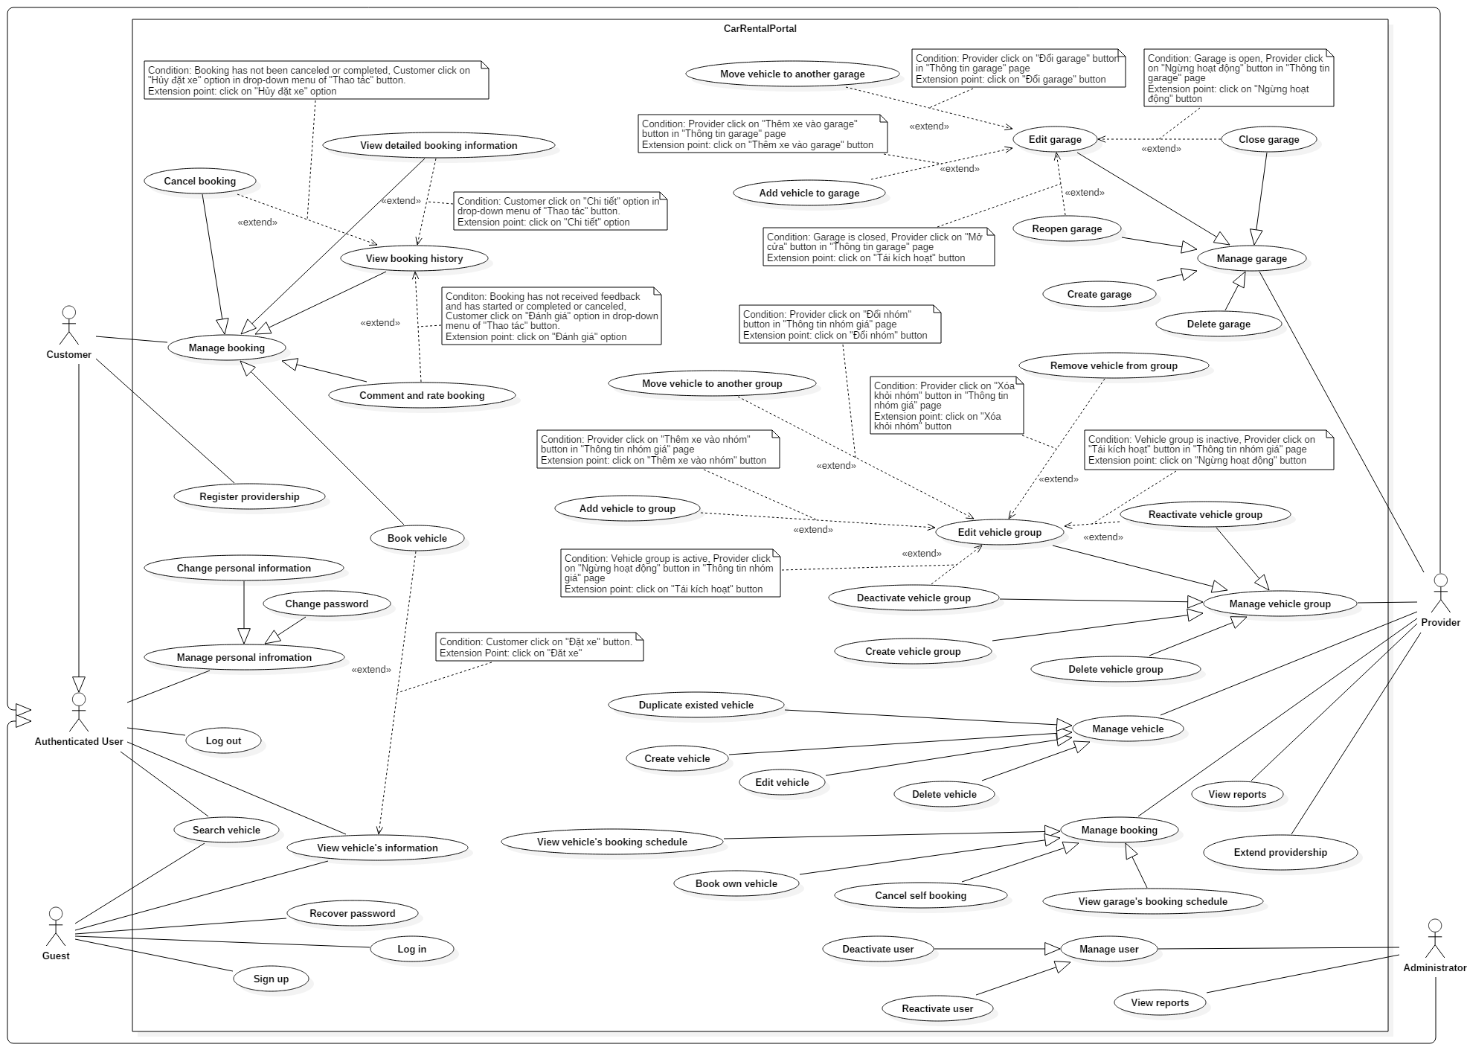

Figure 2: System Overview Use Case

### Use Cases

#### <Guest> Use Cases Overview

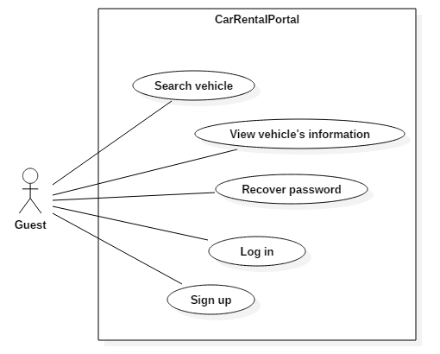

Figure 3: <Guest> Use Case Overview

##### <Guest> Log in (UC01)

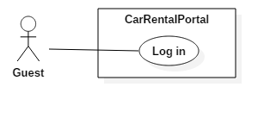

Figure 4: <Guest> Login Use Case

|  |  |  |  |
| --- | --- | --- | --- |
| USE CASE – UC01 | | | |
| Use Case No. | 01 | **Use Case Version** | 1.0 |
| Use Case Name | Log in | | |
| Author | TamNT | | |
| Date | 30/09/2016 | **Priority** | Normal |
| Actor:   * Guest.   Summary:   * This use case allows guest to log into the system.   Goal:   * Guest can log into the system.   Triggers:   * Guest sends the login command.   Preconditions:   * N/A   Post Conditions:   * Success: Guest login the system. * Fail: Show error message.   Main Success Scenario:   |  |  |  | | --- | --- | --- | | Step | Actor Action | System Response | | 1 | Guest click “Đăng nhập” button. | System show popup requires identity information :   * Email: Email format, required. * Password: free text input, required. | | 2 | Guest inputs information. |  | | 3 | Guest sends command to login to system by click button Login | Guest will be logged-in system with their specific role  [Alternative 1, 2]  [Exception 1, 2, 3, 4, 5] |   Alternative Scenario:   |  |  |  | | --- | --- | --- | | Step | Actor Action | System Response | | 1 | Guest click at link “Quên mật khẩu”. | Redirect to “Recover Password” page. | | 2 | Guest click at link “Đăng kí một tài khoản”. | Redirect to “Sign up” page. |   Exceptions:   |  |  |  | | --- | --- | --- | | No | Actor Action | System Response | | 1 | Guest missed to input “Email” field. | System show error message “The Email field is required”. | | 2 | Guest missed to input “Password” field | System show error message “The Password field id required” | | 3 | The email inputted is wrong with email format | System shows error message “The email field is not a valid e-mail address” | | 4 | Guest inputted wrong account, password this account was be blocked | System shows error message “Tài khoản không tồn tại hoặc bị chặn” | | 5 | Account was be blocked | System shows error message “Tài khoản không tồn tại hoặc đã bị chặn”. |   Relationships: N/A  Business Rules:   * Only account that has not been locked out can log into the system. * After logging into system, user will be redirected to specific view according to their role: * If user has role “Admin”, he will be redirected to Administrator Dashboard page. * If user has role “Provider”, he will be redirected to Provider Dashboard page. * If user has role “Customer”, he will be redirected to Personal Information page. | | | |

##### <Guest> Sign up (UC02)

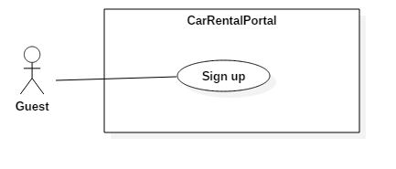

Figure 5: <Guest> Sign up Use Case

|  |  |  |  |
| --- | --- | --- | --- |
| singup.pngUSE CASE – US02 | | | |
| Use Case No. | 02 | **Use Case Version** | 1.0 |
| Use Case Name | Sign up | | |
| Author | TamNT | | |
| Date | 30/09/2016 | **Priority** | Normal |
| Actor:   * Guest.   Summary:   * This use case allows Guest to sign up.   Goal:   * Guest can create an account to login.   Triggers:   * Guest clicks “Đăng kí một tài khoản” link in login popup. * Guest clicks “Đăng kí” button in top bar.   Post Conditions:   * Success: Create an new account for login to this system. * Fail: Show error message.   Main Success Scenario:   |  |  |  | | --- | --- | --- | | Step | Actor Action | System Response | | 1 | Guest clicks “Đăng kí một tài khoản” link in login popup. | System show popup requires identity information:  “Username”: free text input, required, max length 20, not include whitespace.  “Tên đầy đủ”: free text input, required, max length 200, min length 10.  “Email”: Email format, required.  “Xác nhận Email”: Email format, required, matched with field Email.  “Mật khẩu”: Required, mini length 6, max length 100, must be has least 1 upper case, numeric.  “Xác nhận mật khẩu”: Required, must be mactched with “Mật khẩu” field.  “Số điện thoại”: free text input, required, max length 30, min length 1. | | 2 | Guest inputs information. |  | | 3 | Guest sends command to create an account on system | System creates a new account with provided information, then send confirmation email to provided email and redirect guest to homepage.  [Exception 1, 2, 3, 4, 5, 6, 7, 8, 9, 10, 11, 12, 13, 14, 15, 16, 17, 18, 19, 20] | | 4 | Guest click on confirmation url in their email. | System confirms email and sets role “Customer” for confirmed account, then redirect user to success page. |   Exceptions:   |  |  |  | | --- | --- | --- | | No | Actor Action | System Response | | 1 | Guest missed to input “Username” field. | Show error message “Username không được để trống”. | | 2 | Guest missed to input “Email” field | Show error message “Email không được để trống”. | | 3 | Guest missed to input “Xác nhận email” field | Show error message “Email xác nhận không được để trống”. | | 4 | Guest missed to input “Mật khẩu” field | Show error message “Mật khẩu không được trống”. | | 5 | Guest missed to input “Số điện thoại” field. | Show error message “Số điện thoại không được trống.” | | 6 | Guest missed to input “Xác nhận mật khẩu” field. | Show error message “Số điện thoại xác nhận không được trống.” | | 7 | Guest inputted “Username” field with wrong format.  (Out of length) | Show error message “Username chỉ được tối đa 20 kí tự.” | | 8 | Guest inputted “Tên đầy đủ” field with wrong format.  (Out of length) | Show error message “Tên đầy đủ phải có từ 10 đến 200 kí tự.” | | 9 | Guest inputted “Email” field with wrong format. | Show error message “Định dạng email không chính xác”. | | 10 | Guest inputted “Xác nhận email” field with mismatched information. | Show error message “Xác nhận email không khớp”. | | 11 | Guest inputted “Mật khẩu” field with wrong format.  (Out of length) | Show error message “Mật khẩu phải có ít nhất 6 kí tự”. | | 12 | Guest inputted “Xác nhận mật khẩu” do not matched with “Mật khẩu”. | Show error message “Mật khẩu không khớp.” | | 13 | Guest inputted “Số điện thoại” field with wrong format.  (Out of length). | Show error message “Số điện thoại phải lớn hơn 10 kí tự và ít hơn 20 kí tự”. | | 14 | Guest inputted “Email” field is existed in system | Show error message “Email is already taken”. | | 15 | Guest inputted “Username” field is existed in system | Show error message “Username is already taken”. | | 16 | Guest inputted “Username” field include whitespace or blank. | Show error message “Tên đăng nhập không được có khoảng trắng”. | | 17 | Guest inputted “Xác nhận email” field do not mactched with “email”. | Show error message “Email không khớp!”. | | 18 | Guest inputted “Mật khẩu” field with wrong format.  (do not include uppercase, numeric). | Show error message “Mật khẩu có ít nhất kí tự hoa, kí tự thường và số”. | | 19 | Guest inputted “Số điện thoại” field with wrong number format. | Show error message “Định dạng không phù hợp”. |   Relationships: N/A  Business Rules:   * New account’s username and email must not exists in system. * Format input text :   + “Username”: max length 20, required, do not include whitespace.   + “Tên đầy đủ”: max length 200, required.   + “Email”: format xxx@xxx.xxx, max length 256.   + “Xác nhận Email”: format xxx@xxx.xxx, matched with email   + “Mật khẩu”: minlength 6, maxlength 100, have at least 1 uppercase character, 1 lowercase character, and 1 numer.   + “Xác nhận mật khẩu”: Mactched with Mật khẩu field.   + “Số điện thoại”: max length 20, min length 10, allow “-“, “+”, and number. | | | |

##### <Guest> Recover password (UC03)

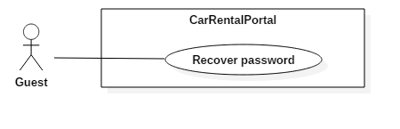

Figure 6: <Guest> Recover password Use Case

|  |  |  |  |
| --- | --- | --- | --- |
| USE CASE – UC03 | | | |
| Use Case No. | 03 | **Use Case Version** | 2.0 |
| Use Case Name | Recover password | | |
| Author | TamNT | | |
| Date | 30/09/2016 | **Priority** | Normal |
| Actor:   * Guest   Summary:   * This use case allows guest to recover their password.   Goal:   * Guest can recover password to login system.   Preconditions:   * Guest has account exist in the system.   Triggers:   * Guest click “Quên mật khẩu” link in “Login” popup.   Post Conditions:   * Success: User’s password is changed to the new one. * Fail: Show according error message.   Main Success Scenario:   |  |  |  | | --- | --- | --- | | Step | Actor Action | System Response | | 1 | Guest click “Quên mật khẩu” Link. | System show page to ask for identity information:   * Email: Email format, required. | | 2 | Guest inputs email field. |  | | 3 | Guest sends command to system | System will send email to inputted email for recover password and show page with “Xin vui lòng kiểm tra email để reset password” text. | | 4 | Guest click on link in their email. | System shows page to ask for new password:   * “Email”: Email format, required. * “Mật khẩu mới”: length 6-30, least 1 upper case and numeric. * “Xác nhận mật khẩu mới”: Macthed with “mật khẩu mới” | | 5 | Guest sends new command to change password to system | System changes password of guest’s account and redirect guest to success page | | 5 | Guest click link “Click vào đây để tiếp tục” in the success page. | System redirects guest to Login page. |   Alternative Scenario: N/A  Exceptions:   |  |  |  | | --- | --- | --- | | No | Actor Action | System Response | | 1 | Guest missed to input “Email” field | System show error message “The email field is required” | | 2 | Guest inputted email with wrong formatting for email | System show error message “The email is not a valid e-mail address” | | 3 | Guest inputted email that has not signed up. | System shows pop up with this email. | | 4 | Guest inputted “Mật khẩu mới” field with wrong format. | System shows error message “Mật khẩu chứa ít nhất một kí tự hoa và số” | | 5 | Guest inputted “Xác nhận mật khẩu mới” field with wrong format. | System shows error message “Mật khẩu không khớp!” |   Relationships: N/A  Business Rules:   * After input the email, system will send email with link to recover password for this email. * Guest must login to email, and click “callbackUrl”. * “Email” must be signed. * “Mật khẩu mới”, “Email” must be inputted correctly. | | | |

##### <Guest> Search vehicle (UC04)

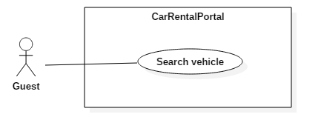

Figure 7: <Guest> Search vehicle Use Case

|  |  |  |  |
| --- | --- | --- | --- |
| USE CASE – UC04 | | | |
| Use Case No. | 04 | **Use Case Version** | 1.0 |
| Use Case Name | Search vehicle | | |
| Author | TamNT | | |
| Date | 30/09/2016 | **Priority** | High |
| Actor:   * Guest.   Summary:   * This use case allows Guest to search vehicle.   Goal:   * Guest can search for the vehicle with their required.   Triggers:   * Guest access search page.   Preconditions: N/A.  Post Conditions:   * Success: Shows vehicles that fit filtering conditions. * Fail: Show error message.   Main Success Scenario:   |  |  |  | | --- | --- | --- | | Step | Actor Action | System Response | | 1 | User access search page. | System shows search page with search result and various filters | | 2 | User changes a filter condition | System refresh search result.  [Alternative 1,2,3,4,5,6] |   Alternative Scenario:   |  |  |  | | --- | --- | --- | | No | Actor Action | System Response | | 1 | User select start time / end time for their trip | System filters out vehicles that has been booked in this time span. | | 2 | User select location where they want to rend vehicle | System shows only | | 3 | User checks seats box at “Số chỗ ngồi” | System shows vehicles which has seats corresponding with seats box user checked:   * 2 chỗ: 2 seats * 4 chỗ: 4 seats * 5 chỗ: 5 seats * 7 chỗ: 7 seats * 8 chỗ: 8 seats * 16 chỗ: 16 seats | | 4 | User pulls the slider at “Mức giá”.  User pulls the left slider to  User pulls the right slider | System shows vehicles with price that fit with user’s conditions.  System changes min pride up to the value of left slider.  System changes max pride up to the value of right slider. | | 5 | User choose options of the list “Sắp xếp theo” | System shows the result order by options user choose:   * Gói thời gian thuê xe phù hợp nhất: System will show vehicles in order of provided rental option that has rental time span closest to user’s rental time span (deduced from start time and end time) * Xe có điểm đánh giá tốt nhất: System will show vehicles order from high rating to lower. * Garage có điểm đánh giá tốt nhất: System will show vehicles order by their garage from high rating to lower   Giá từ thấp đến cao: System will show vehicles order from low pride to high pride.   * Giá từ cao đến thấp: System will show vehicles order from high pride to low pride. * Xe từ mới đến cũ: System will show vehicles order from new to old which define by the year they made * Xe từ cũ đến mới: System will show vehicles order from old to new which define by the year they made | | 6 | User clicks on “Lọc chi tiết hơn về xe” tab:  User choose an option in “Dòng xe” list  User pulls the slider at “Năm sản xuất”  User checks options at “Hộp số”  User choose options of “Loại nhiên liệu” list  User choose options of “Loại xe” list  User checks colors at “Màu xe” | System shows more detail options for user to find suitable vehicles.  System shows vehicles which has brand/model that fits with user’s condition  System shows vehicles fit with the year range user chose  System shows vehicles which has transmission type that fits with user’s choice:   * Số tự động: automatic * Số sàng: manual   System shows vehicles which has fuel type that fits with user’s choice:   * Xăng: gasoline * Dầu diesel: diesel * Điện: electric * Điện hybrid: hybrid electric * Điện plug-in hybrid: plug-in hybrid electric   System shows vehicles belongs to user selected categories.  System will show vehicles which has the color user chose. | | 7 | User clicks on “Lọc theo đánh giá” tab  User choose option of “Đánh giá xe” list.  User choose option of “Đánh giá cửa hàng xe” list. | System will show options for user to find vehicles by rating.  System will show vehicles which rated fit which option user choose:  : above 4 star  : above 3 star  : above 2 star  System will show vehicles which their garage’s rate fit which option user choose:  : above 4 star  : above 3 star  : above 2 star | | 8 | User clicks on “Xóa bỏ lọc” button. | System will reset all filtering conditions, except location, start time, and end time, back to default. |   Exceptions: N/A  Relationships: N/A  Business Rules:   * Start time cannot be sooner than 6 hours from now. * Start time cannot be later than 30 days from now. * End time cannot be sooner than 1 hours from start time. | | | |

##### <Guest> View vehicle’s information (UC05)

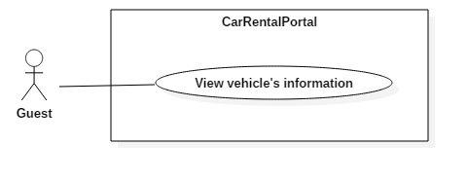

Figure 8: <Guest> View vehicle’s information Use Case

|  |  |  |  |
| --- | --- | --- | --- |
| USE CASE – US05 | | | |
| Use Case No. | 05 | **Use Case Version** | 1.0 |
| Use Case Name | View vehicle’s information | | |
| Author | TamNT | | |
| Date | 30/09/2016 | **Priority** | Normal |
| Actor:   * Guest.   Summary:   * This use case allows Guest to view vehicle’s information.   Goal:   * Guest can view detailed rental information of specific vehicle.   Triggers:   * Guest clicks on a search result in “Search Vehicle” page.   Preconditions: N/A  Post Conditions:   * Success: Guest is shown vehicle’s information page. * Fail: Show error message.   Main Success Scenario:   |  |  |  | | --- | --- | --- | | Step | Actor Action | System Response | | 1 | Guest click on a search result in “Search Vehicle” page. | Redirect to “View vehicle’s information” page of selected vehicle.  [Alternative 1] |   Alternative Scenario: N/A  Exceptions: N/A  Relationships: N/A  Business Rules: N/A | | | |

#### <Authenticated user> Use Case Overview

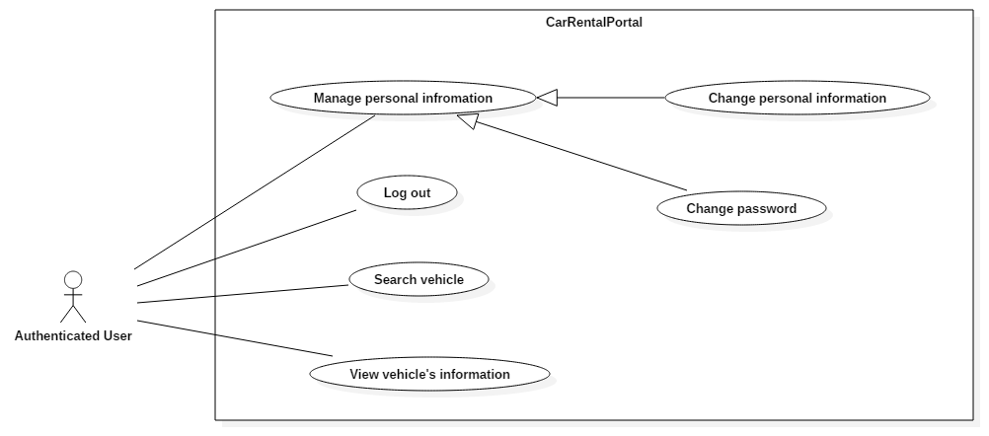

Figure 9: <Authenticated user> Use Case Overview

##### < Authenticated User > Log out (UC06)

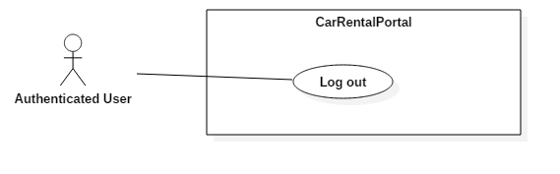

Figure 10: < Authenticated User > Log out Use Case

|  |  |  |  |
| --- | --- | --- | --- |
| USE CASE – UC06 | | | |
| Use Case No. | 06 | **Use Case Version** | 1.0 |
| Use Case Name | Log out | | |
| Author | TamNT | | |
| Date | 30/09/2016 | **Priority** | Normal |
| Actor:   * Authenticated user   Summary:   * This use case allows authenticated user to log out of the system.   Goal:   * Authenticated user can log out the system.   Triggers:   * Authenticated User clicks on “Đăng xuất” button on header bar.   Preconditions:   * User has logged into the system.   Post Conditions:   * Success: User is logged out of the system. * Fail: Do nothing.   Main Success Scenario:   |  |  |  | | --- | --- | --- | | Step | Actor Action | System Response | | 1 | User sends logout command. | Clear session and log user out of the system. Redirect in homepage. |   Alternative Scenario: N/A  Exceptions: N/A  Relationships: N/A  Business Rules: N/A | | | |

##### < Authenticated User > Change personal information (UC07)

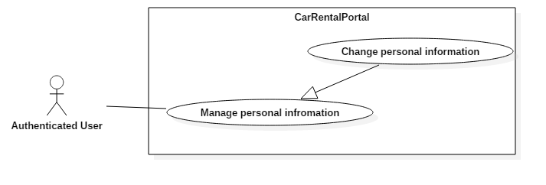

Figure 11: < Authenticated User > Change personal information Use Case

|  |  |  |  |
| --- | --- | --- | --- |
| USE CASE – UC07 | | | |
| Use Case No. | 07 | **Use Case Version** | 1.0 |
| Use Case Name | Change personal information | | |
| Author | TamNT | | |
| Date | 30/09/2016 | **Priority** | Normal |
| Actor:   * Authenticated user   Summary:   * This use case allows user to edit their information.   Goal:   * The Authenticated user’s information is edited.   Triggers:   * User clicks “Thông tin cá nhân” in left bar.   Preconditions:   * User must login to system.   Post Conditions:   * Success: Authenticated user’s information is edited. * Fail: Show error message.   Main Success Scenario:   |  |  |  | | --- | --- | --- | | Step | Actor Action | System Response | | 1 | User clicks “Thông tin cá nhân” in left bar | System show webpage for editing user’s information. | | 2 | User update information and sends updates to system by clicking “Lưu” button.  [Alternative 1, 2] | The data is edited in the system.  Then redirect to “Change personal information” page with new model data.  [Exception 1, 2, 3, 4, 5, 6] |   Alternative Scenario:   |  |  |  | | --- | --- | --- | | Step | Actor Action | System Response | | 1 | User clicks on “Thay đổi password” button | System redirects user to Change Password page. | | 2 | User clicks on “Hủy bỏ” button | System reloads the page. |   Exceptions:   |  |  |  | | --- | --- | --- | | No | Actor Action | System Response | | 1 | User edited “Tên đầy đủ” field with wrong format. | Show error message: “Tên đầy đủ phải có từ 10 đến 200 kí tự”. | | 2 | User edited “Số điện thoại” field with wrong format. | Show error message: “Số điện thoại phải có ít nhất 10 kí tự và nhỏ hơn 20 kí tự”. | | 3 | User uploaded new avatar image larger than 500KB. | Show error message: “Ảnh phải có kích thước dưới 500KB”. | | 4 | User edited “Tên đầy đủ” field with empty string. | Show error message: “Tên đầy đủ không được để trống”. | | 5 | User edited “Số điện thoại” field with empty string. | Show error message: “Số điên thoại không được để trống”. | | 6 | User edited “Số điện thoại” field with wrong format number. | Show error message: “Chỉ chấp nhận số, ‘-‘, và ‘+’.” |   Relationships: N/A  Business Rules:   * “Tên đầy đủ” is required and must be between 10-200 characters. * “Số điện thoại” is required, must be between 10-20 characters, and only accept number, “+”, and “-“. * Avatar image must be smaller than 500KB. | | | |

##### < Authenticated User > Change password (UC08)

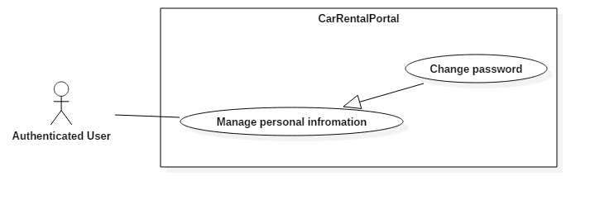

Figure 12: < Authenticated User > Change password Use Case

|  |  |  |  |
| --- | --- | --- | --- |
| USE CASE – UC08 | | | |
| Use Case No. | 08 | **Use Case Version** | 1.0 |
| Use Case Name | Change password | | |
| Author | TamNT | | |
| Date | 30/09/2016 | **Priority** | Normal |
| Actor:   * Authenticated user.   Summary:   * This use case allows authenticated user to change password.   Goal:   * User change password information.   Triggers:   * Staff clicks “Thay đổi password” button in “Change personal information” page.   Preconditions:   * User has logged into the system.   Post Conditions:   * Success: User changes password successfully. * Fail: Show error message.   Main Success Scenario:   |  |  |  | | --- | --- | --- | | Step | Actor Action | System Response | | 1 | User clicks “Thay đổi password” button at change personal information page. | System shows “change password” page.   * “Mật khẩu cũ”: textbox, max length 100, required * “Mật khẩu mới”: textbox, required, max length 50, least 1 upper case and numeric. * “Xác nhận mật khẩu mới”: textbox, required, matched with “mật khẩu mới” field. | | 2 | User types in old password, new password, and confirms new password, then submits change to system | System changes password of account, then redirect user back to “Change personal information page”.  [Exception 1, 2, 3, 4, 5, 6] |   Alternative Scenario: N/A  Exceptions:   |  |  |  | | --- | --- | --- | | No | Actor Action | System Response | | 1 | User missed to input “Mật khẩu cũ” field | Show error message: “Mật khẩu cũ không được trống”. | | 2 | User missed to input “Mật khẩu mới” field | Show error message: “Mật khẩu mới không được trống”. | | 3 | User inputted “Mật khẩu cũ” field with wrong format | Show error message: “Mật khẩu phải có ít nhất 1 ký tự hoa, ký tự thường và số”. | |  | User inputted “Mật khẩu mới” field with wrong format | Show error message: “Mật khẩu phải có ít nhất 1 ký tự hoa, ký tự thường và số”. | | 4 | User inputted “Mật khẩu mới” field with wrong length | Show error message: “Mật khẩu phải có ít nhất 6 kí tự và ít hơn 100 kí tự”. | | 5 | User inputted “Xác nhận mật khẩu mới” field with wrong format | Show error message: “Mật khẩu không khớp”. | | 6 | User inputted “Mật khẩu cũ” field with wrong data | Show error message: “Mật khẩu cũ không chính xác”. |   Relationships: N/A  Business Rules:   * “Mật khẩu cũ” must be correct. * Format input text :   + “Mật khẩu cũ”: textbox, password, required   + “Mật khẩu mới”: textbox, password, required, length 6-100, has at least 1 upper case, 1 lower case and 1 numeric value.   + “Xác nhận mật khẩu mới”: textbox, password, matchs with “Mật khẩu mới”. | | | |

##### < Authenticated User > Search vehicle (UC09)

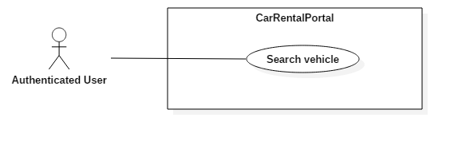

Figure 13: < Authenticated User > Search vehicle Use Case

|  |  |  |  |
| --- | --- | --- | --- |
| USE CASE – UC09 | | | |
| Use Case No. | 09 | **Use Case Version** | 1.0 |
| Use Case Name | Search vehicle | | |
| Author | TamNT | | |
| Date | 30/09/2016 | **Priority** | High |
| Actor:   * Authenticated User.   Summary:   * This use case allows authenticated user to search vehicle.   Goal:   * Authenticated user can search for the vehicle with their required.   Triggers:   * Authenticated user access search page.   Preconditions: N/A.  Post Conditions:   * Success: Shows vehicles that fit filtering conditions. * Fail: Show error message.   Main Success Scenario:   |  |  |  | | --- | --- | --- | | Step | Actor Action | System Response | | 1 | User access search page. | System shows search page with search result and various filters | | 2 | User changes a filter condition | System apply recommender’s scores and refresh search result.  [Alternative 1,2,3,4,5,6] |   Alternative Scenario:   |  |  |  | | --- | --- | --- | | No | Actor Action | System Response | | 1 | User select start time / end time for their trip | System filters out vehicles that has been booked in this time span. | | 2 | User select location where they want to rend vehicle | System shows only | | 3 | User checks seats box at “Số chỗ ngồi” | System shows vehicles which has seats corresponding with seats box user checked:   * 2 chỗ: 2 seats * 4 chỗ: 4 seats * 5 chỗ: 5 seats * 7 chỗ: 7 seats * 8 chỗ: 8 seats * 16 chỗ: 16 seats | | 4 | User pulls the slider at “Mức giá”.  User pulls the left slider to  User pulls the right slider | System shows vehicles with price that fit with user’s conditions.  System changes min pride up to the value of left slider.  System changes max pride up to the value of right slider. | | 5 | User choose options of the list “Sắp xếp theo” | System shows the result order by options user choose:   * Gói thời gian thuê xe phù hợp nhất: System will show vehicles in order of provided rental option that has rental time span closest to user’s rental time span (deduced from start time and end time) * Xe có điểm đánh giá tốt nhất: System will show vehicles order from high rating to lower. * Garage có điểm đánh giá tốt nhất: System will show vehicles order by their garage from high rating to lower   Giá từ thấp đến cao: System will show vehicles order from low pride to high pride.   * Giá từ cao đến thấp: System will show vehicles order from high pride to low pride. * Xe từ mới đến cũ: System will show vehicles order from new to old which define by the year they made * Xe từ cũ đến mới: System will show vehicles order from old to new which define by the year they made | | 6 | User clicks on “Lọc chi tiết hơn về xe” tab:  User choose an option in “Dòng xe” list  User pulls the slider at “Năm sản xuất”  User checks options at “Hộp số”  User choose options of “Loại nhiên liệu” list  User choose options of “Loại xe” list  User checks colors at “Màu xe” | System shows more detail options for user to find suitable vehicles.  System shows vehicles which has brand/model that fits with user’s condition  System shows vehicles fit with the year range user chose  System shows vehicles which has transmission type that fits with user’s choice:   * Số tự động: automatic * Số sàng: manual   System shows vehicles which has fuel type that fits with user’s choice:   * Xăng: gasoline * Dầu diesel: diesel * Điện: electric * Điện hybrid: hybrid electric * Điện plug-in hybrid: plug-in hybrid electric   System shows vehicles belongs to user selected categories.  System will show vehicles which has the color user chose. | | 7 | User clicks on “Lọc theo đánh giá” tab  User choose option of “Đánh giá xe” list.  User choose option of “Đánh giá cửa hàng xe” list. | System will show options for user to find vehicles by rating.  System will show vehicles which rated fit which option user choose:  : above 4 star  : above 3 star  : above 2 star  System will show vehicles which their garage’s rate fit which option user choose:  : above 4 star  : above 3 star  : above 2 star | | 8 | User clicks on “Xóa bỏ lọc” button. | System will reset all filtering conditions, except location, start time, and end time, back to default. |   Exceptions: N/A  Relationships: N/A  Business Rules:   * Start time cannot be sooner than 6 hours from now. * Start time cannot be later than 30 days from now. * End time cannot be sooner than 1 hours from start time. | | | |

##### < Authenticated User > View vehicle’s information (UC10)

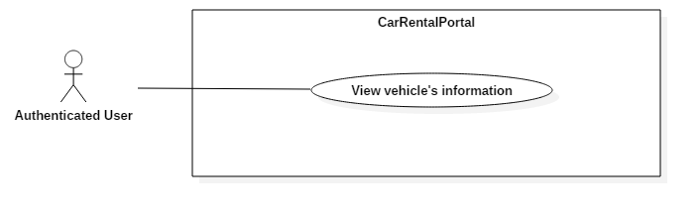

Figure 14: < Authenticated User > View vehicle’s information Use Case

|  |  |  |  |
| --- | --- | --- | --- |
| USE CASE – US10 | | | |
| Use Case No. | 10 | **Use Case Version** | 1.0 |
| Use Case Name | View vehicle’s information | | |
| Author | TamNT | | |
| Date | 30/09/2016 | **Priority** | Normal |
| Actor:   * Authenticated user.   Summary:   * This use case allows authenticated user to view vehicle’s information.   Goal:   * Authenticated user can view detailed rental information of specific vehicle.   Triggers:   * Authenticated user clicks on a search result in “Search Vehicle” page.   Preconditions: N/A  Post Conditions:   * Success: Authenticated user is shown vehicle’s information page. * Fail: Show error message.   Main Success Scenario:   |  |  |  | | --- | --- | --- | | Step | Actor Action | System Response | | 1 | Guest click on a search result in “Search Vehicle” page. | Redirect to “View vehicle’s information” page of selected vehicle.  [Alternative 1] |   Alternative Scenario: N/A  Exceptions: N/A  Relationships: N/A  Business Rules: N/A | | | |

#### <Customer> Use Case Overview

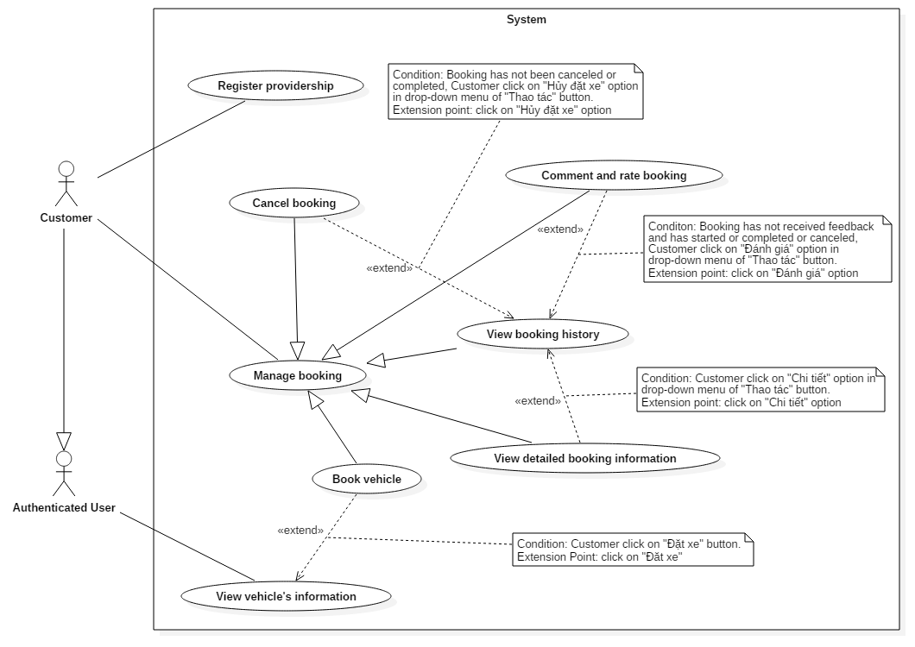

Figure 15 <Customer> Use Case Overview

##### < Customer > Book vehicle (UC11)

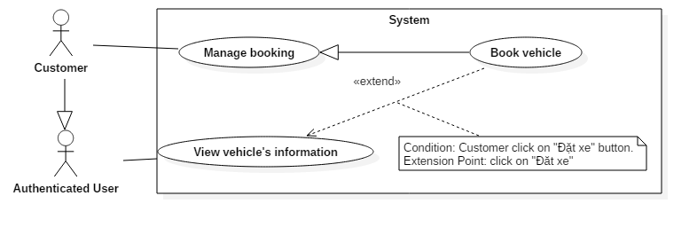

Figure 16: < Customer > Book vehicle Use Case

|  |  |  |  |
| --- | --- | --- | --- |
| USE CASE – UC11 | | | |
| Use Case No. | 11 | **Use Case Version** | 1.0 |
| Use Case Name | Book vehicle | | |
| Author | DucTH | | |
| Date | 30/09/2016 | **Priority** | Normal |
| Actor:   * Customer   Summary:   * This use case allows customer to book vehicle.   Goal:   * Customer books vehicle successfully.   Triggers:   * Customer clicks on “Đặt xe” button in vehicle’s rental information page.   Preconditions:   * Log in successfully as customer.   Post Conditions:   * Success: Vehicle is booked successfully. * Fail: Show error message.   Main Success Scenario:   |  |  |  | | --- | --- | --- | | Step | Actor Action | System Response | | 1 | Customer accesses vehicle’s rental information page. | System shows webpage of corresponding vehicle with options for rental plan (Hourly and daily). | | 2 | Customer select a rental plan, start time and end time, then clicks “Đặt xe” button. | System creates a pending booking receipt, then redirects customer to booking confirmation page, where customer can review the booking and select a payment method from the following methods:   * Thanh toán online bằng thẻ ngân hàng nội địa: purchase using bank’s card. * Thanh toán bằng thẻ tín dụng / ghi nợ: purchase using credit card. * Thanh toán bằng Ví điện tử NgânLượng: purchase using NgânLượng account.   [Exception 1] | | 3 | Customer selects payment method and clicks “Đặt xe” button.  [Alternative 1]  [Alternative 3] | System redirects customer to purchase page. | | 4 | Customer pays the booking.  [Alternative 2]  [Alternative 3] | System validates the booking receipt, sends alert email to related customer and provider, and then redirects customer to receipt page. |   Alternative Scenario:   |  |  |  | | --- | --- | --- | | No | Actor Action | System Response | | 1 | Customer presses “Thay đổi” button or “Hủy” button | System removes the pending booking and redirects user to vehicle’s information page. | | 2 | Customer clicks “Hủy” button. | System removes the pending booking and redirects user to vehicle’s information page. | | 3 | Customer does not pay the booking within 10 minutes | System removes the pending booking and redirects user to vehicle’s information page. |   Exceptions:   |  |  |  | | --- | --- | --- | | No | Actor Action | System Response | | 1 | Customer books vehicle during unavailable time | System alerts the customer. |   Relationships: Extend for “View vehicle’s information”  Business Rules:   * Booking’s start time must be after 6 hours from now. * Booking’s start time must be before 30 days from now. * Booking’s end time must be after 1 hours from start time. * Booking’s start time and end time must be within working time of garage. * The booked vehicle must not has any other booking in this booked time span. | | | |

##### < Customer > View booking history (UC12)

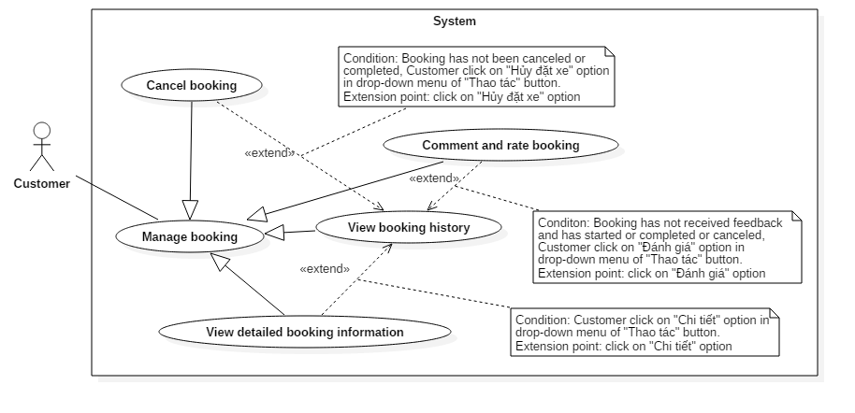

Figure 17: < Customer > View booking history Use Case

|  |  |  |  |
| --- | --- | --- | --- |
| USE CASE – UC12 | | | |
| Use Case No. | 12 | **Use Case Version** | 1.0 |
| Use Case Name | View booking history | | |
| Author | DucTH | | |
| Date | 30/09/2016 | **Priority** | Normal |
| Actor:   * Customer   Summary:   * This use case allows customer to view their booking history.   Goal:   * Customer can view their booking history.   Triggers:   * Customer clicks on “Lịch sử đặt xe” on navigation sidebar.   Preconditions:   * Log in successful as customer.   Post Conditions:   * Success: Bookings belonging to this customer is listed in “Lịch sử đặt xe” page. * Fail: Show error message.   Main Success Scenario:   |  |  |  | | --- | --- | --- | | Step | Actor Action | System Response | | 1 | Customer clicks on “Lịch sử đặt xe” on navigation sidebar. | System shows booking history page with list of bookings belonging to this customer. |   Alternative Scenario: N/A  Exceptions: N/A  Relationships: extended by “Cancel booking”, “View detail’s information” and “Comment and rate booking”.  Business Rules:   * If this user also has provider role and has self-bookings, then self-bookings are not showed in booking history. | | | |

##### < Customer > View detailed booking information (UC13)

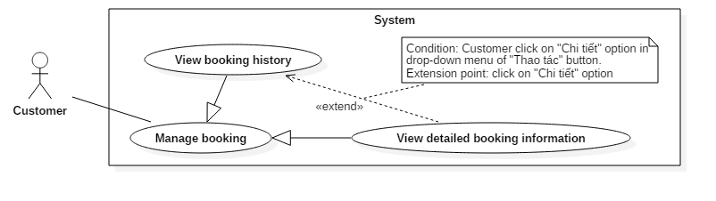

Figure 18: < Customer > View detailed booking information Use Case

|  |  |  |  |
| --- | --- | --- | --- |
| USE CASE – UC13 | | | |
| Use Case No. | 13 | **Use Case Version** | 1.0 |
| Use Case Name | View detailed booking information | | |
| Author | DucTH | | |
| Date | 30/09/2016 | **Priority** | Normal |
| Actor:   * Customer   Summary:   * This use case allows customer to view details of their booking.   Goal:   * Customer can review their booking’s details.   Triggers:   * Customer selects “Chi tiết” option in drop-down menu of “Thao tác” button of a booking record.   Preconditions:   * Log in successful as customer.   Post Conditions:   * Success: Detailed information of target booking is showed to customer. * Fail: Show error message.   Main Success Scenario:   |  |  |  | | --- | --- | --- | | Step | Actor Action | System Response | | 1 | Customer selects “Chi tiết” option in drop-down menu of “Thao tác” button of a booking record.  [Alternative 1] | System shows a popup containing all information of the target booking, including vehicle’s information, provider’s contact information, and booking’s time and constrains. |   Alternative Scenario:   |  |  |  | | --- | --- | --- | | Step | Actor Action | System Response | | 1 | Customer clicks on “Đóng” button, “X” button, or outside the popup. | System close the confirmation popup. |   Exceptions: N/A  Relationships: extend from “View booking history”.  Business Rules: N/A | | | |

##### < Customer > Cancel booking (UC14)

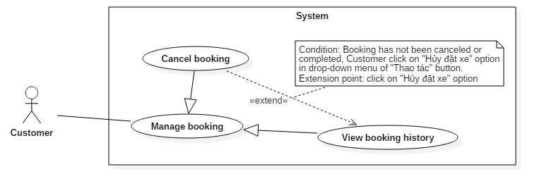

Figure 19: < Customer > Cancel booking Use Case

|  |  |  |  |
| --- | --- | --- | --- |
| USE CASE – UC14 | | | |
| Use Case No. | 14 | **Use Case Version** | 1.0 |
| Use Case Name | Cancel booking | | |
| Author | DucTH | | |
| Date | 30/09/2016 | **Priority** | Normal |
| Actor:   * Customer   Summary:   * This use case allows customer to cancel their booking.   Goal:   * Customer can cancel their unfinished booking.   Triggers:   * Customer selects “Hủy đặt xe” option in drop-down menu of “Thao tác” button of a booking record.   Preconditions:   * Log in successful as customer. * The target booking has not been completed or canceled.   Post Conditions:   * Success: Booked vehicle will appears in “Lịch sử đặt xe” page. * Fail: Show error message.   Main Success Scenario:   |  |  |  | | --- | --- | --- | | Step | Actor Action | System Response | | 1 | Customer selects “Hủy đặt xe” option in drop-down menu of “Thao tác” button of a booking record. | System cancels the target booking, send alert email to the related customer and provider, then close the popup. | | 2 | Customer clicks on “Hủy” button  [Alternative 1] | System cancels the target booking, send alert email to the related customer and provider, then close the popup. |   Alternative Scenario:   |  |  |  | | --- | --- | --- | | Step | Actor Action | System Response | | 1 | Customer clicks on “Đóng” button, “X” button, or outside the popup. | System close the confirmation popup. |   Exceptions: N/A  Relationships: extend from “View booking history”.  Business Rules:   * The target booking has not been completed (End time has not passed) or canceled. | | | |

##### < Customer > Comment and rate booking (UC15)

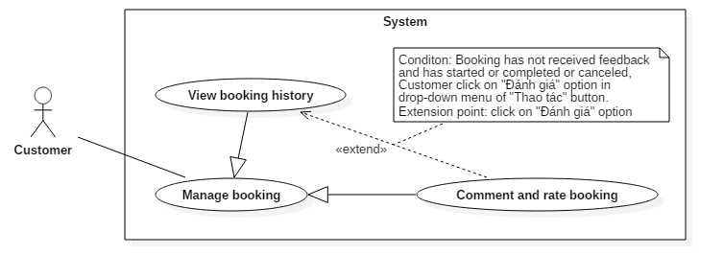

Figure 20: < Customer > Comment and rate booking Use Case

|  |  |  |  |
| --- | --- | --- | --- |
| USE CASE – US15 | | | |
| Use Case No. | 15 | **Use Case Version** | 1.0 |
| Use Case Name | Comment and rate booking | | |
| Author | DucTH | | |
| Date | 30/09/2016 | **Priority** | Normal |
| Actor:   * Customer   Summary:   * This use case allows customer to feedback about their booked vehicle’s service.   Goal:   * Customer submits successfully rating and comment for their booking.   Triggers:   * Customer chooses “Đánh giá” option in drop-down menu of “Thao tác” button of a booking record in “Lịch sử đặt xe” page.   Preconditions:   * Log in successfully as a customer. * The target booking must not have received feedback and have either started (Start time of booking is before current time) or been canceled.   Post Conditions:   * Success: Comment and rating for booking is submitted successfully. * Fail: Show error message.   Main Success Scenario:   |  |  |  | | --- | --- | --- | | Step | Actor Action | System Response | | 1 | Customer chooses “Đánh giá” option in drop-down menu of “Thao tác” button of a booking record in “Lịch sử đặt xe” page. | System shows “Đánh giá xe” popup for customer to write comment and choose rating. | | 2 | Customer fills the form in the popup and clicks “Gởi” button.  [Alternative 1] | System will update booking’s comment and rating, as well as related vehicle’s and garage’s ratings, then show “Đã gửi đánh giá thành công” alert to customer.  [Exception 1]  [Exception 2]  [Exception 3]  [Exception 4] |   Alternative Scenario:   |  |  |  | | --- | --- | --- | | No | Actor Action | System Response | | 1 | Customer clicks “Đóng” button, “X” button, or clicks outside the popup box. | System will close “Đánh giá xe” popup. |   Exceptions:   |  |  |  | | --- | --- | --- | | No | Actor Action | System Response | | 1 | Customer don’t do anything and clicks “Gởi” button | System will display “Vui lòng nhập” alert above “Đánh giá” textbox. | | 2 | Customer choose rating but does not type anything in “Đánh giá” textbox. | System will display “Vui lòng nhập” alert above “Đánh giá” textbox. | | 3 | Customer type less than 20 words. | System will display “Vui lòng nhập ít nhất 20 chữ” alert above “Đánh giá” textbox. | | 4 | Customer type more than 200 words | System will display “Vui lòng nhập ít hơn 200 chữ” alert above “Đánh giá” textbox. |   Relationships: Extend from “View booking history”  Business Rules:   * The target booking must not have received feedback and have either started (Start time of booking is before current time) or been canceled. * The related vehicle’s and garage’s ratings must be updated accordingly. | | | |

##### < Customer > Register providership (UC16)

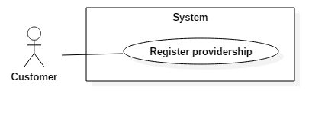

Figure 21: < Customer > Register providership Use Case

|  |  |  |  |
| --- | --- | --- | --- |
| USE CASE – US16 | | | |
| Use Case No. | 16 | **Use Case Version** | 1.0 |
| Use Case Name | Register providership | | |
| Author | DucTH | | |
| Date | 30/09/2016 | **Priority** | Normal |
| Actor:   * Customer   Summary:   * This use case allows customer to become provider.   Goal:   * Customer attains Provider role.   Triggers:   * Customer clicks on “Trở thành nhà cung cấp” link on navigation sidebar.   Preconditions:   * Log in successfully and account only has role customer.   Post Conditions:   * Success: User attains Provider role. * Fail: Show error message.   Main Success Scenario:   |  |  |  | | --- | --- | --- | | Step | Actor Action | System Response | | 1 | User clicks on “Trở thành nhà cung cấp” at navigation bar. | System shows providership registration page, which allows user to choose 1 in 3 subscription plans (1-month, 3-month, and 6-month). | | 2 | User clicks on “Đăng ký” button of a subscription plan. | System shows “Phương thức thanh toán” panel where user can choose payment method:   * Thanh toán online bằng thẻ ngân hàng nội địa: purchase using bank’s card. * Thanh toán bằng thẻ tín dụng / ghi nợ: purchase using credit card. * Thanh toán bằng Ví điện tử NgânLượng: purchase using NgânLượng account. | | 3 | User selects payment method and clicks on “Thanh toán” button.  [Alternative 1] | System redirects user to payment page. | | 4 | User pay for subscription.  [Alternative 2] | System adds role Provider for user and sets expiration day, sends alert email, then redirects user to success page |   Alternative Scenario:   |  |  |  | | --- | --- | --- | | No | Actor Action | System Response | | 1 | User clicks on “Hủy đơn hàng” button at become provider page. | System will redirect user to homepage. | | 2 | User clicks on “Hủy đơn hàng” button at purchase page. | System will redirect user to homepage. |   Exceptions: N/A  Relationships: N/A  Business Rules:   * Only user with role Customer and only role Customer can register new providership. | | | |

#### <Provider> Use Case Overview

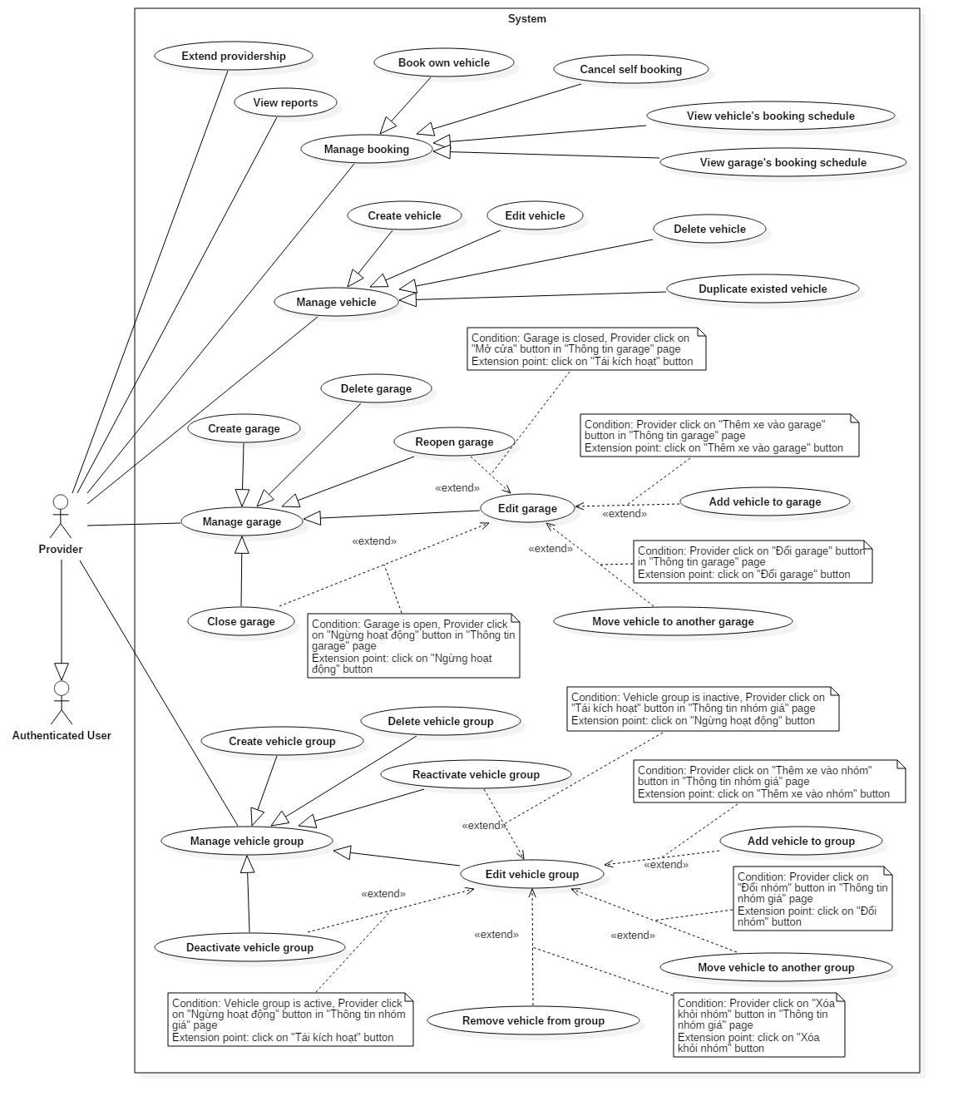

Figure 22 <Provider> Use Case Overview

##### < Provider > Create vehicle (UC17)

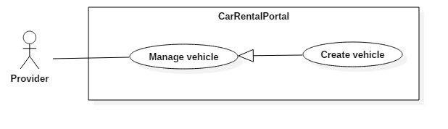

Figure 23: < Provider > Create vehicle Use Case

|  |  |  |  |
| --- | --- | --- | --- |
| USE CASE – UC17 | | | |
| Use Case No. | 17 | **Use Case Version** | 1.0 |
| Use Case Name | Create vehicle | | |
| Author | KhoaLVD | | |
| Date | 30/09/2016 | **Priority** | Normal |
| Actor:   * Provider   Summary:   * This use case allows provider to create vehicle.   Goal:   * Provider can add vehicle for customer to book.   Triggers:   * Provider clicks “Thêm xe mới” button at “Quản lý xe” page.   Preconditions:   * User must login into the system with role “Provider”.   Post Conditions:   * Success: New vehicle appear at chosen garage. * Fail: Show error message.   Main Success Scenario:   |  |  |  | | --- | --- | --- | | Step | Actor Action | System Response | | 1 | Provider clicks “Thêm xe mới” button at “Quản lý xe” page. | System shows “Tạo xe mới” popup display all information needed to fill. | | 2 | Provider inputs vehicle information. | System require information:   * “Tên xe”: textbox, required, min length10, max length100. * “Biển số xe”: textbox, required, min length10, max length50. * “Dòng xe”: dropdownlist, required * “Năm sản xuất”: number, required, chosen from 1908 to current year. * “Garage”: dropdownlist, required * “Nhóm xe”: dropdownlist * “Loại hộp số”: radio button, required, choose between “Số tự động” or “Số sàng” * “Chi tiết về loại hộp số”: textbox, maxlenght50. * “Loại nhiên liệu”: dropdownlist * “Đặc tả về động cơ”: textbox, maxlenght50. * “Màu xe”: radio button, required * “Mô tả xe”: textarea, maxleght500. * “Hình ảnh”: dropzone, at least 4 images, max at 10 images. | | 3 | Provider send creation request.  [Alternative 1] | Popup close and “Tạo xe thành công” alert appear on the top right side.  [Exception 1]  [Exception 2]  [Exception 3]  [Exception 4]  [Exception 5]  [Exception 6]  [Exception 7]  [Exception 8]  [Exception 9]  [Exception 10]  [Exception 11]  [Exception 12]  [Exception 13]  [Exception 14]  [Exception 15]  [Exception 16]  [Exception 17] |   Alternative Scenario:   |  |  |  | | --- | --- | --- | | No | Actor Action | System Response | | 1 | Provider clicks an exit button or clicks outside the popup box. | System will close “Tạo xe mới” popup and back to “Quản lý xe” page. |   Exceptions:   |  |  |  | | --- | --- | --- | | No | Actor Action | System Response | | 1 | Provider does not fill anything and send request. | Show a message to notify that “Tên xe phải từ 10 đến 100 chữ cái” | | 2 | Provider missed to input “Tên xe” field. | Show error message “Tên xe phải từ 10 đến 100 chữ cái”. | | 3 | Provider inputs too long string in “Tên khách hàng” textbox | Show error message “Tên xe phải từ 10 đến 100 chữ cái”. | | 4 | Provider inputs too short string in “Tên khách hàng” textbox | Show error message “Tên xe phải từ 10 đến 100 chữ cái”. | | 5 | Provider missed to input “Biển số xe” field. | Show error message “Biển số xe phải từ 10 đến 50 ký tự”. | | 6 | Provider inputs too long string in “Biển số xe” textbox | Show error message “Biển số xe phải từ 10 đến 50 ký tự”. | | 7 | Provider inputs too short string in “Biển số xe” textbox | Show error message “Biển số xe phải từ 10 đến 50 ký tự”. | | 8 | Provider missed to choose “Dòng xe” list. | Show error message “Vui lòng chọn dòng xe”. | | 9 | Provider missed to input “Năm sản xuất” field. | Show error message “Vui lòng khai báo năm sản xuất của xe”. | | 10 | Provider input the year before 1908 | System will automatic change back the year to 1908 | | 11 | Provider input the year after current year. | System will automatic change back the year to the current year | | 12 | Provider missed to choose “Garage” list. | Show error message “Vui lòng chọn garage xe”. | | 13 | Provider missed to choose “Loại hộp số”. | Show error message “Vui lòng chọn loại hộp số”. | | 14 | Provider missed to choose “Màu xe”. | Show error message “Vui lòng chọn màu xe”. | | 15 | Provider missed to upload picture. | Show error message “Bạn phải upload ít nhất 4 hình”. | | 16 | Provider upload less than 4 pictures | Show error message “Bạn phải upload ít nhất 4 hình”. | | 17 | Provider upload more than 10 pictures | Only the first 10 pictures are uploaded |   Relationships: N/A  Business Rules:  - “Tên xe”: textbox, required, min length 10, max length 100.  - “Biển số xe”: textbox, required, min length 10, max length 50.  - “Dòng xe”: dropdownlist, required  - “Năm sản xuất”: number, required, chosen from 1908 to current year.  - “Garage”: dropdownlist, required  - “Nhóm xe”: dropdownlist  - “Loại hộp số”: radio button, required, choose between “Số tự động” or “Số sàng”  - “Chi tiết về loại hộp số”: textbox, max length 50.  - “Loại nhiên liệu”: dropdownlist  - “Đặc tả về động cơ”: textbox, max length 50.  - “Màu xe”: radio button, required  - “Mô tả xe”: textarea, max length 500.  - “Hình ảnh”: dropzone, at least 4 images, max at 10 images. | | | |

##### < Provider > Duplicate existed vehicle (UC18)

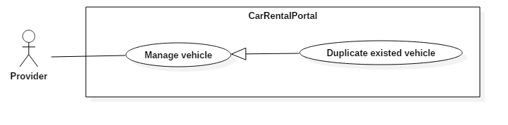

Figure 24: < Provider > Duplicate existed vehicle Use Case

|  |  |  |  |
| --- | --- | --- | --- |
| USE CASE – UC18 | | | |
| Use Case No. | 18 | **Use Case Version** | 1.0 |
| Use Case Name | Duplicate existed vehicle | | |
| Author | KhoaLVD | | |
| Date | 30/09/2016 | **Priority** | Normal |
| Actor:   * Provider   Summary:   * This use case allows provider to duplicate existed vehicle.   Goal:   * Provider can add vehicle with many information similar with existed vehicle.   Triggers:   * Provider clicks “Thêm xe tương tự” button at the vehicle provider wants to duplicate at “Quản lý xe” page.   Preconditions:   * User must login into the system with role “Provider”.   Post Conditions:   * Success: New vehicle appear at chosen garage. * Fail: Show error message.   Main Success Scenario:   |  |  |  | | --- | --- | --- | | Step | Actor Action | System Response | | 1 | Provider clicks “Thêm xe tương tự” button at the vehicle provider wants to duplicate at “Quản lý xe” page. | System shows “Tạo xe mới” popup display all information of the chosen vehicle except “Biển số xe” field. | | 2 | Provider inputs vehicle information. | System require information:   * “Tên xe”: textbox, required, min length 10, max length 100. * “Biển số xe”: textbox, required, min length 10, max length 50. * “Dòng xe”: dropdownlist, required * “Năm sản xuất”: number, required, chosen from 1908 to current year. * “Garage”: dropdownlist, required * “Nhóm xe”: dropdownlist * “Loại hộp số”: radio button, required, choose between “Số tự động” or “Số sàng” * “Chi tiết về loại hộp số”: textbox, max length 50. * “Loại nhiên liệu”: dropdownlist * “Đặc tả về động cơ”: textbox, max length 50. * “Màu xe”: radio button, required * “Mô tả xe”: textarea, max length 500. * “Hình ảnh”: dropzone, at least 4 images. | | 3 | Provider send creation request.  [Alternative 1] | Popup close and “Tạo xe thành công” alert appear on the top right side.  [Exception 1]  [Exception 2]  [Exception 3]  [Exception 4]  [Exception 5]  [Exception 6]  [Exception 7]  [Exception 8]  [Exception 9]  [Exception 10]  [Exception 11]  [Exception 12]  [Exception 13]  [Exception 14]  [Exception 15]  [Exception 16]  [Exception 17] |   Alternative Scenario:   |  |  |  | | --- | --- | --- | | No | Actor Action | System Response | | 1 | Provider clicks an exit button or clicks outside the popup box. | System will close “Tạo xe mới” popup and back to “Quản lý xe” page. |   Exceptions:   |  |  |  | | --- | --- | --- | | No | Actor Action | System Response | | 1 | Provider does not fill anything and send request. | Show a message to notify that “Biển số xe phải từ 10 đến 50 chữ cái” | | 2 | Provider deletes all information in “Tên xe” field. | Show error message “Tên xe phải từ 10 đến 100 chữ cái”. | | 3 | Provider inputs too long string in “Tên khách hàng” textbox | Show error message “Tên xe phải từ 10 đến 100 chữ cái”. | | 4 | Provider inputs too short string in “Tên khách hàng” textbox | Show error message “Tên xe phải từ 10 đến 100 chữ cái”. | | 5 | Provider deletes all information in “Biển số xe” field. | Show error message “Biển số xe phải từ 10 đến 50 ký tự”. | | 6 | Provider inputs too long string in “Biển số xe” textbox | Show error message “Biển số xe phải từ 10 đến 50 ký tự”. | | 7 | Provider inputs too short string in “Biển số xe” textbox | Show error message “Biển số xe phải từ 10 đến 50 ký tự”. | | 8 | Provider deletes all information in “Năm sản xuất” field. | Show error message “Vui lòng khai báo năm sản xuất của xe”. | | 9 | Provider input the year before 1908 | System will automatic change back the year to 1908 | | 10 | Provider input the year after current year. | System will automatic change back the year to the current year | | 11 | Provider missed to upload picture. | Show error message “Bạn phải upload ít nhất 4 hình”. | | 16 | Provider upload less than 4 pictures | Show error message “Bạn phải upload ít nhất 4 hình”. | | 17 | Provider upload more than 10 pictures | Only the first 10 pictures are uploaded |   Relationships: N/A  Business Rules:   * New vehicle must has correct information that provider had input and save to database. * New vehicle must list at “Quản lý xe” page.   *Format input type*:  - “Tên xe”: textbox, required, min length 10, max length 100.  - “Biển số xe”: textbox, required, min length 10, max length 50.  - “Dòng xe”: dropdownlist, required  - “Năm sản xuất”: number, required, chosen from 1908 to current year.  - “Garage”: dropdownlist, required  - “Nhóm xe”: dropdownlist  - “Loại hộp số”: radio button, required, choose between “Số tự động” or “Số sàng”  - “Chi tiết về loại hộp số”: textbox, max length 50.  - “Loại nhiên liệu”: dropdownlist  - “Đặc tả về động cơ”: textbox, max length 50.  - “Màu xe”: radio button, required  - “Mô tả xe”: textarea, max length 500.  - “Hình ảnh”: dropzone, at least 4 images. | | | |

##### < Provider > Edit vehicle (UC19)

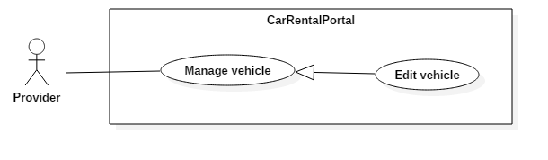

Figure 25: < Provider > Edit vehicle Use Case

|  |  |  |  |
| --- | --- | --- | --- |
| USE CASE – UC19 | | | |
| Use Case No. | 19 | **Use Case Version** | 1.0 |
| Use Case Name | Edit vehicle | | |
| Author | KhoaLVD | | |
| Date | 30/09/2016 | **Priority** | Normal |
| Actor:   * Provider   Summary:   * This use case allows provider to edit information of existed vehicle.   Goal:   * Provider can edit information of existed vehicle for customer to book.   Triggers:   * Provider clicks vehicle’s name at “Quản lý xe” page.   Preconditions:   * User must login into the system with role “Provider” still existed.   Post Conditions:   * Success: Save new information of the chosen vehicle. * Fail: Show error message.   Main Success Scenario:   |  |  |  | | --- | --- | --- | | Step | Actor Action | System Response | | 1 | Provider clicks vehicle’s name at “Quản lý xe” page. | System open “Thông tin chi tiết của xe” page display all information of chosen vehicle. | | 2 | Provider clicks “Chỉnh sửa thông tin” button | System shows form to edit vehicle’s information, which requires:   * “Tên xe”: textbox, required, min length 10, max length 100. * “Biển số xe”: textbox, required, min length 10, max length 50. * “Garage”: dropdownlist, required * “Nhóm xe”: dropdownlist * “Chi tiết về loại hộp số”: textbox, max length 50. * “Động cơ”: textbox, max length 50. * “Màu xe”: radio button, required * “Mô tả xe”: textarea, max length 500. * “Hình ảnh”: dropzone, at least 4 images, max at 10 images. | | 4 | Provider changes vehicle’s information and saves the changes.  [Alternative 1, 2, 3] | System save edited information and reload the page. |   Alternative Scenario:   |  |  |  | | --- | --- | --- | | No | Actor Action | System Response | | 1 | Provider clicks on “Hủy bỏ” button. | System closes the edit form. | | 2 | Provider uploads more pictures | System uploads new pictures sequecially. | | 3 | Provider click on “Xoá” button under a picture. | System deletes the target picture. |   Exceptions:   |  |  |  | | --- | --- | --- | | No | Actor Action | System Response | | 1 | Provider deletes all information in “Tên xe” field. | Show error message “Tên xe phải từ 10 đến 100 chữ cái”. | | 2 | Provider inputs too long string in “Tên xe” textbox | Show error message “Tên xe phải từ 10 đến 100 chữ cái”. | | 3 | Provider inputs too short string in “Tên xe” textbox | Show error message “Tên xe phải từ 10 đến 100 chữ cái”. | | 4 | Provider deletes all information in “Biển số xe” field. | Show error message “Biển số xe phải từ 10 đến 50 ký tự”. | | 5 | Provider inputs too long string in “Biển số xe” textbox | Show error message “Biển số xe phải từ 10 đến 50 ký tự”. | | 6 | Provider inputs too short string in “Biển số xe” textbox | Show error message “Biển số xe phải từ 10 đến 50 ký tự”. | | 7 | Provider missed to upload picture. | Show error message “Bạn phải upload ít nhất 4 hình”. | | 8 | Provider deleted pictures and make the total number of picture less than 4 | Show error message “Bạn phải upload ít nhất 4 hình”. | | 9 | Provider uploaded more pictures and make the total number of picture more than 10. | 11th and later pictures are not uploaded. |   Relationships: N/A  Business Rules:  - “Tên xe”: textbox, required, min length 10, max length 100.  - “Biển số xe”: textbox, required, min length 10, max length 50.  - “Garage”: dropdownlist, required  - “Nhóm xe”: dropdownlist  - “Chi tiết về loại hộp số”: textbox, max length 50.  - “Đặc tả về động cơ”: textbox, max length 50.  - “Màu xe”: radio button, required  - “Mô tả xe”: textarea, max length 500.  - “Hình ảnh”: dropzone, at least 4 images, max at 10 images. | | | |

##### < Provider > Delete vehicle (UC20)

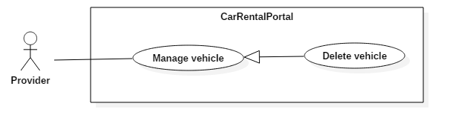

Figure 26: < Provider > Delete vehicle Use Case

|  |  |  |  |
| --- | --- | --- | --- |
| USE CASE – UC20 | | | |
| Use Case No. | 20 | **Use Case Version** | 2.0 |
| Use Case Name | Delete vehicle | | |
| Author | KhoaLVD | | |
| Date | 30/09/2016 | **Priority** | Normal |
| Actor:   * Provider   Summary:   * This use case allows provider to delete vehicle.   Goal:   * Provider can delete existed vehicle.   Triggers:   * Provider clicks “Xóa” button at the vehicle provider wants to delete at “Quản lý xe” page.   Preconditions:   * User must login into the system with role “Provider”.   Post Conditions:   * Success: Deleted vehicle disappear at chosen garage. * Fail: Show error message.   Main Success Scenario:   |  |  |  | | --- | --- | --- | | Step | Actor Action | System Response | | 1 | Provider clicks “Xóa” button at the vehicle provider wants to delete at “Quản lý xe” page. | System shows “Xác nhận xóa” popup display name of the vehicle and ask for confirm to delete. | | 2 | Provider confirms the deletion.  [Alternative 1] | Popup close and “Xóa xe thành công” alert appear on the top right side. |   Alternative Scenario:   |  |  |  | | --- | --- | --- | | No | Actor Action | System Response | | 1 | Provider clicks exit buttons or clicks outside the popup box. | System will close “Xác nhận xóa” popup and back to “Quản lý xe” page. |   Exceptions: N/A  Relationships: N/A  Business Rules:   * Related pictures of deleted vehicle must also be deleted. | | | |

##### < Provider > View vehicle’s booking schedule (UC21)

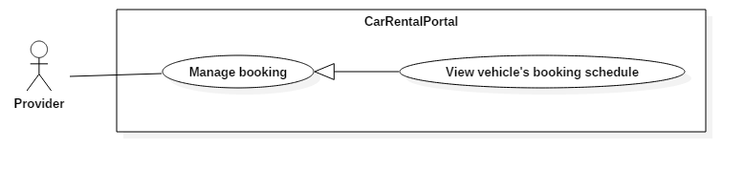

Figure 27: < Provider > View vehicle’s booking schedule Use Case

|  |  |  |  |
| --- | --- | --- | --- |
| USE CASE – UC21 | | | |
| Use Case No. | 21 | **Use Case Version** | 1.0 |
| Use Case Name | View vehicle’s booking schedule | | |
| Author | KhoaLVD | | |
| Date | 30/09/2016 | **Priority** | Normal |
| Actor:   * Provider   Summary:   * This use case allows provider to view vehicle’s booking schedule.   Goal:   * Provider can view vehicle’s booking schedule.   Triggers:   * Provider opens “Thông tin đặt xe” tab in vehicle’s details page.   Preconditions:   * User must login into the system with role “Provider”.   Post Conditions:   * Success: Vehicle’s booking schedule is shown to provider. * Fail: Show error message.   Main Success Scenario:   |  |  |  | | --- | --- | --- | | Step | Actor Action | System Response | | 1 | Provider clicks “Quản lý đặt xe” at the navigation bar.  [Alternative 1, 2, 3, 4, 5, 6] | System shows “Quản lý đặt xe” page has the datatable include vehicle’s booking schedule. |   Alternative Scenario:   |  |  |  | | --- | --- | --- | | No | Actor Action | System Response | | 1 | Provider choose “Tất cả” in “Thời gian thanh toán” box | Datatable will show information of the vehicle has booking in the past and in coming booking. | | 2 | Provider choose “Đã qua” in “Thời gian thanh toán’ box | Datatable will show information of the vehicle has booking in the past. | | 3 | Provider choose “Sắp đến” in “Thời gian thanh toán” box. | Datatable will show information of the vehicle has incoming booking. | | 4 | Provider checks “Hiện hóa đơn đã hủy” | Datatable will show information of the vehicle with status cancel. | | 5 | Provider checks “Hiện hóa đơn tự đặt” | Datatable will show information of the vehicle as provider booked. | | 6 | Provider clicks “Chi tiết” button of a vehicle | System will shows “Thông tin đặt xe” popup include detail information of that vehicle. |   Exceptions: N/A  Relationships: N/A  Business Rules: N/A | | | |

##### < Provider > View garage’s booking schedule (UC22)

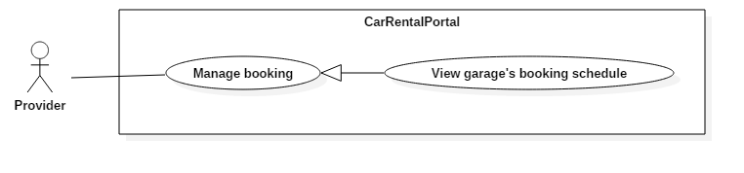

Figure 28: < Provider > View garage’s booking schedule Use Case

|  |  |  |  |
| --- | --- | --- | --- |
| USE CASE – UC22 | | | |
| Use Case No. | 22 | **Use Case Version** | 1.0 |
| Use Case Name | View garage’s booking schedule | | |
| Author | KhoaLVD | | |
| Date | 30/09/2016 | **Priority** | Normal |
| Actor:   * Provider   Summary:   * This use case allows provider to view garage’s booking schedule.   Goal:   * Provider can view garage’s booking schedule.   Triggers:   * Provider clicks on “Thông tin đặt xe” tab in “Thông tin garage” page. * Provider clicks “Quản lý đặt xe” on the navigation sidebar.   Preconditions:   * User must login into the system with role “Provider”.   Post Conditions:   * Success: Garage’s booking schedule is shown to provider. * Fail: Show error message.   Main Success Scenario:   |  |  |  | | --- | --- | --- | | Step | Actor Action | System Response | | 1 | Provider Access “Thông tin đặt xe” tab in “Thông tin garage” page or “Quản lý đặt xe” page.  [Alternative 1, 2, 3, 4, 5] | System shows a table of booking records. |   Alternative Scenario:   |  |  |  | | --- | --- | --- | | No | Actor Action | System Response | | 1 | Provider choose “Tất cả” in “Thời gian thanh toán” box | System will show all bookings in the past and future. | | 2 | Provider choose “Đã qua” in “Thời gian thanh toán’ box | System will show all bookings in the past. | | 3 | Provider choose “Sắp đến” in “Thời gian thanh toán” box. | System will show all bookings in the future. | | 4 | Provider checks “Đã hủy” in “Trạng thái hóa đơn” box | System will show canceled bookings. | | 5 | Provider checks “Tự đặt” in “Trạng thái hóa đơn” box | System will show self-bookings. | | 6 | Provider clicks “Chi tiết” button of a booking. | System will show “Thông tin đặt xe” popup include detail information of that vehicle. | | 7 | Provider selects a garage in the garage dropdownlist of “Quản lý đặt xe” page | System will show bookings of that garage only. |   Exceptions: N/A  Relationships: N/A  Business Rules: N/A | | | |

##### < Provider > Book own vehicle (UC23)

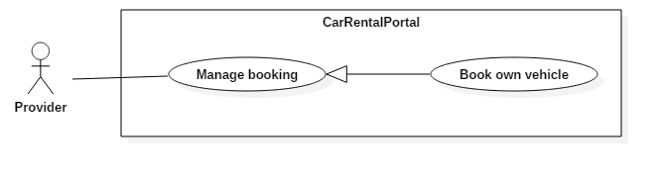

Figure 29: < Provider > Book own vehicle Use Case

|  |  |  |  |
| --- | --- | --- | --- |
| USE CASE – UC23 | | | |
| Use Case No. | 23 | **Use Case Version** | 1.0 |
| Use Case Name | Book own vehicle | | |
| Author | KhoaLVD | | |
| Date | 30/09/2016 | **Priority** | Normal |
| Actor:   * Provider   Summary:   * This use case allows provider to book their own vehicle.   Goal:   * Provider can book their own vehicle in other to reserve it.   Triggers:   * Provider clicks on “Tạo đặt xe mới” button in “Thông tin chi tiết của xe” page of a vehicle.   Preconditions:   * User must login into the system with role “Provider”.   Post Conditions:   * Success: Provider successfully book the vehicle. * Fail: Show error message.   Main Success Scenario:   |  |  |  | | --- | --- | --- | | Step | Actor Action | System Response | | 1 | Provider clicks on “Tạo đặt xe mới” button in “Thông tin chi tiết của xe” page of a vehicle. | System shows popup to create new self-booking. | | 2 | Providers provides start time and end time of the booking, then submit.  [Alternative 1] | System create new self-booking for vehicle.  [Exception 1] |   Alternative Scenario:   |  |  |  | | --- | --- | --- | | No | Actor Action | System Response | | 1 | Provider clicks “Thoát” button, “X” button, or outside the popup box. | System closes the popup. |   Exceptions:   |  |  |  | | --- | --- | --- | | No | Actor Action | System Response | | 1 | Provider submits new booking that time is conflicts with another existed booking. | System shows error alert. |   Relationships: N/A  Business Rules:   * Booking’s start time must be after 6 hours from now. * Booking’s end time must be after 1 hours from start time. * The booked vehicle must not has any other booking in this booked time span. | | | |

##### < Provider > Cancel self-booking (UC24)

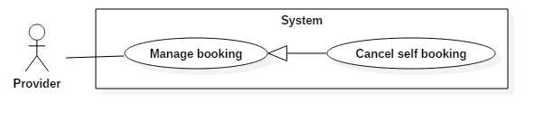

Figure 30: < Provider > Cancel self-booking Use Case

|  |  |  |  |
| --- | --- | --- | --- |
| USE CASE – UC24 | | | |
| Use Case No. | 24 | **Use Case Version** | 1.0 |
| Use Case Name | Cancel self-booking | | |
| Author | KhoaLVD | | |
| Date | 30/09/2016 | **Priority** | Normal |
| Actor:   * Provider   Summary:   * This use case allows provider to cancel their self-booking.   Goal:   * Provider can cancel their self-booking.   Triggers:   * Provider clicks on “Hủy” at “Thông tin đặt xe” tab in vehicle’s detail page.   Preconditions:   * User must login into the system with role “Provider”. * Target self-booking has not been canceled.   Post Conditions:   * Success: Self-booking canceled successfully. * Fail: Show error message.   Main Success Scenario:   |  |  |  | | --- | --- | --- | | Step | Actor Action | System Response | | 1 | Provider clicks on “Hủy” at “Thông tin đặt xe” tab in vehicle’s detail page. | System shows “Hủy đặt xe” popup to ask provider to confirm the action. | | 2 | Provider clicks on “Đồng ý” button  [Alternative 1] | System close the popup. |   Alternative Scenario:   |  |  |  | | --- | --- | --- | | No | Actor Action | System Response | | 1 | Provider clicks on “Đóng” button | System closes the pop up back to vehicle’s detail page. |   Exceptions: N/A  Relationships: N/A  Business Rules:   * Target self-boking has not been canceled. | | | |

##### < Provider > Create garage (UC25)

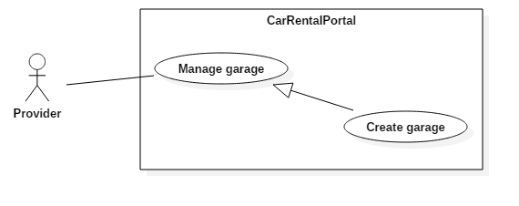

Figure 31: < Provider > Create garage Use Case

|  |  |  |  |
| --- | --- | --- | --- |
| USE CASE – UC25 | | | |
| Use Case No. | 25 | **Use Case Version** | 1.0 |
| Use Case Name | Create garage | | |
| Author | ThanhHC | | |
| Date | 30/09/2016 | **Priority** | Normal |
| Actor:   * Provider   Summary:   * This use case allows provider to create a new garage.   Goal:   * Provider can create new garage.   Triggers:   * Provider send request in page “Quản lý garage” to create garage by click on “Tạo garage mới”.   Preconditions:   * Login as roles provider.   Post Conditions:   * Success: Provider has new garage. * Fail: Show error message.   Main Success Scenario:   |  |  |  | | --- | --- | --- | | Step | Actor Action | System Response | | 1 | Provider click “Tạo garage mới” button. | System show popup requires information :   * Tên garage: free text input, required, max length 100. * Địa điểm: dropdown list, required. * Địa chỉ: free text input, required, max length 200. * Email: free text input, required. * Số điện thoại (mặc định): numeric, required, min length 10, max length 20. * Số điện thoại (bổ sung): numeric, min length 10, max length 20. * Mô tả: free text input. * Điều khoản: free text input. * Thời gian mở cửa: text input with time format and checkbox “Nghỉ”. By default, from Monday to Friday open at 8:00, close at 17:00. Saturday and Sunday checkbox “Nghỉ” is checked. | | 2 | Provider inputs information. |  | | 3 | Provider click to button “Tạo garage” that sends request to create to system.  [Alternative 1] | Provider creates a new garage successfully.  [Exception 1]  [Exception 2]  [Exception 3]  [Exception 4]  [Exception 5]  [Exception 6]  [Exception 7]  [Exception 8]  [Exception 9] |   Alternative Scenario:   |  |  |  | | --- | --- | --- | | No | Actor Action | System Response | | 1 | Provider clicks on “Đóng” button, “X” button, or outside the popup. | Current popup will be closed. |   Exceptions:   |  |  |  | | --- | --- | --- | | No | Actor Action | System Response | | 1 | Provider missed to input “Tên garage” field. | System show error message “Vui lòng nhập tên garage”. | | 2 | Provider missed to input “Địa chỉ” field | System show error message “Vui lòng nhập địa chỉ” | | 3 | Provider missed to input “Email” field | System shows error message “Vui lòng nhập email” | | 4 | Provider missed to input “Số điện thoại (mặc định)” field | System shows error message “Vui lòng nhập số điện thoại” | | 5 | Provider input “Tên garage” is over length allowed | System shows error message “Xin lỗi. Tên của garage vượt quá độ dài quy định” | | 6 | Provider input “Địa chỉ” is over length allowed | System shows error message “Xin lỗi. Địa chỉ vượt quá độ dài quy định” | | 7 | Provider input “Email” is wrong format | System shows error message “Email không hợp lệ” | |  | Provider input “Số điện thoại” is wrong format.  Valid format:  ^[0-9-+]+$ | System shows error message “Số điện thoại không hợp lệ” | | 8 | Provider input “Thời gian mở cửa” textfield “Từ” has higher value than textfield “Đến”. | System shows error message “Xin lỗi, thời gian đóng cửa không được sớm hơn thời gian mở cửa” | | 9 | Provider input “Thời gian mở cửa”wrong time format | System shows error message “Xin lỗi, giá trị thời gian không hợp lệ” |   Relationships: N/A  Business Rules: N/A | | | |

##### < Provider > Delete garage (UC26)

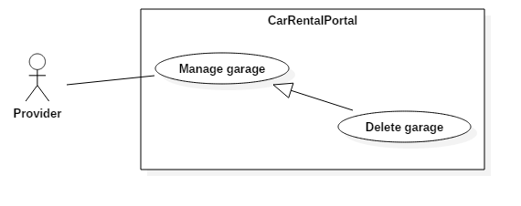

Figure 32: < Provider > Delete garage Use Case

|  |  |  |  |
| --- | --- | --- | --- |
| USE CASE – UC26 | | | |
| Use Case No. | 26 | **Use Case Version** | 1.0 |
| Use Case Name | Delete garage | | |
| Author | ThanhHC | | |
| Date | 30/09/2016 | **Priority** | Normal |
| Actor:   * Provider   Summary:   * This use case allows provider to delete a garage.   Goal:   * Garage is deleted.   Triggers:   * Provider click to “Xóa”in page “Quản lý garage” to delete a garage. * Provider click to button “Xóa garage” in page “Thông tin garage” to delete current garage.   Preconditions:   * Login as roles provider. * There is no vehicle left inside target garage.   Post Conditions:   * Success: Garage is deleted susscessfully. * Fail: Show error message.   Main Success Scenario:   |  |  |  | | --- | --- | --- | | Step | Actor Action | System Response | | 1 | Provider click “Xóa” button. | System show popup to confirm garage’s deletion. | | 2 | Provider confirms garage’s deletion  [Alternative 1] | System deletes the garage.  [Exception 1] |   Alternative Scenario:   |  |  |  | | --- | --- | --- | | No | Actor Action | System Response | | 1 | Provider clicks on exit buttons or outside the popup. | Confirmation popup will be closed. |   Exceptions:   |  |  |  | | --- | --- | --- | | No | Actor Action | System Response | | 1 | Provider chose to delete a garage while there are still vehicles inside. | System show error message “Còn xe trong garage, vui lòng, di chuyển xe qua garage khác trước khi xóa!” |   Relationships: N/A  Business Rules:   * Garage can only be deleted if there is no vehicle inside. | | | |

##### < Provider > Edit garage (UC27)

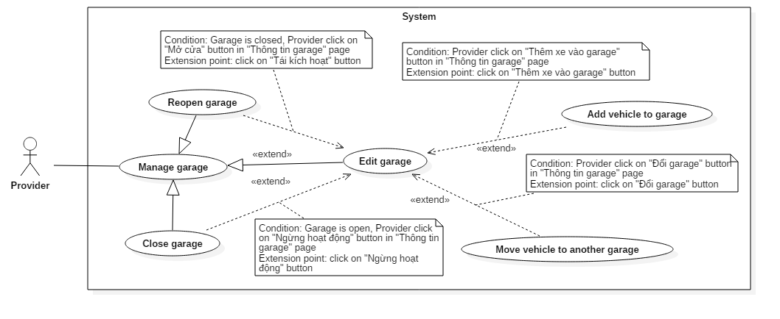

Figure 33: < Provider > Edit garage Use Case

|  |  |  |  |
| --- | --- | --- | --- |
| USE CASE – UC27 | | | |
| Use Case No. | 27 | **Use Case Version** | 1.0 |
| Use Case Name | Edit garage | | |
| Author | ThanhHC | | |
| Date | 30/09/2016 | **Priority** | Normal |
| Actor:   * Provider   Summary:   * This use case allows provider to edit garage’s information.   Goal:   * Garage’s information will be updated.   Triggers:   * Provider clicks “Chỉnh sửa thông tin” button in garage’s details page.   Preconditions:   * Login as roles provider.   Post Conditions:   * Success: Garage’s information will be updated in system. * Fail: Show error message.   Main Success Scenario:   |  |  |  | | --- | --- | --- | | Step | Actor Action | System Response | | 1 | Provider clicks “Chỉnh sửa thông tin” button in garage’s details page. | System shows a form to edit garage, which requires:   * Tên garage: free text input, required, max length 100. * Địa điểm: dropdown list, required * Địa chỉ: free text input, required, max length 200 * Email: free text input, required * Số điện thoại (mặc định): free text input, required, min length 10, max length 20 * Số điện thoại (bổ sung): free text input, min length 10, max length 20 * Mô tả: free text input * Điều khoản: free text input * Thời gian mở cửa: text input with time format and checkbox “Nghỉ”. By default, from Monday to Friday open at 8:00, close at 17:00. Saturday and Sunday checkbox “Nghỉ” is checked. | | 2 | Provider updates garage’s information and saves the updates  [Alternative 1] | System updates garage.  [Exception 1]  [Exception 2]  [Exception 3]  [Exception 4]  [Exception 5]  [Exception 6]  [Exception 7]  [Exception 8]  [Exception 9] |   Alternative Scenario:   |  |  |  | | --- | --- | --- | | No | Actor Action | System Response | | 1 | Provider click to “Hủy bỏ” button. | All display controls will be closed. |   Exceptions:   |  |  |  | | --- | --- | --- | | No | Actor Action | System Response | | 1 | Provider missed to input “Tên garage” field | System show error message “Vui lòng nhập tên garage” | | 2 | Provider missed to input “Địa chỉ” field | System show error message “Vui lòng nhập địa chỉ” | | 3 | Provider missed to input “Email” field | System shows error message “Vui lòng nhập email” | | 4 | Provider missed to input “Số điện thoại (mặc định)” field | System shows error message “Vui lòng nhập số điện thoại” | | 5 | Provider input “Tên garage” is over length allowed | System shows error message “Xin lỗi. Tên của garage vượt quá độ dài quy định” | | 6 | Provider input “Địa chỉ” is over length allowed | System shows error message “Xin lỗi. Địa chỉ vượt quá độ dài quy định” | | 7 | Provider input “Email” is wrong format | System shows error message “Email không hợp lệ” | |  | Provider input “Số điện thoại” is wrong format.  Valid format:  ^[0-9-+]+$ | System shows error message “Số điện thoại không hợp lệ” | | 8 | Provider input “Thời gian mở cửa” textfield “Từ” has higher value than textfield “Đến”. | System shows error message “Xin lỗi, thời gian đóng cửa không được sớm hơn thời gian mở cửa” | | 9 | Provider input “Thời gian mở cửa” wrong time format | System shows error message “Xin lỗi, giá trị thời gian không hợp lệ” |   Relationships: extended by “Close garage”, “Reopen garage”, “Add vehicle to garage” and “Move vehicle to another garage”  Business Rules: N/A | | | |

##### < Provider > Close garage (UC28)

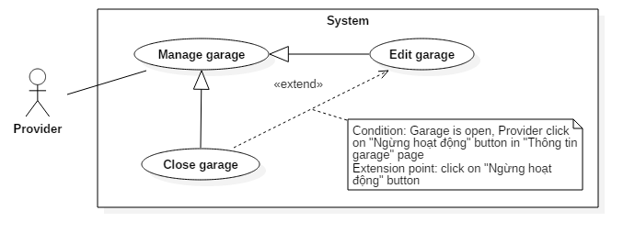

Figure 34: < Provider > Close garage Use Case

|  |  |  |  |
| --- | --- | --- | --- |
| USE CASE – UC28 | | | |
| Use Case No. | UC28 | **Use Case Version** | 1.0 |
| Use Case Name | Close garage | | |
| Author | ThanhHC | | |
| Date | 30/09/2016 | **Priority** | Normal |
| Actor:   * Provider   Summary:   * This use case allows provider to close garage.   Goal:   * Garage’s status will be changed to “Đã đóng cửa”.   Triggers:   * Provider click to “Đóng cửa garage” at “Thao tác” menu button in page “Quản lý garage” to change garage’s status. * Provider click to button “Ngừng hoạt động” in page “Thông tin garage” to change garage’s status.   Preconditions:   * Login as roles provider. * Target garage is open.   Post Conditions:   * Success: Garage is closed successful. * Fail: Show error message.   Main Success Scenario:   |  |  |  | | --- | --- | --- | | Step | Actor Action | System Response | | 1 | Provider click “Đóng cửa garage” button or click “Ngừng hoạt động” at “thông tin garage” page. | System show popup with confirm message:  “Bạn có chắc chắn hủy kích hoạt garage này?  {garageName}” | | 2 | Providerchoose an action. |  | | 3 | Provider click to button “Có” that sends request to change status to system  [Alternative 1] | Provider change garage’s status successfully. |   Alternative Scenario:   |  |  |  | | --- | --- | --- | | No | Actor Action | System Response | | 1 | Provider click to “Không” button. | Current popup will be closed. |   Exceptions: N/A  Relationships: Extend for “Edit garage”.  Business Rules:   * Target garage must be open. * After garage is closed, all vehicles in garage will also be disabled and cannot receive new booking. | | | |

##### < Provider > Reopen garage (UC29)

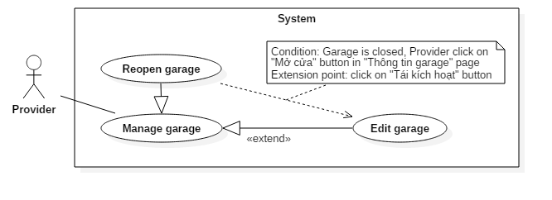

Figure 35: < Provider > Reopen garage Use Case

|  |  |  |  |
| --- | --- | --- | --- |
| USE CASE – UC29 | | | |
| Use Case No. | 29 | **Use Case Version** | 1.0 |
| Use Case Name | Reopen garage | | |
| Author | ThanhHC | | |
| Date | 30/09/2016 | **Priority** | Normal |
| Actor:   * Provider.   Summary:   * This use case allows provider to reopen a closed garage.   Goal:   * Provider can reopen a closed garage.   Triggers:   * Provider click to “Mở cửa garage” in page “Quản lý garage” to change garage’s status. * Provider click to button “Mở cửa garage” in page “Thông tin garage” to change garage’s status.   Preconditions:   * Login as roles provider. * Target garage is closed.   Post Conditions:   * Success: Garage is reopened. * Fail: Show error message.   Main Success Scenario:   |  |  |  | | --- | --- | --- | | Step | Actor Action | System Response | | 1 | Provider click “Mở cửa garage” button. | System shows popup to confirm the action. | | 2 | Provider confirms the action.  [Alternative 1] | System reopens the garage. |   Alternative Scenario:   |  |  |  | | --- | --- | --- | | No | Actor Action | System Response | | 1 | Provider click to “Không” button. | Current popup will be closed. |   Exceptions: N/A  Relationships: Extend from “edit garage”.  Business Rules:   * Target garage was closed. * After reopening the garage, all of its vehicles are reenabled and can receive new booking. | | | |

##### < Provider > Add vehicle to garage (UC30)

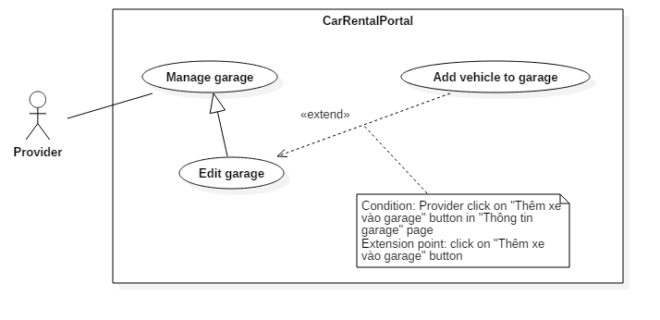

Figure 36: < Provider > Add vehicle to garage Use Case

|  |  |  |  |
| --- | --- | --- | --- |
| USE CASE – UC30 | | | |
| Use Case No. | 30 | **Use Case Version** | 1.0 |
| Use Case Name | Add vehicle to garage | | |
| Author | ThanhHC | | |
| Date | 30/09/2016 | **Priority** | Normal |
| Actor:   * Provider   Summary:   * This use case allows provider to add vehicle to current garage.   Goal:   * The selected vehicle will be moved into the target garage.   Triggers:   * Provider click on “Thêm xe vào garage” at “thông tin garage” page.   Preconditions:   * Login as roles provider.   Post Conditions:   * Success: Vehicle added to garage successfully. * Fail: Show error message.   Main Success Scenario:   |  |  |  | | --- | --- | --- | | Step | Actor Action | System Response | | 1 | Provider clicks “Thêm xe vào Garage” button. | System shows popup for choosing vehicle to add to garage. | | 2 | Provider select vehicle to add to garage and click “Thêm” button  [Alternative 1] | System add vehicle to garage. |   Alternative Scenario:   |  |  |  | | --- | --- | --- | | No | Actor Action | System Response | | 1 | Provider clicks on exist buttons from click outside the popup. | Current popup will be closed. |   Exceptions: N/A  Relationships: Extend from “Edit garage”.  Business Rules: N/A | | | |

##### < Provider > Move vehicle to another garage (UC31)

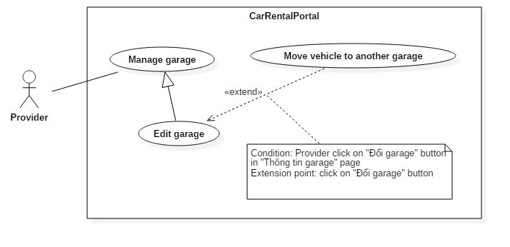

Figure 37: < Provider > Move vehicle to another garage Use Case

|  |  |  |  |
| --- | --- | --- | --- |
| USE CASE – UC31 | | | |
| Use Case No. | 31 | **Use Case Version** | 1.0 |
| Use Case Name | Move vehicle to another garage | | |
| Author | ThanhHC | | |
| Date | 30/09/2016 | **Priority** | Normal |
| Actor:   * Provider   Summary:   * This use case allows provider to move one or multiple vehicles to a garage   Goal:   * Switch vehicle from garage to another garage of provider.   Triggers:   * Provider clicks on “Đổi garage” button in “thông tin garage” page. * Provider selects multiple vehicles and click “Chuyển đến garage” option in “Quản lý xe” page.   Preconditions:   * Login as roles provider.   Post Conditions:   * Success: Vehicle will be switched to another garage. * Fail: Show error message.   Main Success Scenario:   |  |  |  | | --- | --- | --- | | Step | Actor Action | System Response | | 1 | Provider click “Đổi garage” button in “thông tin garage” page or selects multiple vehicles and click “Chuyển đến garage” option in “Quản lý xe” page | System shows popup to prompt provider to select garage to move selected vehicle(s) to. | | 2 | Provider selects a garage and clicks on “OK” button.  [Alternative 1] | System moves selected vehicle(s) to target garage. |   Alternative Scenario:   |  |  |  | | --- | --- | --- | | No | Actor Action | System Response | | 1 | Provider clicks on exist buttons or click outside the popup.. | Current popup will be closed. |   Exceptions:N/A  Relationships: Extend from “Edit garage”.  Business Rules: N/A | | | |

##### < Provider > Create vehicle group (UC32)

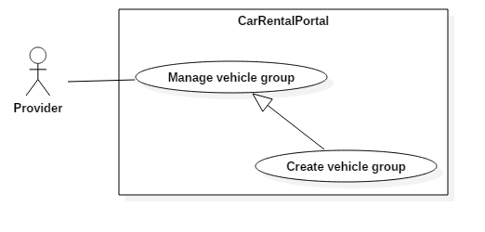

Figure 38: < Provider > Create vehicle group Use Case

|  |  |  |  |
| --- | --- | --- | --- |
| USE CASE – UC32 | | | |
| Use Case No. | 32 | **Use Case Version** | 2.0 |
| Use Case Name | Create vehicle group | | |
| Author | ThanhHC | | |
| Date | 30/09/2016 | **Priority** | Normal |
| Actor:   * Provider   Summary:   * This use case allows provider to create a new vehicle group.   Goal:   * Provider has a group to manage price, info and vehicles belong to this group.   Triggers:   * Provider click button “Thêm nhóm mới” in page “Quản lý nhóm giá”.   Preconditions:   * Login as roles provider.   Post Conditions:   * Success: Provider has new vehicle group to manage price. In default, this vehicle group has 0 vehicles. Provider can add vehicle to this group at later. * Fail: Show error message.   Main Success Scenario:   |  |  |  | | --- | --- | --- | | Step | Actor Action | System Response | | 1 | Provider click “Thêm nhóm mới” button. | System show popup requires information :   * Tên nhóm: free text input, required, max length 50. * Đặt cọc: number input, required, value must in range [0..100] * Giá theo ngày: number input, required, not allow negative number. * Kỳ hạn thuê tối đa: number input, not allow negative number. * Số Km tối đa một ngày: number input, not allow negative number. * Số tiền trả thêm: number input, not allow negative number. Display with hint text “Được áp dụng khi vượt số Km quy định”. * Bảng giá theo giờ: In default, table is hided, and only button “Thêm hàng mới” is displayed. | | 2 | Provider click “Thêm hàng mới” button.  [Alternative 1] | On current popup show a table with columns:   * Thời gian (giờ): number input, value must in range [1..23] * Giá tiền (VNĐ): number input, not allow negative number * Số Km tối đa (Km): number input, not allow negative number. | | 3 | Provider inputs information. |  | | 4 | Provider click to button “Tạo nhóm” that sends request to create to system.  [Alternative 2] | Provider create a new garage successfully.  [Exception 1]  [Exception 2]  [Exception 3]  [Exception 4]  [Exception 5]  [Exception 6]  [Exception 7]  [Exception 8]  [Exception 9]  [Exception 10]  [Exception 11]  [Exception 12]  [Exception 13]  [Exception 14]  [Exception 15]  [Exception 16] |   Alternative Scenario:   |  |  |  | | --- | --- | --- | | No | Actor Action | System Response | | 1 | Provider click to minus icon button. | A row in “Bảng giá theo giờ” table will be deleted. | | 2 | Provider click to “Đóng” button. | Current popup will be closed. |   Exceptions:   |  |  |  | | --- | --- | --- | | No | Actor Action | System Response | | 1 | Provider missed to input “Tên nhóm” field | System show error message “Vui lòng nhập tên nhóm” | | 2 | Provider missed to input “Đặt cọc” field | System show error message “Vui lòng nhập giá trị đặt cọc” | | 3 | Provider missed to input “Giá theo ngày” field | System shows error message “Xin vui lòng nhập giá thuê theo ngày” | | 4 | Providerinput “Tên nhóm” is over length allowed | System shows error message “Xin lỗi. Tên nhóm vượt quá độ dài quy định” | | 5 | Provider input “Đặt cọc” is out of range | System shows error message “Xin lỗi. giá trị đặt cọc phải từ 0% đến 100%” | | 6 | Provider input “Giá theo ngày” is a negative number. | System shows error message “Xin lỗi. Số tiền không được âm” | | 7 | Provider input “Kì hạn thuê tối đa” is a negative number | System shows error message “Xin lỗi. Kì hạn thuê tối đa không được âm” | | 8 | Provider input “Số Km tối đa một ngày” is a negative number. | System shows error message “Xin lỗi số km tối đa không được âm” | | 9 | Provider input “Số tiền trả thêm” is a negative number | System shows error message “Xin lỗi. Số tiền không được âm” | | 10 | Provider input “Thời gian (giờ)” but not input “Giá tiền (VNĐ)” | System shows error message “Vui lòng nhập giá tiền” | | 11 | Provider input “Giá tiền (VNĐ)” but not input “Thời gian (giờ)” | System shows error message “Vui lòng nhập giờ” | | 12 | Provider input “Số Km tối đa (Km)” but not input “Thời gian (giờ)” and “Giá tiền (VNĐ)” | System shows error message “Vui lòng nhập giờ và giá tiền” | | 13 | Provider input “Thời gian (giờ)” is out of range. | System shows error message “Xin lỗi. Số giờ bị sai” | | 14 | Provider input “Thời gian (giờ)” is duplicated. | System shows error message “Xin lỗi. Không được cấu hình giá một khung giờ nhiều lần” | | 15 | Provider input “Giá tiền (VNĐ)” is a negative number. | System shows error message “Xin lỗi. Số tiền không được âm” | | 16 | Provider input “Số Km tối đa (Km)” is a negative number. | System shows error message “Xin lỗi. Số tiền Km tối đa theo giờ không được âm” |   Relationships: N/A  Business Rules:   * After vehicle group is created,group has no vehicle inside and status “Đang hoạt động”. | | | |

##### < Provider > Delete vehicle group (UC33)

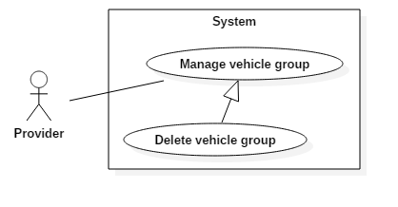

Figure 39: < Provider > Delete vehicle group Use Case

|  |  |  |  |
| --- | --- | --- | --- |
| USE CASE – UC33 | | | |
| Use Case No. | 33 | **Use Case Version** | 1.0 |
| Use Case Name | Delete vehicle group | | |
| Author | TamNT | | |
| Date | 30/09/2016 | **Priority** | Normal |
| Actor:   * Provider.   Summary:   * This use case allows provider to delete a vehicle group.   Goal:   * Provider delete vehicle group.   Triggers:   * Provider clicks “Xoá” button of a record in “Quản lý nhóm giá” page or in “Thông tin nhóm giá” page of a vehicle group.   Preconditions:   * Login to system with role is “Provider”. * There is no vehicle left inside the target vehicle group.   Post Conditions:   * Success: Delete vehicle group successfully. * Fail: Show error message.   Main Success Scenario:   |  |  |  | | --- | --- | --- | | Step | Actor Action | System Response | | 1 | Provider clicks “Xoá” button of a record in “Quản lý nhóm giá” page or in “Thông tin nhóm giá” page of a vehicle group. | System shows confirmation popup. | | 2 | Provider confirms deletion.  [Alternative 1] | System delete  [Exception 1] |   Alternative Scenario:   |  |  |  | | --- | --- | --- | | Step | Actor Action | System Response | | 1 | Provider clicks exit buttons or outside the popup. | System cancels operation. |   Exceptions:   |  |  |  | | --- | --- | --- | | Step | Actor Action | System Response | | 1 | Provider wanted to delete a vehicle group that still has vehicle left inside. | System alerts about the error. |   Relationships: N/A  Business Rules:   * Target vehicle group must not have any vehicle left inside. | | | |

##### < Provider > Edit vehicle group (UC34)

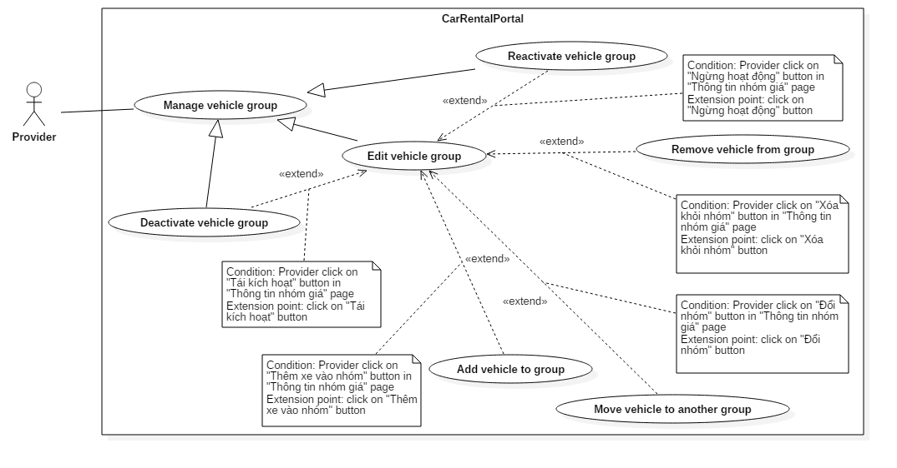

Figure 40: < Provider > Edit vehicle group Use Case

|  |  |  |  |
| --- | --- | --- | --- |
| USE CASE – UC34 | | | |
| Use Case No. | 34 | **Use Case Version** | 2.0 |
| Use Case Name | Edit vehicle group | | |
| Author | ThanhHC | | |
| Date | 30/09/2016 | **Priority** | Normal |
| Actor:   * Provider   Summary:   * This use case allows provider to update vehicle group’s information.   Goal:   * New information of group will be updated.   Triggers:   * Provider click button “Chỉnh sửa thông tin” in page “Thông tin nhóm giá”.   Preconditions:   * Login as roles provider.   Post Conditions:   * Success: Provider has a vehicle group with new information. * Fail: Show error message.   Main Success Scenario:   |  |  |  | | --- | --- | --- | | Step | Actor Action | System Response | | 1 | Provider click “Chỉnh sửa thông tin” button. | System show edit controls requires information :   * Tên nhóm: free text input, required, max length 50. * Đặt cọc: number input, required, value must in range [0..100] * Giá theo ngày: number input, required, not allow negative number. * Kỳ hạn thuê tối đa: number input, not allow negative number. * Số Km tối đa một ngày: number input, not allow negative number. * Số tiền trả thêm: number input, not allow negative number. Display with hint text “Được áp dụng khi vượt số Km quy định”. * Bảng giá theo giờ: In default, table include current list price to rent a vehicle by hour, and button “Thêm hàng mới” is displayed. | | 2 | Provider click “Thêm hàng mới” button.  [Alternative 1] | Add a row on current table “Bảng giá theo giờ” with columns:   * Thời gian (giờ): number input, value must in range [1..23] * Giá tiền (VNĐ): number input, not allow negative number * Số Km tối đa (Km): number input, not allow negative number. | | 3 | Provider inputs information. |  | | 4 | Provider click to button “Lưu lại” that sends request to create to system.  [Alternative 2] | Provider create a new garage successfully.  [Exception 1]  [Exception 2]  [Exception 3]  [Exception 4]  [Exception 5]  [Exception 6]  [Exception 7]  [Exception 8]  [Exception 9]  [Exception 10]  [Exception 11]  [Exception 12]  [Exception 13]  [Exception 14]  [Exception 15]  [Exception 16] |   Alternative Scenario:   |  |  |  | | --- | --- | --- | | No | Actor Action | System Response | | 1 | Provider click to minus icon button. | A row in “Bảng giá theo giờ” table will be deleted. | | 2 | Provider click to “Hủy bỏ” button. | Current edit controls will be closed. |   Exceptions:   |  |  |  | | --- | --- | --- | | No | Actor Action | System Response | | 1 | Provider missed to input “Tên nhóm” field | System show error message “Vui lòng nhập tên nhóm” | | 2 | Provider missed to input “Đặt cọc” field | System show error message “Vui lòng nhập giá trị đặt cọc” | | 3 | Provider missed to input “Giá theo ngày” field | System shows error message “Xin vui lòng nhập giá thuê theo ngày” | | 4 | Providerinput “Tên nhóm” is over length allowed | System shows error message “Xin lỗi. Tên nhóm vượt quá độ dài quy định” | | 5 | Provider input “Đặt cọc” is out of range | System shows error message “Xin lỗi. giá trị đặt cọc phải từ 0% đến 100%” | | 6 | Provider input “Giá theo ngày” is a negative number. | System shows error message “Xin lỗi. Số tiền không được âm” | | 7 | Provider input “Kì hạn thuê tối đa” is a negative number | System shows error message “Xin lỗi. Kì hạn thuê tối đa không được âm” | | 8 | Provider input “Số Km tối đa một ngày” is a negative number. | System shows error message “Xin lỗi số km tối đa không được âm” | | 9 | Provider input “Số tiền trả thêm” is a negative number | System shows error message “Xin lỗi. Số tiền không được âm” | | 10 | Provider input “Thời gian (giờ)” but not input “Giá tiền (VNĐ)” | System shows error message “Vui lòng nhập giá tiền” | | 11 | Provider input “Giá tiền (VNĐ)” but not input “Thời gian (giờ)” | System shows error message “Vui lòng nhập giờ” | | 12 | Provider input “Số Km tối đa (Km)” but not input “Thời gian (giờ)” and “Giá tiền (VNĐ)” | System shows error message “Vui lòng nhập giờ và giá tiền” | | 13 | Provider input “Thời gian (giờ)” is out of range. | System shows error message “Xin lỗi. Số giờ bị sai” | | 14 | Provider input “Thời gian (giờ)” is duplicated. | System shows error message “Xin lỗi. Không được cấu hình giá một khung giờ nhiều lần” | | 15 | Provider input “Giá tiền (VNĐ)” is a negative number. | System shows error message “Xin lỗi. Số tiền không được âm” | | 16 | Provider input “Số Km tối đa (Km)” is a negative number. | System shows error message “Xin lỗi. Số tiền Km tối đa theo giờ không được âm” |   Relationships: Extended by “Deactivate vehicle group”, “Reactivate vehicle group”, “Add vehicle to group”, “Move vehicle to another group”, “Remove vehicle from group”  Business Rules: N/A | | | |

##### < Provider > Deactivate vehicle group (UC35)

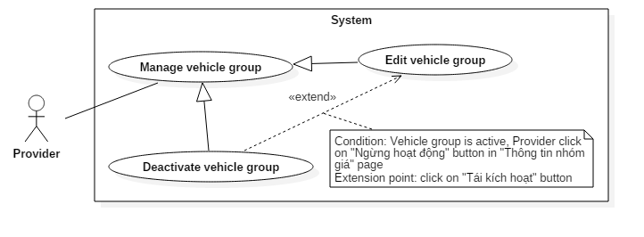

Figure 41: < Provider > Deactivate vehicle group Use Case

|  |  |  |  |
| --- | --- | --- | --- |
| USE CASE – UC35 | | | |
| Use Case No. | 35 | **Use Case Version** | 1.0 |
| Use Case Name | Deactivate vehicle group | | |
| Author | TamNT | | |
| Date | 30/09/2016 | **Priority** | Normal |
| Actor:   * Provider.   Summary:   * This use case allows provider to deactivate a vehicle group.   Goal:   * Provider can deactivate a vehicle group.   Triggers:   * Provider clicks “Ngừng hoạt động” button of a vehicle group in “Quản lý nhóm giá” page or in “Thông tin nhóm giá” page of a vehicle group.   Preconditions:   * Login to system with role is “Provider”. * Target vehicle group was active.   Post Conditions:   * Success: Deactivate vehicle group successfully. * Fail: Show error message.   Main Success Scenario:   |  |  |  | | --- | --- | --- | | Step | Actor Action | System Response | | 1 | Provider clicks “Ngừng hoạt động” button of a vehicle group in “Quản lý nhóm giá” page or in “Thông tin nhóm giá” page of a vehicle group. | System shows confirmation popup. | | 2 | Provider confirms deactivation.  [Alternative 1] | System deactivate target vehicle group. |   Alternative Scenario:   |  |  |  | | --- | --- | --- | | Step | Actor Action | System Response | | 1 | Provider clicks exit buttons or outside popup. | System cancels operation. |   Exceptions:N/A  Relationships: Extended from “edit vehicle group”.  Business Rules:   * Target vehicle group must have been active. * Vehicles inside deactivated vehicle group must also be disabled and can no longer receive booking. | | | |

##### < Provider > Reactivate vehicle group (UC36)

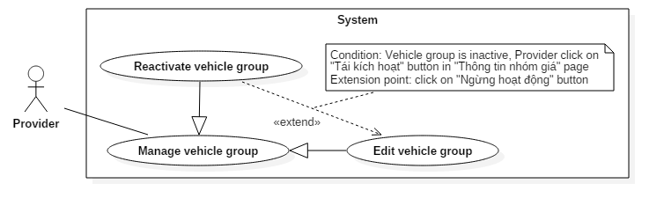

Figure 42: < Provider > Reactivate vehicle group Use Case

|  |  |  |  |
| --- | --- | --- | --- |
| USE CASE – UC36 | | | |
| Use Case No. | 36 | **Use Case Version** | 1.0 |
| Use Case Name | Reactivate vehicle group | | |
| Author | TamNT | | |
| Date | 30/09/2016 | **Priority** | Normal |
| Actor:   * Provider.   Summary:   * This use case allows provider to reactivate a vehicle group.   Goal:   * Provider reactive vehicle group.   Triggers:   * Provider clicks “Tái kích hoạt” button of a vehicle group in “Quản lý nhóm giá” page or in “Thông tin nhóm giá” page of a vehicle group.   Preconditions:   * Login to system with role is “Provider”. * Target vehicle group was deactivated.   Post Conditions:   * Success: Reactivate vehicle group successfully. * Fail: Show error message.   Main Success Scenario:   |  |  |  | | --- | --- | --- | | Step | Actor Action | System Response | | 1 | Provider clicks “Tái kích hoạt” button of a vehicle group in “Quản lý nhóm giá” page or in “Thông tin nhóm giá” page of a vehicle group. | System shows confirmation popup. | | 2 | Provider confirms reactivation.  [Alternative 1] | System reactivates target vehicle group. |   Alternative Scenario:   |  |  |  | | --- | --- | --- | | Step | Actor Action | System Response | | 1 | Provider clicks exist buttons or outside the popup. | System cancels operation. |   Exceptions: N/A  Relationships: Extend from “edit vehicle group”.  Business Rules:   * Target vehicle group must have been deactivated. * All vehicles inside target vehicle group must be reenabled. | | | |

##### < Provider > Add vehicle to group (UC37)

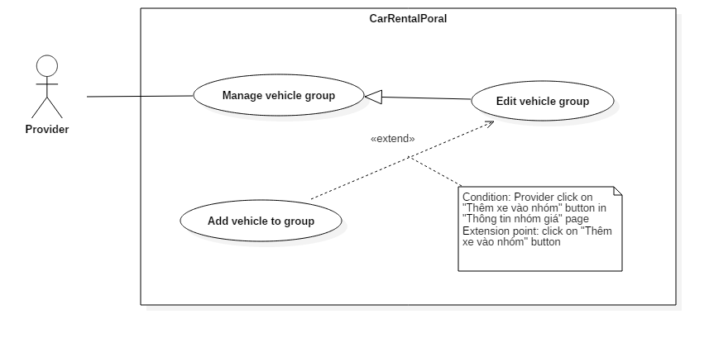

Figure 43: < Provider > Add vehicle to group Use Case

|  |  |  |  |
| --- | --- | --- | --- |
| USE CASE – UC37 | | | |
| Use Case No. | 37 | **Use Case Version** | 1.0 |
| Use Case Name | Add vehicle to group | | |
| Author | TamNT | | |
| Date | 30/09/2016 | **Priority** | Normal |
| Actor:   * Provider.   Summary:   * This use case allows provider to add vehicle to group.   Goal:   * Provider can add vehicle to group.   Triggers:   * Provider clicks on “Thêm xe vào nhóm” button in “Thông tin nhóm giá” page.   Preconditions:   * Login to system as role “Provider”.   Post Conditions:   * Success: Add vehicle to group successfully. * Fail: Show error message.   Main Success Scenario:   |  |  |  | | --- | --- | --- | | Step | Actor Action | System Response | | 1 | Provider clicks on “Thêm xe vào nhóm” button in “Thông tin nhóm giá” page. | System shows popup for provider to select vehicle to add into the target vehicle group. | | 2 | Provider selects vehicle and send adding request.  [Alternative 1] | System adds selected vehicle into target vehicle group. |   Alternative Scenario:   |  |  |  | | --- | --- | --- | | Step | Actor Action | System Response | | 1 | Provider click “Đóng” button | System will cancel operation. |   Exceptions: N/A  Relationships: Extend from “edit vehicle group”.  Business Rules: N/A | | | |

##### < Provider > Remove vehicle from group (UC38)

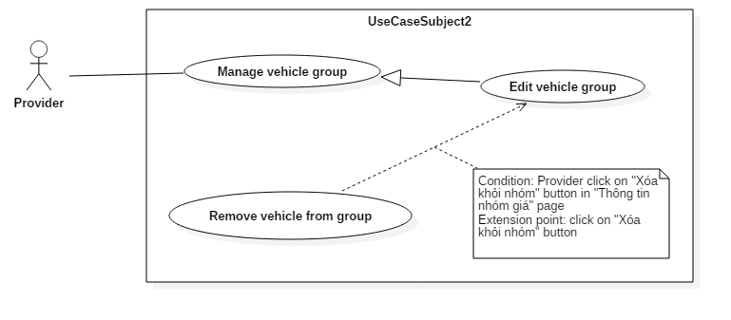

Figure 44: < Provider > Remove vehicle from group Use Case

|  |  |  |  |
| --- | --- | --- | --- |
| USE CASE – UC38 | | | |
| Use Case No. | 38 | **Use Case Version** | 1.0 |
| Use Case Name | Remove vehicle from group | | |
| Author | TamNT | | |
| Date | 30/09/2016 | **Priority** | Normal |
| Actor:   * Provider.   Summary:   * This use case allows provider to remove vehicle from group.   Goal:   * Provider remove vehicle from group.   Triggers:   * Provider click on “Xóa khỏi nhóm” at record of vehicle which want to remove at “Thông tin nhóm giá” page.   Preconditions:   * Login to system with role is “Provider” which has owned vehicle group.   Post Conditions:   * Success: Remove vehicle from group successfully. * Fail: Show error message.   Main Success Scenario:   |  |  |  | | --- | --- | --- | | Step | Actor Action | System Response | | 1 | Provider click on “Xóa khỏi nhóm” at record of vehicle which want to remove at “Thông tin nhóm giá” page. | System will show confirmation popup. | | 2 | Provider clicks “Đống ý” button.  [Alternative 1] | System will remove this vehicle from group in system. Then reload data table at “Thông tin nhóm giá” page. |   Alternative Scenario:   |  |  |  | | --- | --- | --- | | Step | Actor Action | System Response | | 1 | Provider clicks on exit buttons or outside the popup | System will cancel operation. |   Exceptions: N/A  Relationships: Extend from “edit vehicle group”.  Business Rules:   * Removed vehicle which does not belong to any group is disabled and cannot receive any booking. | | | |

##### < Provider > Move vehicle to another group (UC39)

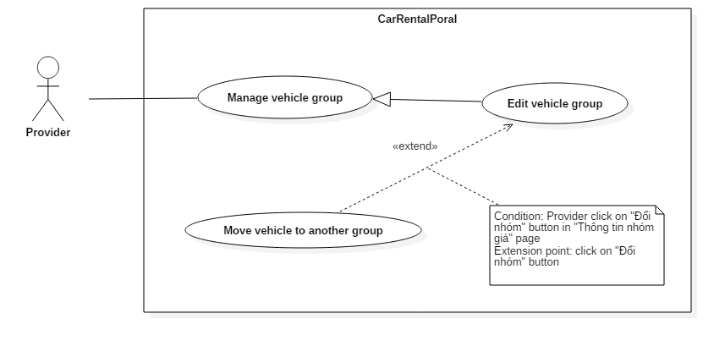

Figure 45: < Provider > Move vehicle to another group Use Case

|  |  |  |  |
| --- | --- | --- | --- |
| USE CASE – UC39 | | | |
| Use Case No. | 39 | **Use Case Version** | 2.0 |
| Use Case Name | Move vehicle to another group | | |
| Author | TamNT | | |
| Date | 30/09/2016 | **Priority** | Normal |
| Actor:   * Provider.   Summary:   * This use case allows provider to move 1 or multiple vehicle to another group.   Goal:   * Provider can move vehicle to another group.   Triggers:   * Provider select vehicles and select “Chuyển đến nhóm giá” option in “Quản lý xe” page or clicks on “Đổi nhóm” button of a vehicle inside “Chi tiết nhóm giá” page.   Preconditions:   * Login to system with role is “Provider”.   Post Conditions:   * Success: Move vehicle to another group successfully. * Fail: Show error message.   Main Success Scenario:   |  |  |  | | --- | --- | --- | | Step | Actor Action | System Response | | 1 | Provider select vehicles and select “Chuyển đến nhóm giá” option in “Quản lý xe” page or clicks on “Đổi nhóm” button of a vehicle inside “Chi tiết nhóm giá” page. | System shows popup for provider to choose vehicle group to move to. | | 2 | Provider selects vehicle group and confirm.  [Alternative 1] | System moves target vehicle(s) to selected vehicle group. |   Alternative Scenario:   |  |  |  | | --- | --- | --- | | Step | Actor Action | System Response | | 1 | Provider click exit buttons or outside the popup | System cancels operation. |   Exceptions: N/A.  Relationships: Extend from “edit vehicle group”.  Business Rules: N/A | | | |

##### < Provider > View reports (UC40)

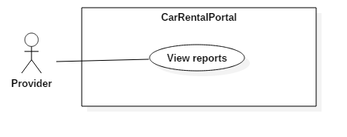

Figure 46: < Provider > View reports Use Case

|  |  |  |  |
| --- | --- | --- | --- |
| USE CASE – UC40 | | | |
| Use Case No. | 40 | **Use Case Version** | 2.0 |
| Use Case Name | View report | | |
| Author | KhoaLVD | | |
| Date | 30/09/2016 | **Priority** | Normal |
| Actor:   * Provider   Summary:   * This use case allows provider to view their report.   Goal:   * Provider can see business reports in their dashboard   Triggers:   * Provider accesses dashboard page.   Preconditions:   * User must login into the system with role “Provider”.   Post Conditions:   * Success: Provider can see their report. * Fail: Show error message.   Main Success Scenario:   |  |  |  | | --- | --- | --- | | Step | Actor Action | System Response | | 1 | Provider accesses dashboard page. | System shows dashboard page has the chart and information of successful booking, current profit, comment and rating, numbers of garage and vehicle. |   Alternative Scenario: N/A  Exceptions: N/A  Relationships: N/A  Business Rules: N/A | | | |

##### < Provider > Extend providership (UC41)

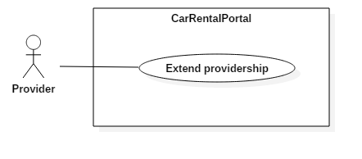

Figure 47: < Provider > Extend providership Use Case

|  |  |  |  |
| --- | --- | --- | --- |
| USE CASE – UC41 | | | |
| Use Case No. | 41 | **Use Case Version** | 1.0 |
| Use Case Name | Extend providership | | |
| Author | KhoaLVD | | |
| Date | 30/09/2016 | **Priority** | Normal |
| Actor:   * Provider   Summary:   * This use case allows provider to extend their providership.   Goal:   * Provider successfully extends their providership.   Triggers:   * Provider clicks on “Trở thành nhà cung cấp” at navigation bar.   Preconditions:   * Log in successful as role provider.   Post Conditions:   * Success: Provider successfully extends their providership. * Fail: Show error message.   Main Success Scenario:   |  |  |  | | --- | --- | --- | | Step | Actor Action | System Response | | 1 | User clicks on “Gia hạng quyền cung cấp” at navigation bar. | System shows providership prolongation page, which allows user to choose 1 in 3 subscription plans (1-month, 3-month, and 6-month). | | 2 | User clicks on “Gia hạn” button of a subscription plan. | System shows “Phương thức thanh toán” panel where user can choose payment method:   * Thanh toán online bằng thẻ ngân hàng nội địa: purchase using bank’s card. * Thanh toán bằng thẻ tín dụng / ghi nợ: purchase using credit card. * Thanh toán bằng Ví điện tử NgânLượng: purchase using NgânLượng account. | | 3 | User selects payment method and clicks on “Thanh toán” button.  [Alternative 1] | System redirect user to payment page. | | 4 | User pay for subscription.  [Alternative 2] | System sets new expiration day for user’s providership, send alert email, then redirect him to success page |   Alternative Scenario:   |  |  |  | | --- | --- | --- | | No | Actor Action | System Response | | 1 | User clicks on “Hủy đơn hàng” button at become provider page. | System will redirect user to homepage. | | 2 | User clicks on “Hủy đơn hàng” button at purchase page. | System will redirect user to homepage. |   Exceptions: N/A  Relationships: N/A  Business Rules: N/A | | | |

#### <Admin> Use Case Overview

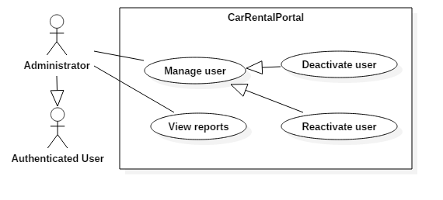

Figure 48: <Admin> Use Case Overview

##### < Admin > View reports (UC42)

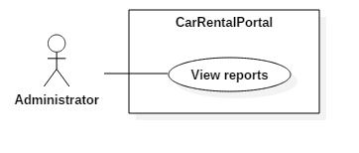

Figure 49: < Admin > View reports Use Case

|  |  |  |  |
| --- | --- | --- | --- |
| USE CASE – UC42 | | | |
| Use Case No. | 42 | **Use Case Version** | 1.0 |
| Use Case Name | View report | | |
| Author | TamNT | | |
| Date | 30/09/2016 | **Priority** | Normal |
| Actor:   * Admin   Summary:   * This use case allows admin to view business reports of CRP system.   Goal:   * Admin can view monthly reports about number of user, booking, vehicle, garage and profit.   Triggers:   * User logged into system with role “Admin * Admin click “Xin chào” tab in top bar.   Preconditions:   * User logged into system with role “Admin”.   Post Conditions:   * Success: Report and statistical will be displayed. * Fail: N/A.   Main Success Scenario:   |  |  |  | | --- | --- | --- | | Step | Actor Action | System Response | | 1 | Login with role “Admin” or click “Xin chào” tab in top bar | System will show some panels include:  “Số lượng người dùng”, “Số lượng nhà cung cấp”, “Số lượng garage”, “Số lượng xe”, “Lượt đặt xe”, “Lợi nhuận”.  Chart will be displayed – representation data of number of booking and profit currently. |   Alternative Scenario: N/A  Exceptions: N/A  Relationships: N/A  Business Rules: N/A | | | |

##### < Admin > Deactivate user (UC43)

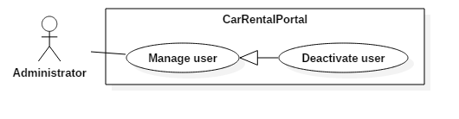

Figure 50: < Admin > Deactivate user Use Case

|  |  |  |  |
| --- | --- | --- | --- |
| USE CASE – UC43 | | | |
| Use Case No. | 43 | **Use Case Version** | 1.0 |
| Use Case Name | Deactivate user | | |
| Author | TamNT | | |
| Date | 30/09/2016 | **Priority** | Normal |
| Actor:   * Admin.   Summary:   * This use case allows Admin to deactivate users.   Goal:   * Admin can deactivates users.   Triggers:   * Admin click “Chặn” button on corresponding record at management user page.   Preconditions:   * User logged into system with role “Admin”.   Post Conditions:   * Success: Deactivate users successfully. * Fail: Show error message.   Main Success Scenario:   |  |  |  | | --- | --- | --- | | Step | Actor Action | System Response | | 1 | Admin click “Quản lý người dùng” tab in left bar. | System will show “Manage Users” page. | | 2 | Admin click “Chặn” button to select record which want to deactivate. | System will show Activation Confirmation. “Bạn có chắc chặn người dùng này?” There are “Không” and “Đúng” button.  [Alternative 1] | | 3 | Admin click “Đúng” | System will deactivate user in this records which were selected from list.  [Exception 1] |   Alternative Scenario:   |  |  |  | | --- | --- | --- | | Step | Actor Action | System Response | | 1 | Admin click “Hủy” button | System will cancel operation. |   Exceptions:   |  |  |  | | --- | --- | --- | | Step | Actor Action | System Response | | 1 | Admin selected record that is has admin role item. | Show error message “Có lỗi xảy ra!” |   Relationships: N/A  Business Rules:   * Admin cannot deactivate another admin or himself. | | | |

##### < Admin > Reactivate user (UC44)

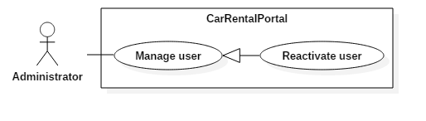

Figure 51: < Admin > Reactivate user Use Case

|  |  |  |  |
| --- | --- | --- | --- |
| USE CASE – UC44 | | | |
| Use Case No. | 44 | **Use Case Version** | 1.0 |
| Use Case Name | Reactivate user | | |
| Author | TamNT | | |
| Date | 30/09/2016 | **Priority** | Normal |
| Actor:   * Admin.   Summary:   * This use case allows Admin to reactivate user.   Goal:   * Admin can reactivate user.   Triggers:   * Admin click “Bỏ chặn” button on corresponding record.   Preconditions:   * User logged into system with role “Admin”.   Post Conditions:   * Success: Reactivate users successfully. * Fail: Show error message.   Main Success Scenario:   |  |  |  | | --- | --- | --- | | Step | Actor Action | System Response | | 1 | Admin click “Quản lý người dùng” tab in left bar. | System will show “Quản lý người dùng” page. | | 2 | Admin click “Bỏ chặn” button to select record which want to reactivate. | System will show Activation Confirmation. “Bạn có chắc bỏ chặn người dùng này?” There are “Không” and “Đúng” button. | | 3 | Admin click “Đúng”  [Alternative 1] | System will reactivate user in this records which were selected from list. |   Alternative Scenario:   |  |  |  | | --- | --- | --- | | Step | Actor Action | System Response | | 1 | Admin click “Hủy” button | System will cancel operation. |   Exceptions: N/A  Relationships: N/A  Business Rules: N/A | | | |

## Software System Attribute

### Usability

#### Graphic User Interface

GUI must use Vietnamese as main language and should be simple, clear, intuitive, and, reminiscent.

#### Usability

* Rental service provider should be able to operate the system properly in the matter of hours.
* The system must be simple and intuitive so that customer can start using without any taking any tutorial or training.

#### Installation

The system should be easy and fast to deploy following installation guide.

### Reliability

The system must not have any inconsistency in booking processing.

### Availability

The system should not have any downtime beside 6 hours of monthly maintenance.

### Security

* System must implement strict authorization and authentication.
* Passwords have to be encrypted before saving into database.

### Maintainability

* The system must be divided into separated, high-cohesive, and low-coupling modules.
* Code should be clear, DRY, and have helpful commends.

### Portability

* The web server can be deployed in any server machine that supports IIS8.
* Website should be able to run on Chrome (v.42 and above), Firefox (v.38 and above), and any equivalent web browser.

### Performance

Server must respond to user’s request from machine with minimum 4 Mbps connection and 1GHz CPU in less than 5 seconds.

## Conceptual Diagram

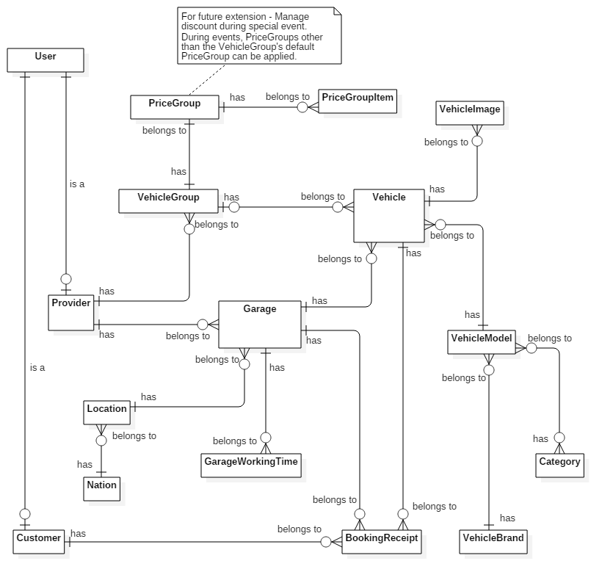

Figure 52: Conceptual Diagram

**Data Dictionary**

|  |  |
| --- | --- |
| Entity Data dictionary | |
| Entity Name | **Description** |
| User | Abstract entity, represent user in system |
| Provider | User with provider role |
| Customer | User with customer role |
| Vehicle | Represent vehicle in system |
| VehicleImage | Represent image of vehicle |
| VehicleModel | Represent vehicle model |
| VehicleBrand | Represent vehicle brand |
| Category | Represent vehicle category |
| Garage | Represent garage |
| GarageWorkingTime | Describe working time constraints of garage each day of week |
| Location | Represent location inside a country |
| Nation | Represent nation |
| VehicleGroup | Represent group of vehicles with the same rental constraints |
| PriceGroup | Describe rental constraints of a vehicle group |
| PriceGroupItem | Describe rental constraints of each daily rental option of price group |
| BookingReceipt | Represent booking receipt in system |

# Software Design Description

## Design Overview

This document describes the technical and user interface design of CRP System. The document includes architectural design, detailed design of core functions and business functions, and database design.

The architectural design describes the overall architecture of the system and relations between components and sub-systems inside.

The detailed design describes static and dynamic structure of each component and function. The design includes class diagram, class explanations, and sequence diagrams of each of the important use case.

The database design describes the relationships between system entities and details about attributes of each entity.

**Document overview:**

* Section 2: System architectural design.
* Section 3: Component diagrams describes the connections and integration of components inside the system.
* Section 4: Detailed design description including class diagram, class explanations, and sequence diagrams.
* Section 5: User interface design.
* Section 6: Database design.
* Section 7: Algorithms.

## System Architecture Design

|  |
| --- |
| HTTP Request (1)    (5)  Object Relational Mapping (ORM)  Return data (7)  Query (6)  HTTP Response (11)  (10)  (3)  (8)  View Model  (9)  Model  (4)  Entity Framework 6.0  ADO.NET Data Provider  Database  Web browser  **Annotation**  Call / Send  Dependency  Select (2)  URL Routing  View  Business  Controller |

Figure 53: System architecture design

### Web Application architecture description

The system is developed using ASP.NET MVC5 and Entity Framework 6.0 (EF6). The system has 5 important parts:

* **Model** is the part that acts as a data transfer object between the system and database. Models are generated using Object relational mapping (ORM) offered by EF6.
* **View** is the part that handles the display of data. A view renders the display using data from the model or view model that is passed down by controller.
* **Controller** is the part that acts as event handler to handle the user interaction. Typically, a controller reads data from the request, calls the appropriate Business’s method, then selects view to render display and then send response back to user.
* **Business** is the part that contains all business handling methods.
* **View Model** is the part that acts like value object. Typically controller passes view model to view and view uses view model as data source for display rendering.

## Component Diagram

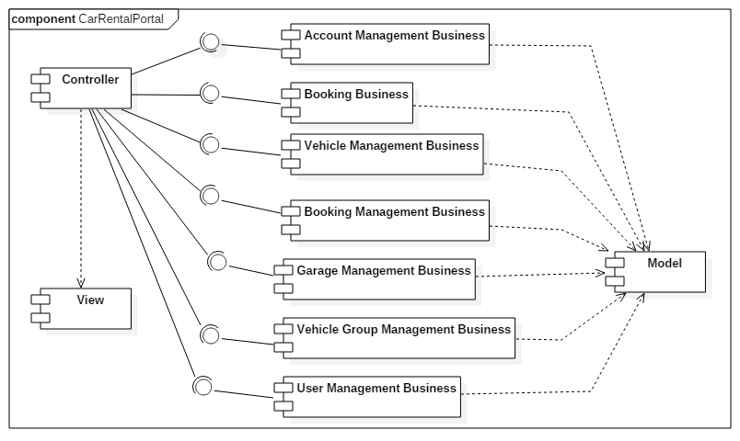

Figure 54 : Component diagram

|  |  |
| --- | --- |
| Component | Description |
| Controller | Represent all controllers in the system. |
| View | Represent all views in the system. |
| Model | Represent all models mapped by Entity Framework. |
| Account Management Business | Contain functions for handling account management (Register, change account information, change password …). |
| Booking Business | Contain functions for handling vehicle booking actions from customer. |
| Vehicle Management Business | Contain methods for handling vehicle management actions from provider. |
| Booking Management Business | Contain functions for handling booking management actions from provider. |
| Garage Management Business | Contain functions for handling garage management actions from provider. |
| Vehicle Group Management Business | Contain functions for handling vehicle group management actions from provider. |
| User Management Business | Contain functions for handling user management actions from admin. |

Table 8: Component dictionary

## Detailed Description

### Class Diagram

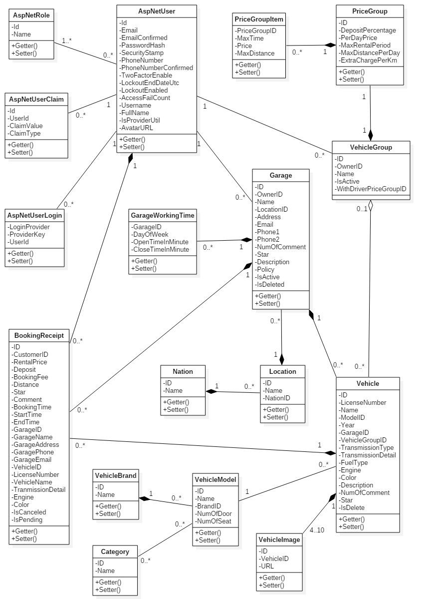

Figure 1: Class Diagram

|  |  |  |
| --- | --- | --- |
| Class dictionary | | |
| Class Name | **Mapping column with Conceptual diagram** | **Description** |
| AspNetUser | User | Generated by ASP.NET MVC5. Describe all user in system |
| AspNetRole | N/A | Generated by ASP.NET MVC5. Describe existing user’s roles in system. |
| AspNetUserClaim | N/A | Generated by ASP.NET MVC5. Describe all stored claims (Special attributes) of AspNetUsers. |
| AspNetUserLogin | N/A | Generated by ASP.NET MVC5. Describe information about 3rd party/external logins allowed for each AspNetUsers. |
| Vehicle | Vehicle | Describe all vehicles in system. |
| VehicleImage | VehicleImage | Describe all images of each vehicle. |
| VehicleModel | VehicleModel | Describe all vehicle models in system. |
| VehicleBrand | VehicleBrand | Describe all vehicle brands in system. |
| Category | Category | Describe all vehicle categories in system. |
| VehicleGroup | VehicleGroup | Describe all vehicle groups in system |
| PriceGroup | PriceGroup | Describe rental constraints (Pricing, travel distance…) of each VehicleGroup. |
| PriceGroupItem | PriceGroupItem | Describe detailed constraints for hourly rental options of each PriceGroup in system. |
| Garage | Garage | Describe all garages in system |
| GarageWorkingTime | GarageWorkingTime | Describe working time constraints of each Garage in system. |
| Location | Location | Describe all locations in system. |
| Nation | Nation | Describe all nations in system. |
| BookingReceipt | BookingReceipt | Describe all booking receipts in system. |

Table 9: Class dictionary

### Class Diagram Explanation

#### AspNetUser

|  |  |  |  |
| --- | --- | --- | --- |
| **Attribute** | **Type** | **Visibility** | **Description** |
| Id | String | Private | Unique identifier of AspNetUser. |
| Email | String | Private | Email of user. |
| EmailConfirmed | Boolean | Private | Status indicating whether email has been confirmed. |
| PasswordHash | String | Private | Encoded password of user. |
| SecurityStamp | String | Private | Stamp used to authenticate user’s cookies and session. |
| PhoneNumber | String | Private | Phone number of user. |
| PhoneNumberConfirmed | Boolean | Private | Status indicating whether phone number has been confirmed. |
| TwoFactorEnabled | Boolean | Private | Status indicating whether two-factor sign-in is enabled. |
| LockoutEndDateUtc | Nullable<DateTime> | Private | Date until which this user is locked out if lockoutEnable is true. |
| LockoutEnable | Boolean | Private | Status indicating whether lockout is enabled. |
| AccessFailedCount | Integer | Private | Number of failed access for this account. |
| UserName | String | Private | Username |
| FullName | String | Private | Full name of user |
| IsProviderUntil | Nullable<DateTime> | Private | Date until which this user has provider role. |
| AvatarURL | String | Private | URL of user’s avatar |

Table 10: AspNetUser class - Attributes

|  |  |  |  |
| --- | --- | --- | --- |
| **Method** | **Return type** | **Visibility** | **Description** |
| Getter | Attribute type | Public | Get value of attribute |
| Setter | Void | Public | Set value of attribute |

Table 11: AspNetUser class – Methods

#### AspNetRole

|  |  |  |  |
| --- | --- | --- | --- |
| **Attribute** | **Type** | **Visibility** | **Description** |
| Id | String | Private | Unique identifier of AspNetRole |
| Name | String | Private | Name of role |

Table 12: AspNetRole class - Attributes

|  |  |  |  |
| --- | --- | --- | --- |
| **Method** | **Return type** | **Visibility** | **Description** |
| Getter | Attribute type | Public | Get value of attribute |
| Setter | Void | Public | Set value of attribute |

Table 13: AspNetRole class - Methods

#### AspNetUserClaim

|  |  |  |  |
| --- | --- | --- | --- |
| **Attribute** | **Type** | **Visibility** | **Description** |
| Id | Integer | Private | Unique identifier of claim |
| UserId | String | Private | ID of AspNetUser whom this claim belongs to |
| ClaimType | Stirng | Private | Type of claim |
| ClaimValue | String | Private | Value of claim |

Table 14: AspNetUserClaim class - Attributes

|  |  |  |  |
| --- | --- | --- | --- |
| **Method** | **Return type** | **Visibility** | **Description** |
| Getter | Attribute type | Public | Get value of attribute |
| Setter | Void | Public | Set value of attribute |

Table 15: AspNetUserClaim class - Methods

#### AspNetUserLogin

|  |  |  |  |
| --- | --- | --- | --- |
| **Attribute** | **Type** | **Visibility** | **Description** |
| LoginProvider | String | Private | Name of third-party login provider |
| ProviderKey | String | Private | Login key of user provided by third-party service |
| UserId | String | Private | ID of AspNetUser who can log in using this login |

Table 16: AspNetUserLogin class - Attributes

|  |  |  |  |
| --- | --- | --- | --- |
| **Method** | **Return type** | **Visibility** | **Description** |
| Getter | Attribute type | Public | Get value of attribute |
| Setter | Void | Public | Set value of attribute |

Table 17: AspNetUserLogin class - Methods

#### Vehicle

|  |  |  |  |
| --- | --- | --- | --- |
| **Attribute** | **Type** | **Visibility** | **Description** |
| ID | String | Private | Unique identifier of vehicle |
| LicenseNumber | String | Private | License number of vehicle |
| Name | String | Private | Name of vehicle |
| ModelID | Integer | Private | Model of vehicle |
| Year | Integer | Private | Year in which this vehicle was produced |
| GarageID | Integer | Private | ID of Garage containing this vehicle |
| VehicleGroupID | Nullable<Integer> | Private | ID of VehicleGroup containing this vehicle |
| TransmissionType | Integer | Private | Transmission type of vehicle |
| TransmissionDetail | String | Private | Detailed description about transmisson of vehicle |
| FuelType | Nullable<Integer> | Private | Fuel type of vehicle |
| Engine | String | Private | Description about engine of vehicle |
| Color | Integer | Private | Color of vehicle |
| Description | String | Private | Description about vehicle |
| NumOfComment | Integer | Private | Number of customer’s feedback this vehicle has received |
| Star | Decimal | Private | Rating of vehicle |
| IsDeleted | Boolean | Private | Status indicating whether this vehicle was deleted |

Table 18: Vehicle class - Attributes

|  |  |  |  |
| --- | --- | --- | --- |
| **Method** | **Return type** | **Visibility** | **Description** |
| Getter | Attribute type | Public | Get value of attribute |
| Setter | Void | Public | Set value of attribute |

Table 19: Vehicle class - Methods

#### VehicleImage

|  |  |  |  |
| --- | --- | --- | --- |
| **Attribute** | **Type** | **Visibility** | **Description** |
| ID | String | Private | Unique identifier of image returned by cloudinary |
| VehicleID | Integer | Private | ID of Vehicle which this image belongs to |
| URL | String | Private | URL of image |

Table 20: VehicleImage class - Attributes

|  |  |  |  |
| --- | --- | --- | --- |
| **Method** | **Return type** | **Visibility** | **Description** |
| Getter | Attribute type | Public | Get value of attribute |
| Setter | Void | Public | Set value of attribute |

Table 21: VehicleImage class - Methods

#### VehicleModel

|  |  |  |  |
| --- | --- | --- | --- |
| **Attribute** | **Type** | **Visibility** | **Description** |
| ID | Integer | Private | Unique identifier of vehicle model |
| Name | String | Private | Name of role |
| BrandID | Integer | Private | ID of Brand of this model |
| NumOfDoor | Integer | Private | Number of door on this vehicle |
| NumOfSeat | Integer | Private | Number of seat in this vehicle |

Table 22: VehicleModel class - Attributes

|  |  |  |  |
| --- | --- | --- | --- |
| **Method** | **Return type** | **Visibility** | **Description** |
| Getter | Attribute type | Public | Get value of attribute |
| Setter | Void | Public | Set value of attribute |

Table 23: VehicleModel class - Methods

#### VehicleBrand

|  |  |  |  |
| --- | --- | --- | --- |
| **Attribute** | **Type** | **Visibility** | **Description** |
| ID | Integer | Private | Unique identifier of vehicle brand |
| Name | String | Private | Name of brand |

Table 24: VehicleBrand class - Attributes

|  |  |  |  |
| --- | --- | --- | --- |
| **Method** | **Return type** | **Visibility** | **Description** |
| Getter | Attribute type | Public | Get value of attribute |
| Setter | Void | Public | Set value of attribute |

Table 25: VehicleBrand class - Methods

#### Category

|  |  |  |  |
| --- | --- | --- | --- |
| **Attribute** | **Type** | **Visibility** | **Description** |
| ID | Integer | Private | Unique identifier of category |
| Name | String | Private | Name of category |

Table 26: VehicleBrand class - Attributes

|  |  |  |  |
| --- | --- | --- | --- |
| **Method** | **Return type** | **Visibility** | **Description** |
| Getter | Attribute type | Public | Get value of attribute |
| Setter | Void | Public | Set value of attribute |

Table 27: VehicleBrand class - Methods

#### Garage

|  |  |  |  |
| --- | --- | --- | --- |
| **Attribute** | **Type** | **Visibility** | **Description** |
| ID | Integer | Private | Unique identifier of garage |
| OwnerID | String | Private | ID of AspNetUser owing this garage |
| Name | String | Private | Name of garage |
| LocationID | Integer | Private | ID of Location of garage |
| Address | String | Private | Address of garage |
| Email | String | Private | Email of garage |
| Phone1 | String | Private | Primary phone number of garage |
| Phone2 | String | Private | Secondary phone number of garage |
| NumOfComment | Integer | Private | Number of customer’s feedback this garage has received |
| Star | Decimal | Private | Rating of garage |
| Description | String | Private | Description of garage |
| Policy | String | Private | Policy of garage |
| IsActive | Boolean | Private | Status indicating whether this garage is active. |
| IsDeleted | Boolean | Private | Status indicating whether this garage was deleted. |

Table 28: Garage class - Attributes

|  |  |  |  |
| --- | --- | --- | --- |
| **Method** | **Return type** | **Visibility** | **Description** |
| Getter | Attribute type | Public | Get value of attribute |
| Setter | Void | Public | Set value of attribute |

Table 29: Garage class - Methods

#### GarageWorkingTime

|  |  |  |  |
| --- | --- | --- | --- |
| **Attribute** | **Type** | **Visibility** | **Description** |
| GarageID | Integer | Private | ID of Garage which this working time constraint is applied to. |
| DayOfWeek | Integer | Private | Day of week which this working time constraint represents. |
| OpenTimeInMinute | Integer | Private | Opening time of this garare in this day of week. |
| CloseTimeInMinute | Integer | Private | Closing time of this garage in this day of week. |

Table 30: GarageWorkingTime class - Attributes

|  |  |  |  |
| --- | --- | --- | --- |
| **Method** | **Return type** | **Visibility** | **Description** |
| Getter | Attribute type | Public | Get value of attribute |
| Setter | Void | Public | Set value of attribute |

Table 31: GarageWorkingTime class - Methods

#### Location

|  |  |  |  |
| --- | --- | --- | --- |
| **Attribute** | **Type** | **Visibility** | **Description** |
| ID | Integer | Private | Unique identifier of location. |
| Name | String | Private | Name of location. |
| NationID | Integer | Private | ID of Nation to which this location belongs. |

Table 32: Location class - Attributes

|  |  |  |  |
| --- | --- | --- | --- |
| **Method** | **Return type** | **Visibility** | **Description** |
| Getter | Attribute type | Public | Get value of attribute |
| Setter | Void | Public | Set value of attribute |

Table 33: Location class - Methods

#### Nation

|  |  |  |  |
| --- | --- | --- | --- |
| **Attribute** | **Type** | **Visibility** | **Description** |
| ID | Integer | Private | Unique identifier of nation |
| Name | String | Private | Name of nation |

Table 34: Nation class - Attributes

|  |  |  |  |
| --- | --- | --- | --- |
| **Method** | **Return type** | **Visibility** | **Description** |
| Getter | Attribute type | Public | Get value of attribute |
| Setter | Void | Public | Set value of attribute |

Table 35: Nation class - Methods

#### VehicleGroup

|  |  |  |  |
| --- | --- | --- | --- |
| **Attribute** | **Type** | **Visibility** | **Description** |
| ID | Integer | Private | Unique identifier of vehicle group |
| OwnerID | String | Private | ID of AspNetUser whom this group belongs to |
| Name | String | Private | Name of group |
| IsActive | Boolean | Private | Status indicating whether this group is active |
| WithDriverPriceGroupID | Integer | Private | ID of default PriceGroup which is applied for driver-included rent. |

Table 36: VehicleGroup class - Attributes

|  |  |  |  |
| --- | --- | --- | --- |
| **Method** | **Return type** | **Visibility** | **Description** |
| Getter | Attribute type | Public | Get value of attribute |
| Setter | Void | Public | Set value of attribute |

Table 37: VehicleGroup class - Methods

#### PriceGroup

|  |  |  |  |
| --- | --- | --- | --- |
| **Attribute** | **Type** | **Visibility** | **Description** |
| ID | Integer | Private | Unique identifier of price group. |
| DepositPercentage | Decimal | Private | Percentage of total rental price which customer has to pay to provider when booking. |
| PerDayPrice | Double | Private | Pricing of daily rental. |
| MaxRentalPeriod | Nullable<Integer> | Private | Maximum days a rental can last. |
| MaxDistancePerDay | Nullable<Integer> | Private | Maximum km that customer can travel in 1 days without being charged extra fee with the rented vehicle. |
| ExtraChargePerKm | Nullable<Double> | Private | Extra fee for every 1 km outside allowed travel distance. |

Table 38: PriceGroup class - Attributes

|  |  |  |  |
| --- | --- | --- | --- |
| **Method** | **Return type** | **Visibility** | **Description** |
| Getter | Attribute type | Public | Get value of attribute |
| Setter | Void | Public | Set value of attribute |

Table 39: PriceGroup class - Methods

#### PriceGroupItem

|  |  |  |  |
| --- | --- | --- | --- |
| **Attribute** | **Type** | **Visibility** | **Description** |
| PriceGroupID | Integer | Private | ID of PriceGroup to which this hourly rental option belongs. |
| MaxTime | Integer | Private | Rental duration of this rental option. |
| Price | Double | Private | Rental price of this rental option. |
| MaxDistance | Integer | Private | Maximum km that customer can travel without being charged extra fee with the rented vehicle using this rental option. |

Table 40: PriceGroupItem class - Attributes

|  |  |  |  |
| --- | --- | --- | --- |
| **Method** | **Return type** | **Visibility** | **Description** |
| Getter | Attribute type | Public | Get value of attribute |
| Setter | Void | Public | Set value of attribute |

Table 41: PriceGroupItem class - Methods

#### BookingReceipt

|  |  |  |  |
| --- | --- | --- | --- |
| **Attribute** | **Type** | **Visibility** | **Description** |
| ID | Integer | Private | Unique identifier of receipt. |
| CustomerID | String | Private | ID of AspNetUser who is the customer of this receipt. |
| RentalPrice | Double | Private | Total rental price. |
| Deposit | Double | Private | Deposit paid by customer to provider when booking. |
| BookingFee | Double | Private | Fee paid by customer to system when booking. |
| Distance | Nullable<Integer> | Private | Maximum distance customer can travel without being charged extra fee with the rented vehicle. |
| Star | Nullable<Integer> | Private | Rating from customer for this rental period. |
| Comment | String | Private | Feedback from customer about this rental reriod. |
| BookingTime | DateTime | Private | Time when this booking is made. |
| StartTime | DateTime | Private | Time when rental period starts. |
| EndTime | DateTime | Private | Time when rental period ends. |
| GarageID | Integer | Private | ID of Garage to which this booking belongs. |
| GarageName | String | Private | Name of Garage at booking moment. |
| GarageAddress | String | Private | Address of Garage at booking moment. |
| GaragePhone | String | Private | Phone1 of Garage at booking moment. |
| GarageEmail | String | Private | Email of Garage at booking moment. |
| VehicleID | Integer | Private | ID of booked Vehicle. |
| LicenseNumber | String | Private | License number of Vehicle at booking moment. |
| VehicleName | String | Private | Name of Vehicle at booking moment. |
| TransmissionDetail | String | Private | TransmissionDetail of Vehicle at booking moment. |
| Engine | String | Private | Engine of Vehicle at booking moment. |
| Color | Integer | Private | Color of Vehicle at booking moment. |
| IsCanceled | Boolean | Private | Status indicating whether this booking has been canceled. |
| IsPending | Boolean | Private | Status indicating whether this booking has not been paid. |

Table 42: BookingReceipt class - Attributes

|  |  |  |  |
| --- | --- | --- | --- |
| **Method** | **Return type** | **Visibility** | **Description** |
| Getter | Attribute type | Public | Get value of attribute |
| Setter | Void | Public | Set value of attribute |

Table 43: BookingReceipt class - Methods

### 

### Interactive Diagram

#### Common

##### Search vehicle

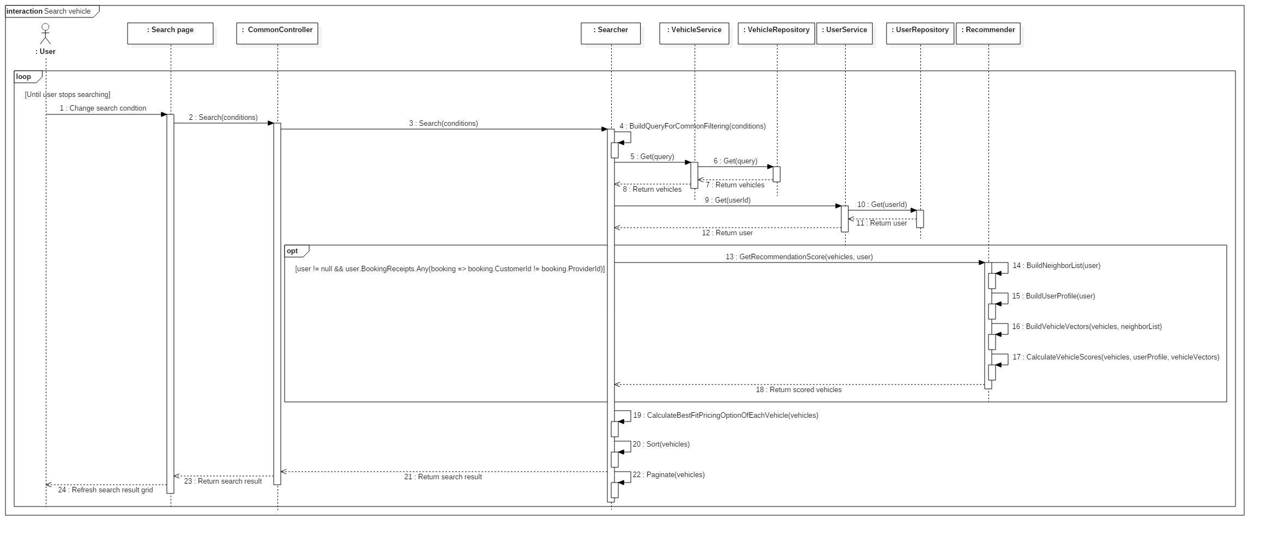

Figure 55: Search vehicle sequence

#### Guest

##### Recover password

Figure 56: Recover password

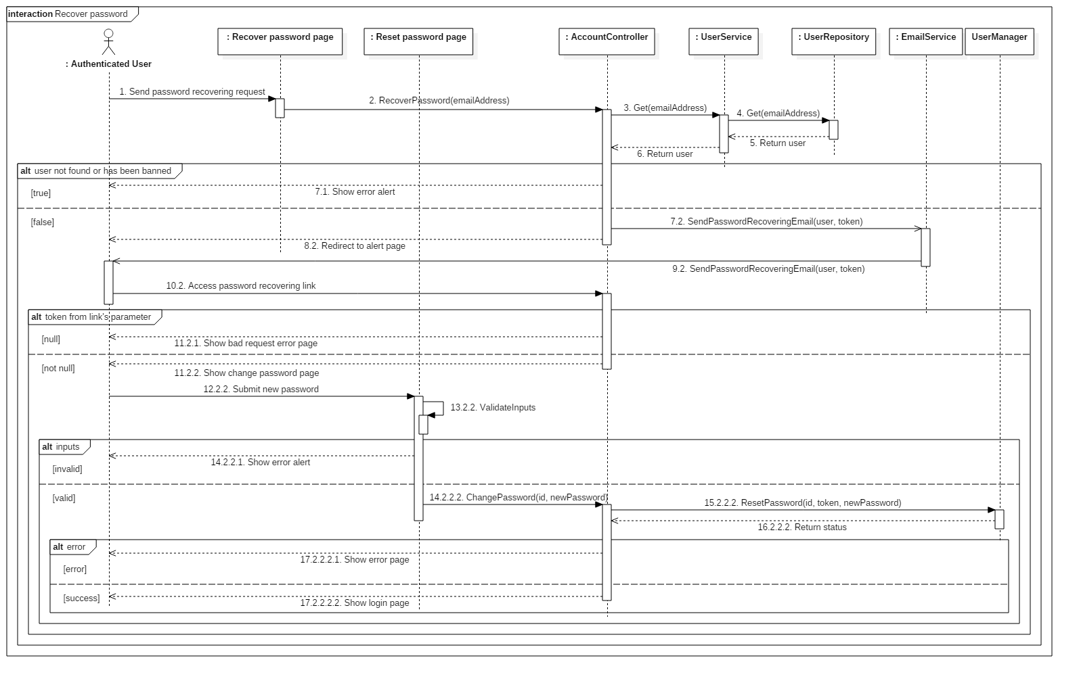

#### Authenticated User

##### Change personal information

#### Customer

##### Book vehicle

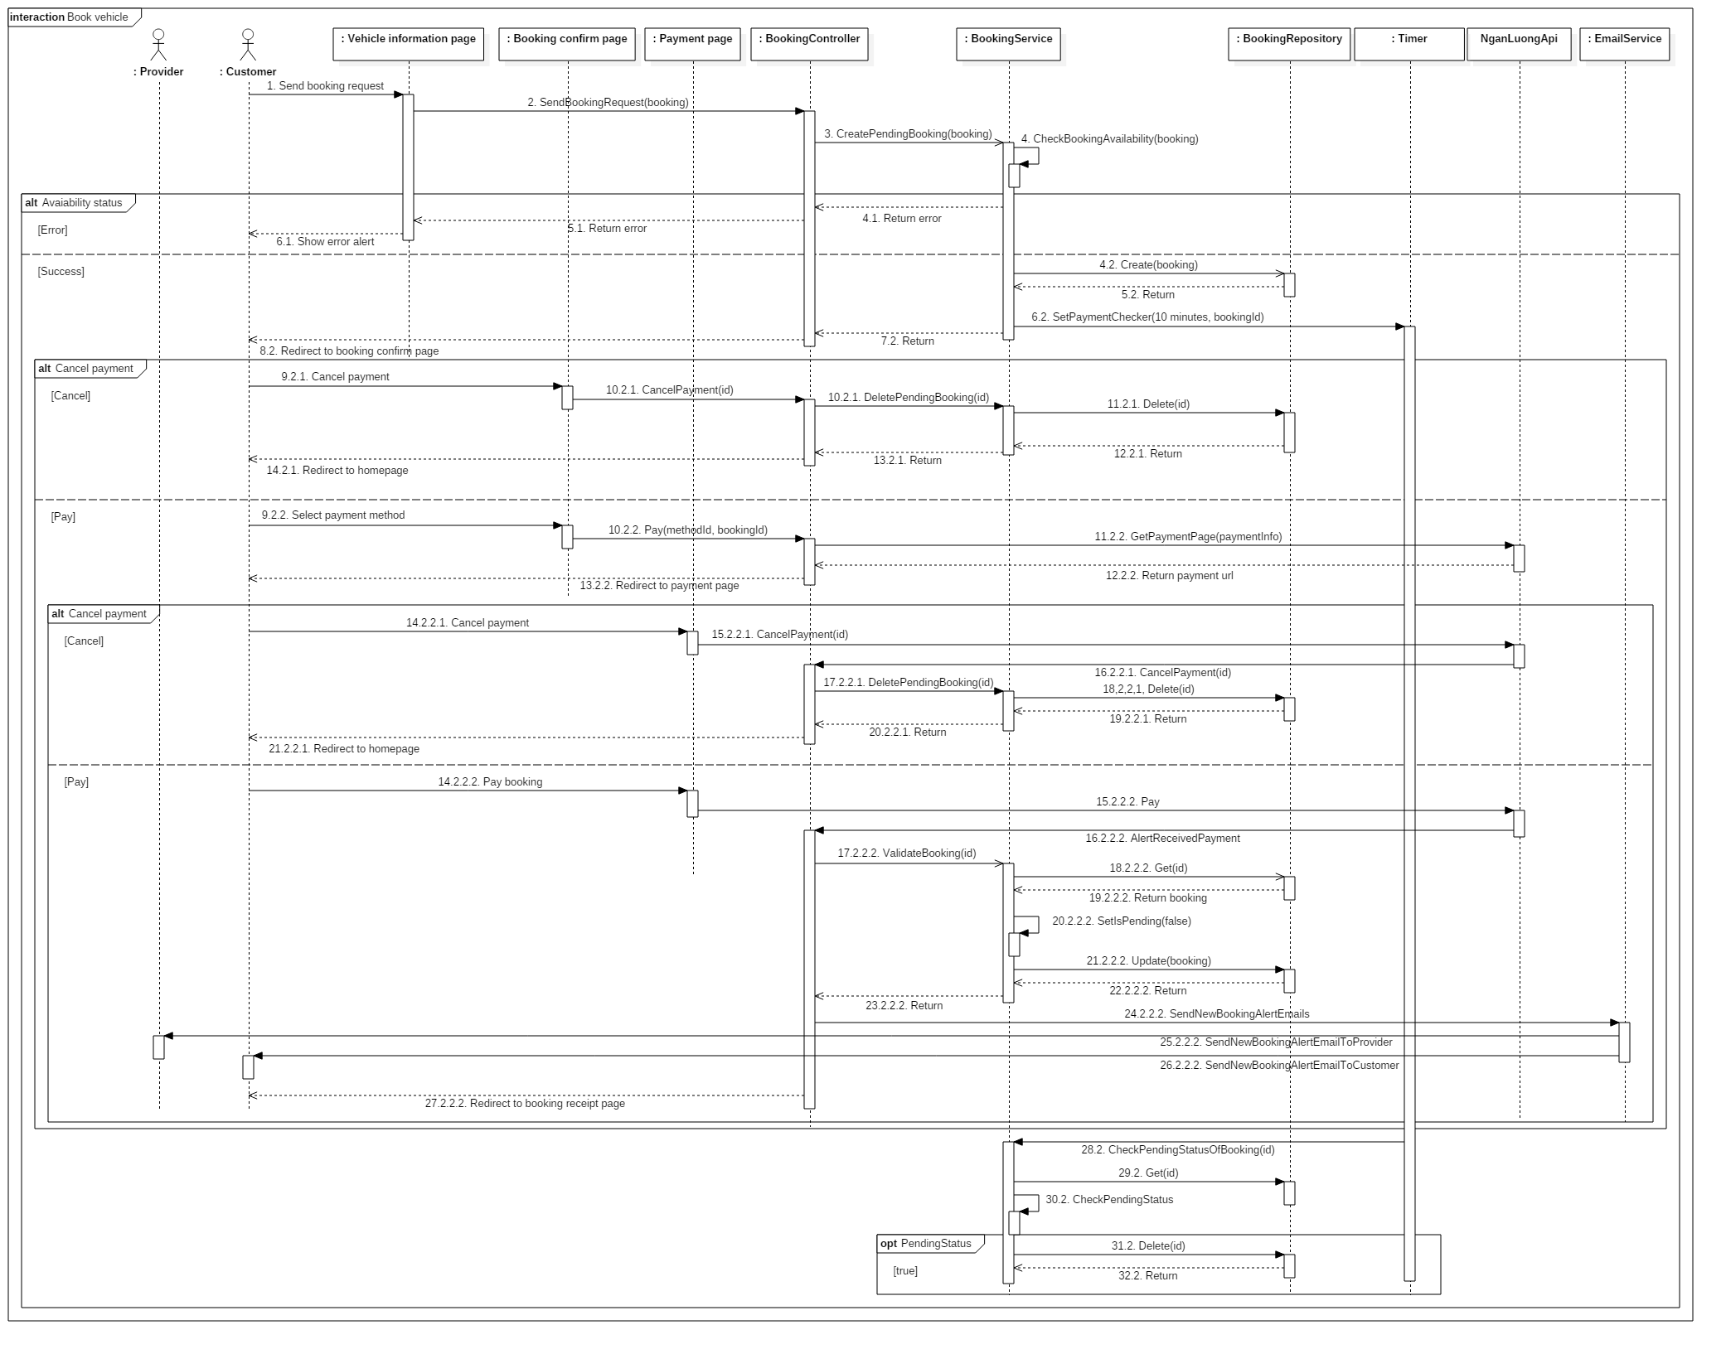

Figure 56: Book vehicle sequence

##### Comment and rate booking

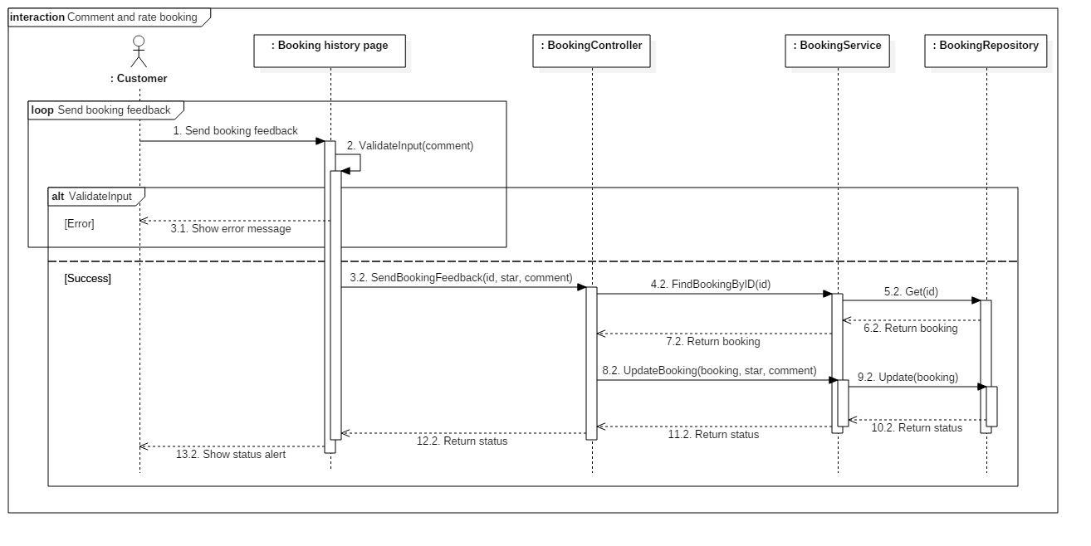

Figure 57: Comment and rate booking sequence

##### Cancel booking

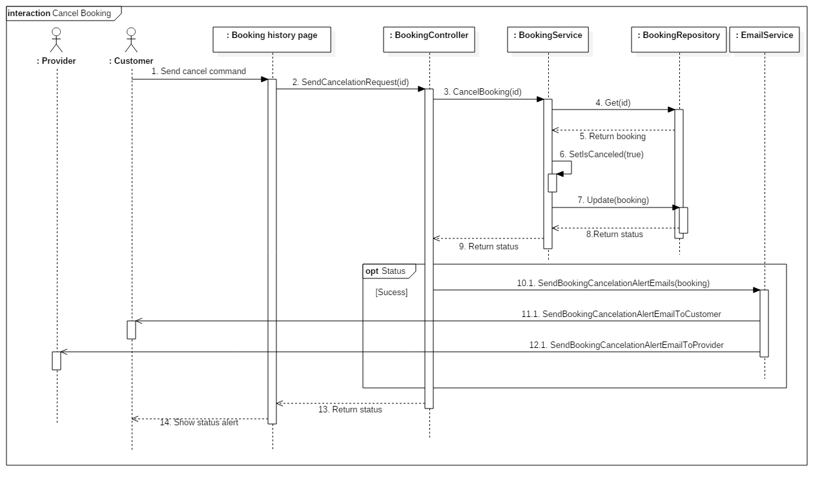

Figure 58: Cancel booking sequence

##### Register providership

#### Provider

##### Create vehicle

##### Add image for vehicle

##### Delete image of vehicle

##### Edit vehicle

##### Create garage

##### Create vehicle group

##### Extend providership

#### System

##### Check providership expiration

## User Interface Design

## Database Design

### Entity relationship diagram

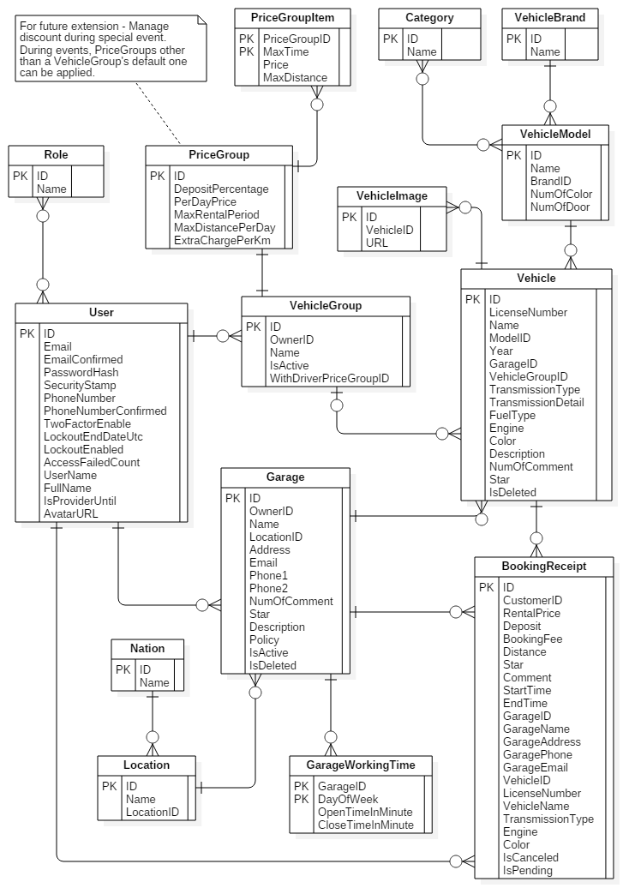

Figure 59 : Entity Relationship Diagram

### Entity Dictionary

|  |  |
| --- | --- |
| Entity dictionary | |
| Entity Name | **Description** |
| User | Abstract entity, represent user in system |
| Provider | User with provider role |
| Customer | User with customer role |
| Vehicle | Represent vehicle in system |
| VehicleImage | Represent image of vehicle |
| VehicleModel | Represent vehicle model |
| VehicleBrand | Represent vehicle brand |
| Category | Represent vehicle category |
| Garage | Represent garage |
| GarageWorkingTime | Describe working time constraints of garage each day of week |
| Location | Represent location inside a country |
| Nation | Represent nation |
| VehicleGroup | Represent group of vehicles with the same rental constraints |
| PriceGroup | Describe rental constraints of a vehicle group |
| PriceGroupItem | Describe rental constraints of each daily rental option of price group |
| BookingReceipt | Represent booking receipt in system |

Table 44 : Entity dictionary

#### User

|  |  |  |  |
| --- | --- | --- | --- |
| **Attribute** | **Domain** | **Allows null** | **Description** |
| Id | nvarchar(128) | No | Unique identifier of user. |
| Email | varchar(256) | No | Email of user. |
| EmailConfirmed | bit | No | Status indicating whether email has been confirmed. |
| PasswordHash | nvarchar(MAX) | Yes | Encoded password of user. |
| SecurityStamp | nvarchar(MAX) | Yes | Stamp used to authenticate user’s cookies and session. |
| PhoneNumber | nvarchar(MAX) | Yes | Phone number of user. |
| PhoneNumberConfirmed | bit | No | Status indicating whether phone number has been confirmed. |
| TwoFactorEnabled | bit | No | Status indicating whether two-factor sign-in is enabled. |
| LockoutEndDateUtc | datetime | Yes | Date until which this user is locked out if lockoutEnable is true. |
| LockoutEnable | bit | No | Status indicating whether lockout is enabled. |
| AccessFailedCount | int | No | Number of failed access for this account. |
| UserName | nvarchar(256) | Yes | Username |
| FullName | nvarchar(200) | Yes | Full name of user |
| IsProviderUntil | datetime | Yes | Date until which this user has provider role. |
| AvatarURL | varchar(200) | Yes | URL of user’s avatar |

Table 45: User entity – Attributes

#### Role

|  |  |  |  |
| --- | --- | --- | --- |
| **Attribute** | **Domain** | **Allows null** | **Description** |
| Id | nvarchar(128) | No | Unique identifier of AspNetRole |
| Name | nvarchar(256) | No | Name of role |

Table 46: Role entity - Attributes

#### Vehicle

|  |  |  |  |
| --- | --- | --- | --- |
| **Attribute** | **Domain** | **Allows null** | **Description** |
| ID | int | No | Unique identifier of vehicle |
| LicenseNumber | varchar(50) | No | License number of vehicle |
| Name | nvarchar(100) | No | Name of vehicle |
| ModelID | int | No | Model of vehicle |
| Year | int | No | Year in which this vehicle was produced |
| GarageID | int | No | ID of Garage containing this vehicle |
| VehicleGroupID | int | Yes | ID of VehicleGroup containing this vehicle |
| TransmissionType | int | No | Transmission type of vehicle |
| TransmissionDetail | nvarchar(100) | Yes | Detailed description about transmisson of vehicle |
| FuelType | int | Yes | Fuel type of vehicle |
| Engine | nvarchar(100) | Yes | Description about engine of vehicle |
| Color | int | No | Color of vehicle |
| Description | nvarchar(1000) | Yes | Description about vehicle |
| NumOfComment | int | No | Number of customer’s feedback this vehicle has received |
| Star | decimal(2, 1) | No | Rating of vehicle |
| IsDeleted | bit | No | Status indicating whether this vehicle was deleted |

Table 47: Vehicle entity – Attributes

#### VehicleImage

|  |  |  |  |
| --- | --- | --- | --- |
| **Attribute** | **Domain** | **Allows null** | **Description** |
| ID | varchar(100) | No | Unique identifier of image returned by cloudinary |
| VehicleID | int | No | ID of Vehicle which this image belongs to |
| URL | varchar(200) | No | URL of image |

Table 48: VehicleImage entity - Attributes

#### VehicleModel

|  |  |  |  |
| --- | --- | --- | --- |
| **Attribute** | **Domain** | **Allows null** | **Description** |
| ID | int | No | Unique identifier of vehicle model |
| Name | nvarchar(50) | No | Name of role |
| BrandID | int | No | ID of Brand of this model |
| NumOfDoor | int | No | Number of door on this vehicle |
| NumOfSeat | int | No | Number of seat in this vehicle |

Table 49: VehicleModel entity - Attributes

#### VehicleBrand

|  |  |  |  |
| --- | --- | --- | --- |
| **Attribute** | **Domain** | **Allows null** | **Description** |
| ID | int | No | Unique identifier of vehicle brand |
| Name | nvarchar(50) | No | Name of brand |

Table 50: VehicleBrand entity - Attributes

#### Category

|  |  |  |  |
| --- | --- | --- | --- |
| **Attribute** | **Domain** | **Allows null** | **Description** |
| ID | int | No | Unique identifier of category |
| Name | nvarchar(50) | No | Name of category |

Table 51: VehicleBrand entity - Attributes

#### Garage

|  |  |  |  |
| --- | --- | --- | --- |
| **Attribute** | **Domain** | **Allows null** | **Description** |
| ID | int | No | Unique identifier of garage |
| OwnerID | nvarchar(128) | No | ID of AspNetUser owing this garage |
| Name | nvarchar(100) | No | Name of garage |
| LocationID | int | No | ID of Location of garage |
| Address | nvarchar(200) | No | Address of garage |
| Email | varchar(256) | No | Email of garage |
| Phone1 | varchar(50) | No | Primary phone number of garage |
| Phone2 | varchar(50) | Yes | Secondary phone number of garage |
| NumOfComment | int | No | Number of customer’s feedback this garage has received |
| Star | decimal(2, 1) | No | Rating of garage |
| Description | nvarchar(1000) | Yes | Description of garage |
| Policy | nvarchar(1000) | Yes | Policy of garage |
| IsActive | bit | No | Status indicating whether this garage is active. |
| IsDeleted | bit | No | Status indicating whether this garage was deleted. |

Table 52: Garage entity - Attributes

#### GarageWorkingTime

|  |  |  |  |
| --- | --- | --- | --- |
| **Attribute** | **Domain** | **Allows null** | **Description** |
| GarageID | int | No | ID of Garage which this working time constraint is applied to. |
| DayOfWeek | int | No | Day of week which this working time constraint represents. |
| OpenTimeInMinute | int | No | Opening time of this garare in this day of week. |
| CloseTimeInMinute | int | No | Closing time of this garage in this day of week. |

Table 53: GarageWorkingTime entity - Attributes

#### Location

|  |  |  |  |
| --- | --- | --- | --- |
| **Attribute** | **Domain** | **Allows null** | **Description** |
| ID | int | No | Unique identifier of location. |
| Name | nvarchar(50) | No | Name of location. |
| NationID | int | No | ID of Nation to which this location belongs. |

Table 54: Location entity - Attributes

#### Nation

|  |  |  |  |
| --- | --- | --- | --- |
| **Attribute** | **Domain** | **Allows null** | **Description** |
| ID | int | No | Unique identifier of nation |
| Name | nvarchar(50) | No | Name of nation |

Table 55: Nation entity - Attributes

#### VehicleGroup

|  |  |  |  |
| --- | --- | --- | --- |
| **Attribute** | **Domain** | **Allows null** | **Description** |
| ID | int | No | Unique identifier of vehicle group |
| OwnerID | nvarchar(128) | No | ID of AspNetUser whom this group belongs to |
| Name | nvarchar(50) | No | Name of group |
| IsActive | bit | No | Status indicating whether this group is active |
| WithDriverPriceGroupID | int | No | ID of default PriceGroup which is applied for driver-included rent. |

Table 56: VehicleGroup entity - Attributes

#### PriceGroup

|  |  |  |  |
| --- | --- | --- | --- |
| **Attribute** | **Domain** | **Allows null** | **Description** |
| ID | int | No | Unique identifier of price group. |
| DepositPercentage | decimal(3, 2) | No | Percentage of total rental price which customer has to pay to provider when booking. |
| PerDayPrice | float | No | Pricing of daily rental. |
| MaxRentalPeriod | int | Yes | Maximum days a rental can last. |
| MaxDistancePerDay | int | Yes | Maximum km that customer can travel in 1 days without being charged extra fee with the rented vehicle. |
| ExtraChargePerKm | int | Yes | Extra fee for every 1 km outside allowed travel distance. |

Table 57: PriceGroup entity - Attributes

#### PriceGroupItem

|  |  |  |  |
| --- | --- | --- | --- |
| **Attribute** | **Domain** | **Allows null** | **Description** |
| PriceGroupID | int | No | ID of PriceGroup to which this hourly rental option belongs. |
| MaxTime | int | No | Rental duration of this rental option. |
| Price | float | No | Rental price of this rental option. |
| MaxDistance | int | Yes | Maximum km that customer can travel without being charged extra fee with the rented vehicle using this rental option. |

Table 58: PriceGroupItem entity - Attributes

#### BookingReceipt

|  |  |  |  |
| --- | --- | --- | --- |
| **Attribute** | **Domain** | **Allows null** | **Description** |
| ID | int | No | Unique identifier of receipt. |
| CustomerID | String | No | ID of AspNetUser who is the customer of this receipt. |
| RentalPrice | float | No | Total rental price. |
| Deposit | float | No | Deposit paid by customer to provider when booking. |
| BookingFee | float | No | Fee paid by customer to system when booking. |
| Distance | int | Yes | Maximum distance customer can travel without being charged extra fee with the rented vehicle. |
| Star | int | Yes | Rating from customer for this rental period. |
| Comment | nvarchar(200) | Yes | Feedback from customer about this rental reriod. |
| BookingTime | datetime | No | Time when this booking is made. |
| StartTime | datetime | No | Time when rental period starts. |
| EndTime | datetime | No | Time when rental period ends. |
| GarageID | int | No | ID of Garage to which this booking belongs. |
| GarageName | nvarchar(100) | No | Name of Garage at booking moment. |
| GarageAddress | nvarchar(200) | No | Address of Garage at booking moment. |
| GaragePhone | varchar(50) | No | Phone1 of Garage at booking moment. |
| GarageEmail | varchar(50) | No | Email of Garage at booking moment. |
| VehicleID | int | No | ID of booked Vehicle. |
| LicenseNumber | varchar(50) | No | License number of Vehicle at booking moment. |
| VehicleName | nvarchar(100) | No | Name of Vehicle at booking moment. |
| TransmissionDetail | nvarchar(200) | Yes | TransmissionDetail of Vehicle at booking moment. |
| Engine | nvarchar(200) | Yes | Engine of Vehicle at booking moment. |
| Color | int | No | Color of Vehicle at booking moment. |
| IsCanceled | bit | No | Status indicating whether this booking has been canceled. |
| IsPending | bit | No | Status indicating whether this booking has not been paid. |

Table 59: BookingReceipt entity - Attributes

## Algorithms

### Recommender Engine

#### Introduction

As a car rental solution, CRP has to be able to introduce the most suitable vehicles to customers. This will helps improving not only the customers’ but also the providers’ satisfaction, and ultimately gaining more transactions, as well as interest for our application. Consequently, a recommender engine is necessary.

#### Common approaches

Two common approaches on designing recommender solution are *Collaborative filtering* and *Content-based filtering*.

Collaborative filtering methods are based on collecting and analyzing a large amount of information on users’ behaviors, activities or preferences and predicting what users will like based on their similarity to other users. [3]

Content-based filtering methods are based on a description of the item and a profile of the user’s preference. In a content-based recommender system, keywords are used to describe the items and a user profile is built to indicate the type of item this user likes. In other words, these algorithms try to recommend items that are similar to those that a user liked in the past (or is examining in the present). [4]

Collaborative approach does not require analyzing the content of item that it recommend since it is based entirely on the user’s information. However, exactly because it depends solely on the data generated by users, it suffers the three common problem of computing, namely *cold* *start* (Lack of user’s interaction in the beginning), *scalability* (Scale badly when the number of user and their interaction increase), and *sparsity* (The number of item is much bigger than the number of user). Considering the low-number-of-transaction nature of car rental service when compares to other kind of services, scalability and sparsity issues can be evaded.

Content-based approach works well even under scarce user’s interaction environment since its recommendations are based on the items’ description. Its issue of not being able to recommend items with different content type (For instance, car and phone) is also not a problem, since CRP only has one type of item.

#### Solution’s approaches

CRP’s recommender design take a hybrid approach between content-based and collaborative. We score vehicles base on how each of them is similar to the vehicles the customer has booked in the past and how many other customers that have booked this vehicle also have booked a similar vehicle as this customer in the past. Vehicles with higher score will have higher priority in recommendation.

Since our system’s recommended targets, namely vehicles, have many attributes that we can take advantage of (Brand, number of seat, color…), we initially tackles the problem using content-based methods. These includes *Vector space model* and *tf-idf.*

##### Represent items using vector space model

We first abstract the vehicles and their attributes by applying *Vector space model* [5], an item presentation algorithm.

Each vehicle is modeled as a vector (Refer to as *master vector* from now) in a multi-dimension space (Refer to as *vector space* from now), with each dimension corresponds to an attribute. If a vehicle has an attribute, the component vector (Refer to as *attribute vector* from now) corresponding to that attribute will has non-zero length.

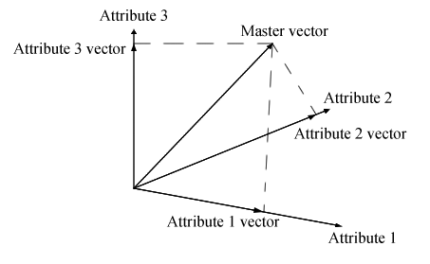

Figure 60 – Example for 3-dimensional vector space

There are several weighting scheme that can be used to calculate the attribute vector’s length. Amongst them, the most popular one is *tf-idf* (Term frequency – Inverse document frequency)[6], which. In our solution, tf-idf is applied with *binary scheme* (Further explanation will be given in *solution’s design* section).

##### Customer profile

A customer profile is another vector in the *vector space* which indicate a particular customer’s interest in vehicle, like which color or which fuel type that he has more affinity with.

In vector space model, the angle between 2 vectors determine the similarity between them. This means the smaller the angle between a vehicle’s *master vector* and a customer profile, the more similar that vehicle is to the customer’s reference.

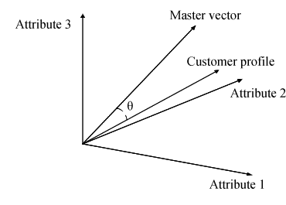

Figure 61 – Example for customer profile vector

It is common to use the cosine of this angle to represent their similarity, since their values are between 1 and -1. This form allows us to tell at how many percent a customer will like a vehicle (Positive value), or dislike it (Negative value). Our recommender engine will find the cosine between each vehicle’s *master vector* and a customer profile, then recommend vehicles with the highest cosine value to that customer.

##### Mix in collaborative element

To further improve the diversity of our solution’s recommendation, we apply collaborative methods into our content-based solution. Our collaborative approach work under the assumption that other customers that has booked the same vehicle with this customer (Refer to as neighbor from now) will have similar vehicle reference; and the more *neighbors* a vehicle has, the more similar it is to this customer’s reference.

Our collaborative approach introduces new attributes into the *vector space*. Each of these new attribute represent a neighbor and whether the item has been booked by this neighbor before.

|  | Neighbor 1 | Neighbor 2 | Neighbor 3 | Neighbor 4 |
| --- | --- | --- | --- | --- |
| Vehicle 1 | Yes | Yes | No | No |
| Vehicle 2 | No | Yes | No | No |
| Vehicle 3 | Yes | Yes | Yes | No |

Table 60 – Example of vehicle with 4 neighbor attributes

#### Solution’s design

##### How to calculate cosine of angle between 2 vectors

Cosine of the angle θ between 2 vectors $a=\left[a_{1},a_{2},…,a_{n}\right]$ and $b=\left[b_{1},b_{2},…,b_{n}\right]$ in n-dimension *vector space* can be calculated as follow:

$$\cos{θ}=\frac{a∙b}{\left\|a\right\|\left\|b\right\|}$$

where $a∙b$ is dot product of 2 vectors, $\left\|a\right\|$ and $\left\|b\right\|$ is the norm of each vector.

The dot product can be calculated as follow:

$$a∙b=\sum_{i=1}^{n}{a_{i}b_{i}}$$

The norm of a vector $v=\left[v_{1},v,…,v_{n}\right]$ can be calculated as follow:

$$\left\|v\right\|=\sqrt{\sum_{i=1}^{n}{v_{i}^{2}}}$$

##### Apply tf-idf weighting scheme

Applying tf-idf, length, or ‘weight’ of each *attribute vector* of $v=\left[v_{1},v,…,v_{n}\right]$ can be calculated as follow:

$$v_{i}={tf}_{i}∙{idf}_{i}$$

idf (Inverse document frequency) can be calculated as follow:

$${idf}_{i}=\log{\frac{\left|D\right|}{\left|{df}_{i}\right|+1}}$$

with $\left|D\right|$ being the total number of item and $\left|{df}_{i}\right|$ being the total number of item that has attribute i.

The scheme to calculate tf will be discussed in the next section.

##### Binary representation of attributes

In our approach, raw attributes can only either appear or does not appear in an item. This leads to representing them as binary values. Under this form, we can apply *binary tf weighting scheme* of *tf-idf*, where tf weight equals the raw binary value.

|  | 4-seat | 7-seat | Gasoline | Diesel | Neighbor 1 | Neighbor 2 |
| --- | --- | --- | --- | --- | --- | --- |
| Vehicle 1 | 1 | 0 | 1 | 0 | 1 | 1 |
| Vehicle 2 | 1 | 0 | 0 | 1 | 0 | 1 |
| Vehicle 3 | 0 | 1 | 1 | 0 | 1 | 1 |
| Vehicle 4 | 0 | 1 | 1 | 0 | 1 | 0 |
| Vehicle 5 | 1 | 0 | 0 | 1 | 0 | 0 |

Table 61 – Example tf values of vehicles with 6 binary attributes

With this approach, there is also no need to apply normalization to eliminate item’s size bias (For document-like item, the total number of ‘word’ in them varies, meaning bigger document will more likely to have more ‘hit’(tf) for each search term/attribute. However, with binary attributes, an item either ‘has’ or ‘does not have’ an attribute. In other words, tf is limited to 1 and 0, and therefore has no such bias).

| **attribute** | | 4-seat | 7-seat | Gasoline | Diesel | Neighbor 1 | Neighbor 2 |
| --- | --- | --- | --- | --- | --- | --- | --- |
| **tf** | Vehicle 1 | 1 | 0 | 1 | 0 | 1 | 1 |
| Vehicle 2 | 1 | 0 | 0 | 1 | 0 | 1 |
| Vehicle 3 | 0 | 1 | 1 | 0 | 1 | 1 |
| Vehicle 4 | 0 | 1 | 1 | 0 | 1 | 0 |
| Vehicle 5 | 1 | 0 | 0 | 1 | 0 | 0 |
| **df** | | 3 | 2 | 3 | 2 | 3 | 3 |
| **idf (With D = 5)** | | 0.097 | 0.222 | 0.097 | 0.222 | 0.097 | 0.097 |
| **weight** | Vehicle 1 | 0.097 | 0 | 0.097 | 0 | 0.097 | 0.097 |
| Vehicle 2 | 0.097 | 0 | 0 | 0.222 | 0 | 0.097 |
| Vehicle 3 | 0 | 0.222 | 0.097 | 0 | 0.097 | 0.097 |
| Vehicle 4 | 0 | 0.222 | 0.097 | 0 | 0.097 | 0 |
| Vehicle 5 | 0.097 | 0 | 0 | 0.222 | 0 | 0 |

Table 62 – Example weight of 5 vehicles with 6 binary attributes

##### Build the customer profile

We can build a user profile by using that user’s booking history as reference. Every booking has all the necessary data to construct an item vector similar to vehicle vector.

| # | Vehicle | 4-seat | 7-seat | Neighbor 1 | Neighbor 2 | Star |
| --- | --- | --- | --- | --- | --- | --- |
| 1 | Vehicle 1 | 1 | 0 | 1 | 1 | 2 |
| 2 | Vehicle 5 | 1 | 0 | 0 | 0 | 1 |
| 3 | Vehicle 3 | 0 | 1 | 1 | 1 | 4 |
| 4 | Vehicle 2 | 1 | 0 | 0 | 1 | 5 |
| 5 | Vehicle 3 | 0 | 1 | 1 | 1 | - |

Table 63 – Example of 5 bookings with 4 attributes

The bookings also have star-rating, which we can utilize to determine whether the customer liked or dislike the booking. In our approach, we assume that a rating lower than 3-star indicates *dislike* (-1), higher than 3-star indicates *like* (1) and equals 3 or empty rating means *neutral* (0).

| # | Vehicle | 4-seat | 7-seat | Neighbor 1 | Neighbor 2 | Star | Like |
| --- | --- | --- | --- | --- | --- | --- | --- |
| 1 | Vehicle 1 | -1 | 0 | -1 | -1 | 2 | -1 |
| 2 | Vehicle 5 | 1 | 0 | 0 | 0 | 1 | -1 |
| 3 | Vehicle 3 | 0 | 1 | 1 | 1 | 4 | 1 |
| 4 | Vehicle 2 | 1 | 0 | 0 | 1 | 5 | 1 |
| 5 | Vehicle 3 | 0 | 0 | 0 | 0 | - | 0 |

Table 64 – Example tf of 5 bookings with 4 attributes applying like-dislike scheme

tf of each of the customer profile’s *attribute vector* can be calculated as tf of sum of tf of every booking’s attribute vector of the same dimension. Since these sum are no longer binary, we calculate customer profile’s ${tf}_{i}$ of dimension i using *log normalization* scheme instead:

$${tf}_{i}=tf\left(\sum_{j}^{m}{{tf}_{j}}\right)=\left\{\begin{aligned}1+\log{\sum_{j}^{m}{{tf}_{j}}}, if \sum_{j}^{m}{{tf}_{j}}>0 \\ -\left(1+\log\left(-\sum_{j}^{m}{{tf}_{j}}\right)\right), if \sum_{j}^{m}{{tf}_{j}}<0 \\ 0, otherwise\end{aligned}\right.$$

In this equation, m is the total of booking. This equation has been modified from the original scheme to accomplice negative value. The customer profile’s vector can be calculated using our default tf-idf weighting scheme.

| **Attribute** | # | Vehicle | 4-seat | 7-seat | Neighbor 1 | Neighbor 2 |
| --- | --- | --- | --- | --- | --- | --- |
| **Booking’s tf** | 1 | Vehicle 1 | -1 | 0 | -1 | -1 |
| 2 | Vehicle 5 | -1 | 0 | 0 | 0 |
| 3 | Vehicle 3 | 0 | 1 | 1 | 1 |
| 4 | Vehicle 2 | 1 | 0 | 0 | 1 |
| 5 | Vehicle 3 | 0 | 0 | 0 | 0 |
| **df** | | | 3 | 1 | 2 | 3 |
| **idf (D=5)** | | | 0.097 | 0.398 | 0.222 | 0.097 |
| **Customer profile** | **tf** | | -1 | 1 | 0 | 1 |
|  | **weight** | | -0.097 | 0.398 | 0 | 0.097 |

Table 65 – Example weight for attribute vectors of a customer profile

##### Calculate vehicle’s score

As mentioned, the score used to recommend vehicle will be the cosine between the vehicle master vector and the customer profile.

$$\cos{θ}=\frac{a∙b}{\left\|a\right\|\left\|b\right\|}=\frac{\sum_{i=1}^{n}{a_{i}b_{i}}}{\sqrt{\sum_{i=1}^{n}{a_{i}^{2}}}∙\sqrt{\sum_{i=1}^{n}{b_{i}^{2}}}}$$

| Attribute | | | 4-seat | 7-seat | Neighbor 1 | Neighbor 2 |
| --- | --- | --- | --- | --- | --- | --- |
| **Customer profile** | | | -0.097 | 0.398 | 0 | 0.097 |
| **Vehicle** | **tf** | Vehicle 1 | 1 | 0 | 1 | 1 |
| Vehicle 2 | 1 | 0 | 0 | 1 |
| Vehicle 3 | 0 | 1 | 1 | 1 |
| Vehicle 4 | 0 | 1 | 1 | 0 |
| Vehicle 5 | 1 | 0 | 0 | 0 |
| **df** | | 3 | 2 | 3 | 3 |
| **idf (D=5)** | | 0.097 | 0.222 | 0.097 | 0.097 |
| **weight** | Vehicle 1 | 0.097 | 0 | 0.097 | 0.097 |
| Vehicle 2 | 0.097 | 0 | 0 | 0.097 |
| Vehicle 3 | 0 | 0.222 | 0.097 | 0.097 |
| Vehicle 4 | 0 | 0.222 | 0.097 | 0 |
| Vehicle 5 | 0.097 | 0 | 0 | 0 |
| **Score** | Vehicle 1 | 0 | | | |
| Vehicle 2 | 0 | | | |
| Vehicle 3 | 0.889907 | | | |
| Vehicle 4 | 0.866331 | | | |
| Vehicle 5 | -0.23042 | | | |

Table 66 – Example score for 5 vehicles with 4 attributes

A positive value shows us the probability the customer will like the vehicle, while a negative one shows us the probability the customer will dislike the vehicle.

#### Algorithm’s time complexity

Considering a *vector space* with n attributes, k vehicles, and a customer with m bookings in her booking history; assuming all n attributes of an item (either a vehicle or a booking) has been ready before-hand, C#’s Math.Log10(double) and Math.Sqrt(double) have O(1) time complexity, we can estimate the time complexity of this recommender algorithm as follow.

##### Build customer profile

| **Step** | **Complexity** |
| --- | --- |
| Calculate each attribute vector $a_{i}$ of the profile $a$ | O(m) |
| * Calculate ${idf}_{i}$ | O(m) |
| * Calculate | O(m) |
| * Calculate | O(1) |
| * Calculate ${tf}_{i}$ | O(m) |
| * Calculate $\sum_{j}^{m}{{tf}_{j}}$ | O(m) |
| * Calculate ${tf}_{i}=\left\{\begin{aligned}1+\log{\sum_{j}^{m}{{tf}_{j}}}, if \sum_{j}^{m}{{tf}_{j}}>0 \\ -\left(1+\log\left(-\sum_{j}^{m}{{tf}_{j}}\right)\right), if \sum_{j}^{m}{{tf}_{j}}<0 \\ 0, otherwise\end{aligned}\right.$ | O(1) |
| * Calculate $a_{i}={tf}_{i}∙{idf}_{i}$ | O(1) |
| **Total** | **O(nm)** |

Table 67 – Time complexity of **Build customer profile** step

##### Build vehicle vectors

| **Step** | **Complexity** |
| --- | --- |
| Calculate each vehicle vector $v$ | O(nk) |
| * Calculate each attribute vector $v_{i}$ of $v$ | O(k) |
| * Calculate ${idf}_{i}$ | O(k) |
| Calculate | O(k) |
| Calculate | O(1) |
| * Calculate $v_{i}={tf}_{i}∙{idf}_{i}$ | O(1) |
| **Total** | **O(nk2)** |

Table 68 – Time complexity of **Build vehicle vectors** step

##### Score vehicles

| **Step** | **Complexity** |
| --- | --- |
| Calculate norm | O(n) |
| Calculate each vehicle’s score | O(n) |
| * Calculate norm | O(n) |
| * Calculate dot product $a∙v=\sum_{i=1}^{n}{a_{i}v_{i}}$ | O(n) |
| * Calculate vehicle’s score | O(1) |
| **Total** | **O(nk)** |

Table 69 – Time complexity of **Score vehicles** step

##### Overall time complexity

The overall time complexity of our algorithm is **O(n(k2 + k + m))**. This complexity has 2 pain points. The first being k2, which can somehow be reduced by applying normal filtering first to lessen the number of vehicle in vector space. The second pain point is the number of collaborative attributes in n.

n is the sum between the content-based attributes presented naturally on every vehicle and the collaborative attributes which are the neighbors a vehicle has. The more booking the customer makes, the more neighbors he may have, and the bigger n will become. However, as a car rental solution, our transactions tend to be big in value but small in quantity. The average number of booking a single customer makes may just stop at a few dozen. Further conclusion can only be drawn with concrete statistics, however.

Conclusively, this algorithm’s scalability is quite poor, but this is common and is still very acceptable as a recommendation solution, especially those follow collaborative approach. In the future that the system will increase in size, there will be a need for either an upgrade of hardware and software to increase computing power, or the development of a new engine.

# システムの展開とテスト

## はじめに

### 概要

本節、物理データベースの詳細とその記述は表れています。その上、BMAのテストの方法やテストプランやテストケースも記載されています。

### テストアプローチ

* ゴール: 要求を満たすため、すべてのシステムが正常に実行されていること。
* 方法: システムテスト, ブラックボックステスト。

## データベース関係ダイアグラム

### ウェブアプリケーション物理的なダイアグラム

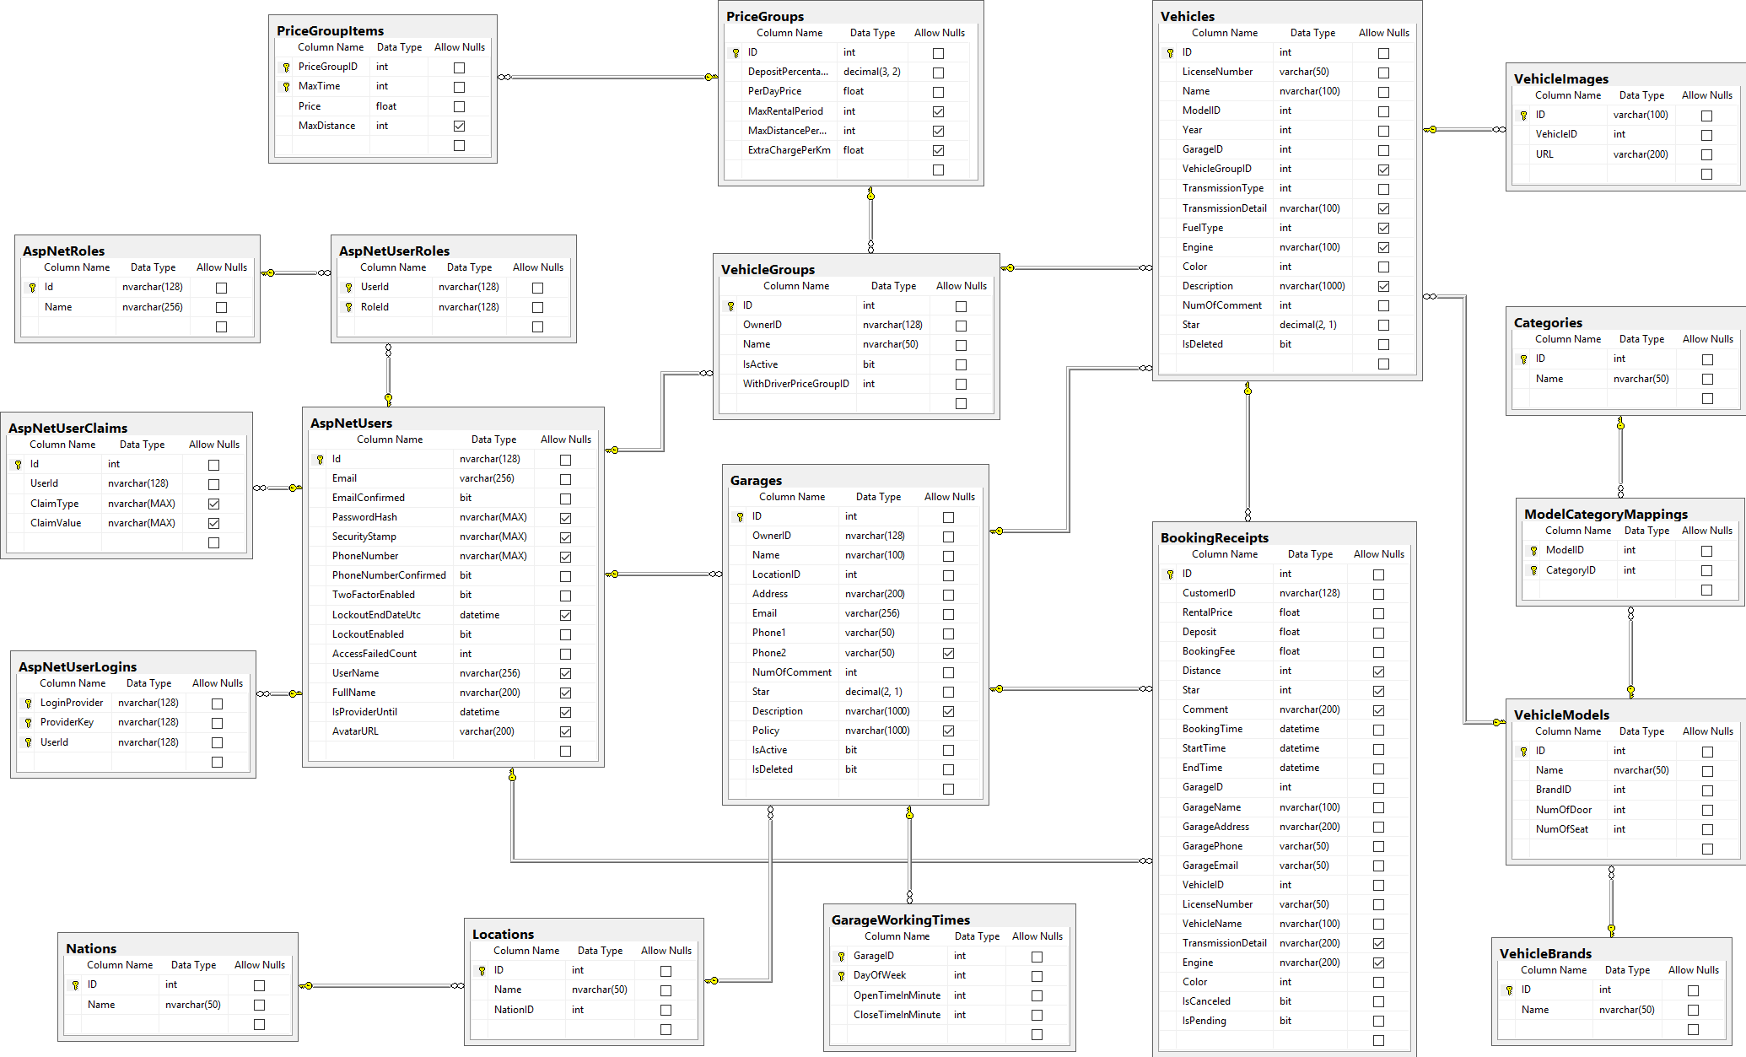

Figure 62: ウェブサイトアプリケーション物理的なダイアグラム

### 2.2 ウェブアプリケーションデータ辞書

## パフォーマンス対策

パフォーマンスを測定するために、デプロイとともにazure ホスティングでテストして、予測を行いました。

### 製品検索、メンバーのパフォーマンス

一般的に、結果はユーザが検索フォームを提出した後、5秒未満を現されます。

### 送り状リストが展示されるパフォーマンス

一般的には、ユーザーが「送り状リスト」のリンクをクリックすると、注文リストはより5秒以内に展示されます。

### 収入統計など展示されるパフォーマンス

一般的に、時間を選んで、「統計」というボタンをクリックすると、10秒以内で収入統計など展示されます。

## テスト計画

### テストする機能

システムテストはコアワークフローに基づいて行うことになります。

テストする機能:

* ユーザログイン
* ゲスト：
  + 製品を注文します
* 顧客：
  + 製品を注文します
  + 送り状を確認します
* 人員
  + 送り状を造ります
  + 送り状を承認します
  + 送り状の状態を変化します
  + 送り状を編集します
  + 入力原料を付加します
  + 入力原料を捨てます
  + 入力法案を付加します
* 管理
  + 収入統計
  + 製品別収益
  + お客様による純益統計
  + 消費税申告
  + 免許税申告

### テストされない機能

* ログ‐アウト
* プロフィールを編集
* 消費税申告
* 免許税申告
* 顧客管理
* 人員管理

## システムテストのテストケース

# ソフトウェアユーザーズマニュアル

## インストレーションガイド

### サーパ側の環境を設定

#### ハードウェア要件

**スムーズにウェブサイトを実行するてめには、以下の要件を備えたコンピュータが必要になります:**

* オペレーティングシステム: ウィンドウXPまたはウィンドウのそれ以降のバージョン。
* プロセッサ：１GHｚ以上。
* メモリ：2GB以上。
* ハードウェア：2GB以上のハードドライブスペース。
* Wifi インターネット(> 2Mbps)。

#### ソフトウェア要件

* + - ウェブサーバー ：Internet information system – IIS 8 With MVC5 enable
    - Microsoft Windows Server 2008 R2 Enterprise (Server Pack 1 64 bit): オペレイティングシ
    - .Net Framework 4.5.1
    - SQL Server 2008 R2

### サーパ側で展開

#### 展開パッケージの準備

* データベース　ファイル： BMA.mdf
* サーパーでのフォルダにソースコードファイル（BMA）をコピーする。
  + 例えば：C:\BMA

#### サーパーの構成前に展開

* **データベースの構成：**

<connectionString>

<add name = “DefaultConnection”

connectionString =”Datasource:(local);Initial Catalog=BMA;Persist Security Info = True;user id=sa;password=123456789” providerName = “System.Data.SqlClient” />

<add name = “BMAChangeDB”

connectionString =”Datasource:(local);Initial Catalog=BMA;Persist Security Info = True;user id=sa;password=123456789” providerName = “System.Data.SqlClient” />

</connectionString>

* Catalog : データベース名。
* User id :ユーザ名データベース。
* Password :パスワード

#### サーパ側でWebアプリケーションの展開

* **データベース展開：**
* ＳＱＬ Server 2008 R2 にBMA.mdfをアタックしてください。
* **ソースコードの展開：**
* オーペンIISマネージャ
* “Default Web Site”にマウスを右クリックします。“Add Application”を選びます。
  + Alias : Aliasを入力してください。例えば：ＢMA
  + Application pool : ASP.NET v4.0 を選んでください
  + Physical path:サーパーのソースコードファイルを選んでください（C:\BMA）
* “OK”ボタンをクリックしてください。
* オーペン：<http://localhost/BMA>

### クライアント側の環境の設定

#### コンピュータのための設定

* クライアントデバイスは、ウェブサイトを起動するには、以下のブラウザのいずれかを持っている必要があります：
  + Google Chrome(ダウンロードリンク):
    - <http://www.google.com/Chrome>
  + Coc Coc（コックコック）：
    - <http://www.coccoc.com/>

## ユーザーガイド

### ログイン



図面63: ログインポップアップ

|  |  |
| --- | --- |
| ステップ | 説明 |
| **1** | 口座を入力して |
| **2** | パスワードを入力して |
| **3** | 「Đăng nhập」ボタンをリックして |
| **4** | パスワードを忘れたら、「Quên mật khẩu」ボタンをリックして |

テーブル70: ログインポップアップ

### 製品を注文すること



図面 64:製品を注文すること

|  |  |
| --- | --- |
| ステップ | 説明 |
| **1** | 製品を探す |
| **2** | 「Mua hàng」 ボタンをクリックして、 製品を注文する |

テーブル 71:　製品を注文する

### カートに製品を追加すること



図面 65: カートに製品を追加すること

|  |  |
| --- | --- |
| ステップ | 説明 |
| **1** | この製品の数量 |
| **2** | 「Thêm vào giỏ hàng 」 ボタンをくりっくして、カートに製品を追加する |

テーブル 72: カートに製品を追加する

### かーとをチェックすること



図面 66: かーとをチェックすること

|  |  |
| --- | --- |
| Step | 説明 |
| **1** | 「Giỏ hàng 」 ボタン をクリックして、製品のリストが見える |
| **2** | 「Thanh toán 」 ボタン をクリックして、カートの精細を見える |

テーブル 73: かーとをチェックすること

### カーとの精細



図面 67: カートの精細

|  |  |
| --- | --- |
| ステップ | 説明 |
| **1** | 製品の数量を変われる |
| **2** | 製品のリストを戻って、製品を注文して行く |
| **3** | 「Cập nhật giỏ hàng 」 ボタンをクリックして、 カートを更新する |
| **4** | 配送日をセレクトする |
| **5** | 「Đặt hàng 」ボタン をクリックして、注文を完成する |

テーブル 74: カートの精細

### 送り状を確認すること



図面 68: 送り状を確認すること

|  |  |
| --- | --- |
| ステップ | 説明 |
| **1** | カートの精細を戻れば、「Quay lại giỏ hàng 」 ボタン をクリックする |
| **2** | 送り状の確認のボタン |

テーブル 75: 送り状を確認すること

### 送り状に顧客の情報を充実すること



図面 69: 送り状に顧客の情報を充実すること

|  |  |
| --- | --- |
| ステップ | 説明 |
| **1** | これに成員をログインする |
| **2** | 成員なければ、情報を充実するところ |
| **3** | 「Quay lại giỏ hàng 」 ボタン をクリックして、送り状の確認ページを戻る |
| **4** | 口座とパスワードを入力して,「Đăng nhập 」ボタンをクリックして、送り状を完成する |
| **5** | 顧客の情報を入力して,「Hoàn tất 」 ボタンをクリックして、送り状を完成する |

テーブル 76: 送り状に顧客の情報を充実すること

### 送り状のリストを見ること



図面 70: 送り状のリストを見ること

|  |  |
| --- | --- |
| ステップ | 説明 |
| **1** | 不足の原料のリスト |
| **2** | 新し送り状を造る |
| **3** | 送り状の精細 |
| **4** | 送り状を変わる |
| **5** | 送り状を取り消す |
| **6** | 探す |

テーブル 77: 送り状のリストを見ること

### 「人員」送り状を造ること



図面 71: 「人員」送り状を造ること

|  |  |
| --- | --- |
| ステップ | 説明 |
| **1** | 製品 の単価 |
| **2** | 製品の数量 |
| **3** | 送り状に製品をテーキオフする |
| **4** | 送り状をキャンセルこと |
| **5** | 送り状を続く |
| **6** | 送り状に製品を追加する |

テーブル 78: 「人員」送り状を造ること

### 送り状に顧客を追加すること



図面 72: 送り状に顧客を追加すること

|  |  |
| --- | --- |
| ステップ | 説明 |
| **1** | 顧客をセレクトする |
| **2** | 顧客なければ、口座を造る |
| **3** | お客さんの名前 |
| **4** | お客さんの口座 |
| **5** | お客さんのメール |
| **6** | お客さんの住所 |
| **7** | お客さんの電話番号 |
| **8** | お客さんの税額 |
| **9** | 入力をすべてリセット |
| **10** | 口座を造って、この口座にその送り状を追加する |
| **11** | 送り状を造るのページを戻る |
| **12** | 送り状をキャンセルする |

テーブル 79: 送り状に顧客を追加すること

### 新い顧客の口座で送り状をチェックアウト



図面 73: 新顧客の口座で送り状をチェックアウト

|  |  |
| --- | --- |
| ステップ | 説明 |
| **1** | 新顧客の情報 |
| **2** | 送り状の情報 |
| **3** | この送り状に原料数量 を過ごす |
| **4** | 送り状にお客さんを追加する ページを戻る |
| **5** | 送り状を造るのページを戻る |
| **6** | この送り状を確認する |
| **7** | この送り状をキャンセルする |

テーブル 80: 新顧客の口座で送り状をチェックアウト

### 入力法案 リスク



図面 74: 入力法案 リスク

|  |  |
| --- | --- |
| ステップ | 説明 |
| **1** | 新入力法案を造る |
| **2** | 探す |
| **3** | 入力法案 リスク |
| **4** | 入力法案 の精細を見る |
| **5** | 入力法案 の情報を変わる |

テーブル 81:入力法案 リスク

### 新入力法案を造ること



図面 75: 新入力法案を造ること

|  |  |
| --- | --- |
| ステップ | 説明 |
| **1** | サプライヤー をセレクトする |
| **2** | この入力法案料(VATがない) |
| **3** | VAT の料金 |
| **4** | 輸入日 |
| **5** | 入力法案の写真 |
| **6** | 入力法案 陸とを戻る |
| **7** | 新入力法案を造る |

テーブル 82: 新入力法案を造ること

### 入力原料 リスクを見る



図面 76: 入力原料 リスク

|  |  |
| --- | --- |
| ステップ | 説明 |
| **1** | 新入力原料を造ること |
| **2** | 探す |
| **3** | 入力原料 リスク |
| **4** | 入力原料 精細 |
| **5** | 入力原料 の情報を変わる |
| **6** | 入力原料をデリーとする |

テーブル 83: 入力原料リスク

### 入力原料 の精細を見ること



図面 77:入力原料 の精細を見ること

|  |  |
| --- | --- |
| ステップ | 説明 |
| **1** | 入力原料の情報 |
| **2** | 入力原料をデリートする |
| **3** | 同じ入力法案の入力原料リスク |
| **4** | 入力原料の脚注 |
| **5** | 入力原料デリーとの情報 |
| **6** | 入力原料 リスクを戻る |
| **7** | 入力原料 の情報を更新する |

テーブル 84:入力原料の精細を見ること

### 新入力原料を造ること



図面 78: 新入力原料を造ること

|  |  |
| --- | --- |
| ステップ | 説明 |
| **1** | 入力原料名 |
| **2** | 入力原料の数量 |
| **3** | 入力原料の総価格 |
| **4** | 入力原料の輸入日 |
| **5** | 入力原料の有効期限 |
| **6** | 入力原料の脚注 |
| **7** | 入力原料の 入力法案 のコード |
| **8** | 入力原料 リスクを戻る |
| **9** | 入力原料を造る |

テーブル 85:入力原料を造ること

# Appendix

1. Sashimi – Modified Waterfall Model:

<http://www.waterfall-model.com/sashimi-waterfall-model>

1. UML 2.0 standard

<http://www.omg.org/spec/UML/2.0>

1. Collaborative filtering approach

[https://en.wikipedia.org/wiki/Recommender_system#Collaborative_filtering](https://en.wikipedia.org/wiki/Recommender_system%23Collaborative_filtering)

1. Content-based approach

[https://en.wikipedia.org/wiki/Recommender_system#Content-based_filtering](https://en.wikipedia.org/wiki/Recommender_system%23Content-based_filtering)

1. Vector space model

<https://en.wikipedia.org/wiki/Vector_space_model>

1. tf-idf

<https://en.wikipedia.org/wiki/Tf%E2%80%93idf>